
info@argusoft.com www.argusoft.com

Technical Proposal
A proposal for Assignment

System design, development, and support and maintenance of the Data Management System for Health Accounts.
Ref : PFD -2026-001

Submitted on
12th August, 2026

WHO

Table of Contents
Table of Contents 2
Cover Letter 3
Executive Summary 6
Compliance Matrix - Mandatory Requirements 8
Relevant Experience (Past Project References) 12
Relevant Project Experience 14
Technical Proposal / Methodology Proposed in the Proposal 36
Scope of Work - Our Understanding 36
Approach 39
Methodology 41
Functional Landscape Diagram 42
Proposed Solution 43
Proposed Work Plan 72
Development Timeline 75
Quality Assurance Methodologies and Processes 76
Capacity Building and Knowledge Transfer 80
Support, Maintenance & Warranty Services 83
Key Personnel 86
Key Experts 86
Non Key Experts 88
Resumes of Key Resources 89
Annexure 1 : Company Profile 124
About Argusoft India 124
Annexure 2 : ISO Certifications 130
Argusoft India 130
Annexure 3: Letters of Recommendation 136
Annexure 4 – Functional Compliance Matrix (Uc001–Uc061) 140

Cover Letter
Date: 12th August, 2026
To
The Procurement Committee
World Health Organization (WHO)
Subject: Proposal Submission – Development of the Health Accounts Data System (HADS), built upon WHO’s existing xMart data warehouse (Reference: PFD-2026-001)
Dear Sir/Madam,
Argusoft India Limited is pleased to submit its Technical and Financial Proposal for the Development of the Health Accounts Data System (HADS), built upon WHO’s existing xMart data warehouse. We appreciate the opportunity to partner with the World Health Organization (WHO) in delivering a secure, scalable, and configurable platform that strengthens the collection, validation, management, and analysis of National Health Accounts data across Member States.
We recognize that National Health Accounts are fundamental to evidence-based health financing and health system governance. Reliable Health Accounts data enables governments to monitor health expenditure, evaluate financing reforms, support Universal Health Coverage (UHC), and make informed policy decisions. Through this initiative, WHO is modernizing its digital ecosystem to improve data quality, standardization, collaboration, and analytical capabilities. We are committed to delivering a sustainable platform that contributes to stronger national health information systems and better health financing decisions worldwide.
For over 25 years, Argusoft has been delivering enterprise digital transformation solutions for governments, international organizations, and public sector institutions. Our expertise includes configurable enterprise platforms, metadata-driven applications, workflow automation, analytics, cloud-native architectures, secure software engineering, interoperability, and long-term application support.
Argusoft has built a strong partnership with the World Health Organization through the successful delivery and ongoing support of several strategic digital platforms. Our WHO portfolio includes the Joint External Evaluation (JEE) Reporting Platform, Early Warning, Alert and Response System (EWARS), Event Management Suite (EMS2), Simulation Exercise (SimEx), WHO Emergency Public Dashboard, and the P4H World Platform, which supports global collaboration on social health protection and health financing. These engagements have provided us with a deep understanding of WHO's digital ecosystem, delivery standards, cybersecurity requirements, and collaborative implementation approach.
Equally important, Argusoft has extensive experience implementing national-scale Health Information Systems, directly aligning with the objectives of this assignment. Our portfolio includes TeCHO+, serving over 65 million citizens through 13,500+ health workers in Gujarat; eKavach, supporting more than 300 million beneficiaries through 180,000+ field health workers in Uttar Pradesh; ImpactHealth Nigeria; EmCare (Clinical Care in Crisis) developed with WHO; and P-HMMS for HIV programme management. These platforms demonstrate our expertise in developing configurable, metadata-driven health information systems with complex workflows, data validation, reporting, interoperability, mobile applications, and large-scale data management.
Our broader experience includes delivering enterprise platforms for governments and international organizations such as the License Management System for the Government of Jamaica, the Data Visualization and Business Intelligence Platform, Trust and Estate Management System, Jamaica Customs Portal, and Boston College EagleApps. These engagements demonstrate our capability to deliver enterprise applications involving configurable workflows, document management, analytics, dashboards, API integrations, and secure cloud deployments.
Having reviewed the Terms of Reference and technical requirements, we understand that the solution will leverage xMart’s existing capabilities while extending the ecosystem to support Health Accounts-specific processes. Argusoft’s direct experience integrating the WHO Emergency Public Dashboard with xMart, together with our end-to-end experience delivering applications within WHO’s Azure environment and our expertise in configurable enterprise platforms, workflow engines, metadata-driven applications, validation frameworks, and analytics solutions, positions us well to deliver a scalable, maintainable, and sustainable HADS solution.
Our implementation approach combines collaborative requirements validation, agile delivery, rigorous quality assurance, comprehensive documentation, structured knowledge transfer, and user training. We are committed to working closely with WHO throughout the project lifecycle to deliver a secure, user-centric, and future-ready solution that meets the highest standards of quality and performance.
We confirm that we have carefully reviewed the Request for Proposal, its Terms of Reference, and the accompanying annexes, and that our proposal has been prepared in accordance with the stated requirements and the applicable Long-Term Agreement. We are confident that our extensive WHO experience, proven track record in national health information systems, and expertise in configurable enterprise platforms strongly position Argusoft to successfully deliver the Health Accounts Data System on the xMart Platform.
We thank you for considering our proposal and look forward to the opportunity to partner with the World Health Organization on this important initiative.
Yours faithfully,

Ravi Shankar
Senior President, Professional Services, Argusoft India Limited
Email: info@argusoft.com

Executive Summary
The World Health Organization (WHO) is undertaking the modernization of its Health Accounts Data Management System (DMS) to replace the current legacy application with a centralized, web-based platform built on the existing xMart platform. The new DMS will support the collection, storage, consolidation, validation, analysis, and publication of National Health Accounts data while improving system performance, strengthening quality checks, supporting report production, and enabling seamless integration with WHO's Health Accounts ecosystem, including xMart, HAPT, eDamis, the Global Health Expenditure Database (GHED), and other data sources.
Argusoft India Limited proposes a configurable, secure, and scalable Data Management System that leverages the existing capabilities of the xMart platform while implementing the functional, technical, and integration requirements defined by WHO. The proposed solution will provide a centralized environment for managing Health Accounts data, metadata, formulas, workbooks, reports, quality checks, and version-controlled information through configurable modules and standards-based APIs. In line with the proposed target architecture, xMart will continue to serve as the primary Health Accounts data warehouse, while the DMS will provide the business functionality and user interface required for data management and analysis.
Argusoft is particularly well positioned for this assignment through its direct, hands-on experience with WHO’s xMart platform. For the WHO Emergency Public Dashboard, our team integrated the application with the secured xMart OData API to retrieve and process data from xMart tables and views for dashboards, reports, and analytics. The team also used xMart’s Excel-based model upload capability to define and update custom data models. Combined with our end-to-end experience delivering and supporting applications within WHO’s Azure environment, this provides Argusoft with practical familiarity with WHO’s integration patterns, accessibility expectations, cybersecurity requirements, deployment processes, release governance, and operational standards. This existing knowledge will reduce onboarding, integration, security-review, and deployment risks and support accelerated delivery of the Pilot and subsequent phases.
Our solution is designed to support the complete business processes defined within the Requirements Document, including user and role management, metadata and configuration management, workbook management, reporting, data and metadata versioning, configurable quality checks, xMart integration, and phased implementation. The solution will support controlled two-way data exchange with xMart, including retrieval of the required Health Accounts data, metadata, formulas, version information, and configuration through xMart’s secured OData API, and transmission of DMS-generated updates through the applicable WHO-approved xMart data-ingestion mechanism. This approach will maintain consistency between the DMS and xMart while aligning with WHO’s prescribed integration architecture.
Recognizing that the success of this assignment depends not only on technology but also on an effective delivery methodology, Argusoft proposes a hybrid implementation approach combining the strengths of both Waterfall and Agile methodologies. The initial phases will follow a structured approach focused on project initiation, requirements validation, business process analysis, solution architecture, and interactive prototype development to establish a common understanding of the proposed solution. Following design approval, development will transition to iterative Agile delivery through two-to-three-week sprints, enabling incremental delivery of prioritized functionalities, regular demonstrations, stakeholder feedback, and progressive validation. Sprint deliverables will first be deployed to the UAT environment for WHO review and acceptance before approved releases are promoted to Production, with identified defects addressed within the current or following sprint. This approach provides clarity during solution definition while maintaining the flexibility required to support WHO’s phased implementation model.
The proposed implementation covers the complete project lifecycle, including solution design, development of the Pilot functionalities, incremental implementation of subsequent functionalities, quality assurance, testing, deployment to User Acceptance Testing (UAT) and Production environments, integration with WHO systems, legacy data and formula migration, documentation, administrator and end-user training, source code handover, and cloud infrastructure support and maintenance in accordance with the Terms of Reference.
The proposed solution provides the following key capabilities:
- Centralized, web-based Data Management System built upon WHO’s existing xMart data warehouse.
- Configurable management of users, roles, metadata, formulas, workbooks, reports, and quality check rules.
- Controlled two-way integration with xMart for the retrieval and synchronization of data, metadata, formulas, version information, and configuration through WHO-approved integration mechanisms.
- Support for Health Accounts data collection, validation, consolidation, reporting, and publication.
- Data and metadata versioning, comparison, restoration, auditability, and configurable quality checks.
- Phased implementation beginning with Pilot functionalities followed by incremental delivery of the remaining requirements.
- Secure cloud deployment, comprehensive documentation, knowledge transfer, user training, and post-implementation support.
By combining a configurable platform architecture, a structured hybrid delivery methodology, and a collaborative implementation approach, Argusoft will deliver a sustainable Health Accounts Data Management System that aligns with WHO's functional and technical requirements while providing a scalable foundation for future enhancements and continued support of the Health Accounts programme.

Compliance Matrix - Mandatory Requirements
Sr. No. | Evaluation Criteria | Argusoft's Response
1 | Quality of Overall Proposal & Project Management Plan | Argusoft presents a complete implementation approach covering inception, design, Agile development, integration, testing, UAT, deployment, training, handover and warranty, supported by project governance, risk management, QA and stakeholder coordination. [Approach & Methodology] [Proposed Work Plan] [Development Timeline]
2 | Understanding of the Assignment & Health Accounts Context | Argusoft demonstrates understanding of the legacy DMS replacement, Health Accounts data lifecycle, xMart dependency, data validation, reporting, publication, migration and operational requirements. [Scope of Work – Our Understanding]
3 | Approach & Methodology / Agile Delivery | Argusoft proposes an Agile-led approach with structured inception/design followed by two-to-three-week development sprints, regular demonstrations, stakeholder feedback, UAT validation and controlled Production releases. [Methodology]
4 | Project Management & Governance | The proposed Project Manager provides structured governance, stakeholder coordination, progress reporting, risk and issue management, resource coordination, quality oversight and delivery control. [Key Personnel – Project Manager]
5 | Implementation Work Plan & Timeline | The six-phase implementation plan covers initiation, design, development, testing/UAT, deployment/training/handover and warranty, aligned with WHO's 1-, 6-, 7- and 10-month milestone framework. [Proposed Work Plan] [Development Timeline]
6 | Quality Assurance, Risk & Change Management | The proposal establishes structured QA covering functional, integration, migration, security, performance, accessibility and UAT testing, supported by risk, issue and change-management processes. [Quality Assurance]
7 | Training, Knowledge Transfer & Sustainability | Argusoft provides user/administrator training, technical documentation, source-code handover, database documentation, operational knowledge transfer and warranty support to enable WHO's long-term ownership and sustainability. [Capacity Building & Knowledge Transfer] [Support, Maintenance & Warranty]
8 | Previous Work with WHO / International Organizations | Argusoft has extensive experience delivering and supporting WHO platforms, including the WHO Emergency Public Dashboard, JEE Reporting, eNAPHS, EWARS and SIMEX, covering requirements, development, testing, Azure deployment, maintenance and support. [Relevant Experience – Past Project References]
9 | Experience with xMart Technology-Based Development | Argusoft has direct hands-on WHO xMart experience through the WHO Emergency Public Dashboard, including secured xMart OData API integration, retrieval from xMart tables/views and xMart model configuration. [Relevant Experience – WHO Emergency Public Dashboard]
10 | Experience in Expenditure / Financial Large or Complex Data Solutions | Argusoft demonstrates experience delivering complex data-management, reporting, analytics and health-information platforms involving multidimensional datasets, data validation, metadata, reporting and integration. Relevant health-financing and expenditure-data capabilities are further supported through the proposed Data Analyst and team. [Relevant Experience]
11 | Business Analysis & Cross-Functional Process Experience | Argusoft demonstrates requirements engineering, process documentation, stakeholder workshops and cross-functional business analysis across government, WHO and international digital transformation projects. [Relevant Experience] [Key Expert 2 – Business Analyst]
12 | Project Framework, Agile Methods & Design Thinking | The team combines PMI/project-management experience with Agile/Scrum delivery and user-centred design capabilities, supporting structured governance alongside iterative development and stakeholder validation. [Methodology] [Key Personnel]
13 | Technical Scope – Cloud Architecture, Microsoft Technologies & Containerization | The proposed team combines Azure cloud architecture, Microsoft .NET/SQL Server technologies, Azure DevOps, Kubernetes/containerization and Infrastructure-as-Code capabilities relevant to the requested technical scope. [Proposed Solution] [Key Experts – Technical Lead / DevOps]
14 | Statistical / Data Analytics Capability | The proposed Data Analyst has 9+ years of data analysis and data-science experience covering data modelling, ETL, statistical analysis, reporting, data quality, healthcare analytics and large datasets, with relevant statistical-tool exposure. [Key Expert 5 – Data Analyst]
15 | Proof of Similar Large Fixed-Price Projects (>1,000 Man-Days) | Argusoft's project portfolio demonstrates delivery of large, complex enterprise and public-sector platforms with substantial multidisciplinary teams and long-term implementation/support engagements. [Relevant Experience – Past Project References]
16 | Key Personnel – Strength & Relevance of Proposed Team | The proposed Key Experts collectively cover project management, business analysis, technical leadership, software engineering, data analysis, product design and DevOps, supported by relevant health, WHO, government and enterprise experience. [Key Personnel / CVs]
17 | Organizational Quality & Security Credentials | Argusoft's organizational capability is supported by ISO 9001:2015, ISO/IEC 27001 and other relevant management-system certifications, demonstrating established quality and information-security practices. [Company Profile / Certifications]

Relevant Experience (Past Project References)
Argusoft brings over 25 years of experience in designing, developing, deploying, and supporting large-scale enterprise data management platforms, digital health information systems, and workflow-driven applications for the World Health Organization (WHO), international organizations, governments, and public-sector institutions. Our portfolio includes mission-critical systems supporting disease surveillance, emergency response, health financing, clinical decision support, analytics, and national public health programmes.
Of particular relevance to this assignment, Argusoft has direct, hands-on experience with WHO’s xMart platform through the development and ongoing support of the WHO Emergency Public Dashboard. The Argusoft team integrated the application with the secured xMart OData API to retrieve and process data from xMart tables and views for dashboards, reports and analytics. The team also used xMart’s Excel-based model upload capability to define and update custom data models within the applicable mart. This work provided practical experience with xMart mart structures, tables and views, OData query patterns, filtering, authentication, model configuration and downstream data consumption—capabilities directly relevant to the proposed Health Accounts DMS.
Argusoft also has proven experience delivering WHO applications through the complete software development lifecycle within WHO’s Azure environment. For applications including the JEE Reporting Platform, eNAPHS and EWARS, Argusoft has been responsible for requirements analysis, solution design, application development, testing, security remediation, deployment to WHO Azure environments, production release, documentation, training, maintenance, and ongoing technical support. Through these engagements, our teams have developed practical familiarity with WHO’s accessibility expectations, including applicable WCAG requirements; cybersecurity and application-security requirements; Azure deployment and release processes; technical documentation standards; quality assurance practices; and operational governance procedures.
This combination of existing xMart integration experience, end-to-end WHO Azure delivery experience, and long-term support of mission-critical WHO platforms provides Argusoft with a significant advantage for this assignment. Our team will begin with established knowledge of WHO’s technology and governance environment, thereby reducing onboarding time, avoiding preventable integration and deployment issues, and accelerating delivery of the Pilot and subsequent phases.
Our broader experience encompasses the complete lifecycle of enterprise application delivery, including business analysis, requirements engineering, solution architecture, UI/UX design, application development, API integration, cloud deployment, legacy system modernization, data and metadata migration, testing, training, knowledge transfer, warranty services, and long-term maintenance. We have successfully developed platforms that manage complex and multidimensional datasets, configurable workflows, validation rules, metadata, reporting and analytics, and interoperability across enterprise systems.
Across the selected projects, Argusoft demonstrates:
- Direct experience with WHO xMart, including OData-based API integration and the use of the xMart Model Uploader for onboarding custom data models and associated data.
- End-to-end delivery within WHO’s Azure environment, covering development, testing, deployment, production release, monitoring, maintenance, and technical support.
- Practical understanding of WHO accessibility, cybersecurity, quality assurance, deployment, documentation, and governance requirements.
- Proven delivery and long-term support of mission-critical WHO digital platforms.
- Extensive experience developing health information systems, enterprise data management platforms, and workflow-driven applications.
- Strong capability in metadata-driven solution design, data validation, workflow automation, reporting, dashboards, and analytics.
- Experience integrating multiple systems through OData, REST APIs, and standards-based interoperability mechanisms.
- Successful modernization of legacy enterprise applications into scalable, secure, and maintainable web-based platforms.
- Proven capability in training, knowledge transfer, warranty services, and long-term operational support.
Health Accounts DMS requirement | Argusoft Evidence
xMart technology-based development | WHO Emergency Dashboard: OData-based xMart API integration and xMart Model Uploader
API integration with xMart | Production integration for retrieval and processing of xMart data
WHO Azure deployment | End-to-end deployment and support for JEE, eNAPHS and other WHO applications
Accessibility and security | Experience applying WHO accessibility, cybersecurity and release requirements
Data management and analytics | Emergency Dashboard, MEDPlat, EWARS and other enterprise platforms
Full SDLC and sustainability | Requirements through production, training, warranty and long-term support

Relevant Project Experience

1. WHO Emergency Public Dashboard
Project Name: Emergency Dashboard
Client: World Health Organization (WHO)
Implementation Period: 2022 – Present
Country / Region: Global / WHO
Project Status: Ongoing
Approx.Man Months: 70–80 staff-months + 2 staff-months/month for ongoing enhancements.
Contract Value: $425k Plus
Argusoft's Role: End-to-end design, development, integration, testing, deployment, enhancement, hosting support and ongoing maintenance.
Project Description
The WHO Emergency Public Dashboard is an enterprise data management, analytics and reporting platform providing centralized visibility into emergency programme information across WHO. The platform consolidates data from multiple WHO systems to support operational monitoring, evidence-based planning and decision-making. Argusoft was responsible for end-to-end design, development, integration, testing, deployment, enhancement, hosting support and ongoing maintenance. The team integrated the application with WHO xMart APIs using the OData protocol for structured retrieval and processing of xMart data and used the xMart Excel-based Model Uploader to define and update custom data models. The solution provides interactive dashboards, configurable visualizations, secure access, automated data exchange and integration with WHO's wider digital ecosystem.
Key Deliverables
- WHO xMart integration using OData APIs.
- xMart data retrieval, processing and transformation.
- Custom xMart data-model configuration using Model Uploader.
- Interactive dashboards and configurable visualizations.
- Reporting and visual analytics.
- Secure access management.
- Azure deployment and production release support.
- QA, cybersecurity and accessibility activities.
- Technical documentation.
- Production support and continuous enhancement.
Technology Stack
- WHO xMart
- OData
- Microsoft Azure
- Web application technologies
- APIs and data integration
- Data models
- Dashboard and visualization technologies
Scale / Outcomes
- Direct production experience with WHO xMart.
- Direct experience with OData-based xMart APIs.
- Practical experience with the xMart Model Uploader.
- Integration of information from multiple WHO systems.
- Production deployment and operational support within the WHO environment.
- Long-term enhancement and maintenance of a WHO enterprise platform.
Relevance to HADS
- Directly demonstrates the most specific technical experience required for HADS: WHO xMart integration.
- Demonstrates practical understanding of xMart data structures, models, APIs, data retrieval, transformation and ingestion, directly applicable to the proposed DMS.
- Directly relevant to the HADS requirement for xMart-to-DMS and DMS-to-xMart API-based data and metadata exchange.
- Demonstrates experience consolidating information from multiple WHO systems into a centralized data and analytics platform.
- Provides direct experience with reporting, dashboards, visual analytics and structured presentation of data, supporting the HADS Reports and Analytics requirements.
- Demonstrates deployment and operation within WHO Azure infrastructure and governance processes, including cybersecurity, accessibility, QA and release management.
- Covers the full lifecycle from solution design through development, deployment and long-term support, directly relevant to HADS implementation, handover and maintenance.

2. MEDPlat – Digital Public Health Platform
Project Name: MEDPlat and its Implementations
Client / Partners: Bill & Melinda Gates Foundation / Governments / NGOs
Implementation Period: Multiple implementations
Country / Region: India, Nigeria and other implementation countries
Project Status: Multiple completed and ongoing implementations
Implementations | Approx Man Months | Contract Value
Public Health Management Platform | 50-60 Staff month | Part of BMGF funding of $4 Million (approx cost of specific implementation is INR 240 Lakhs
Techo+ | 300+ Staff month. | Part of BMGF funding of $4 Million (approx cost of specific implementation is INR 900 Lakhs )
CHiP (Community Health information Platform) | 110 staff-months (development) + 2 staff-months/month ongoing | INR 680 Lakhs
eKavach | 250–300 staff-months + 4 staff-months/month ongoing | Part of BMGF funding of $4 Million (approx cost of specific implementation is INR 1800 Lakhs )
iMomCare | 140–160 staff-months (development) + 1 staff-month/month ongoing | INR 320 Lakhs
Argusoft's Role: Platform developer and implementation partner.
Project Description
MEDPlat is Argusoft's low-code Digital Public Good (DPG) platform for designing and implementing large-scale health information systems. Developed with support from the Bill & Melinda Gates Foundation, the platform enables governments and development organizations to configure and deploy public-health programmes through configurable workflows, metadata-driven forms, validation, business rules, reporting, analytics, interoperability and mobile applications. MEDPlat integrates with national HMIS, healthcare applications and other enterprise systems and has been implemented across maternal and child health, immunization, disease surveillance, nutrition and non-communicable disease programmes. Its implementations include TeCHO+, eKavach and ImpactHealth at significant national and programme scale.
Key Deliverables
- Configurable health information platform.
- Metadata-driven forms and data structures.
- Configurable workflows and business rules.
- Data validation and quality controls.
- Structured health-data management.
- Reporting and analytics.
- Web and mobile applications.
- HMIS and enterprise-system integration.
- Interoperability capabilities.
- Multi-country implementation and support.
Technology Stack
- Metadata/configuration-driven platform architecture.
- Web and mobile technologies.
- APIs and system integration.
- Enterprise databases.
- Reporting and analytics.
- FHIR and CQL interoperability technologies.
Scale / Outcomes
- TeCHO+: 13,500+ field health workers; approximately 65 million citizens; more than one million health services recorded weekly.
- eKavach: 180,000+ field health workers; approximately 300 million citizens.
- ImpactHealth, Nigeria: 1,431 field health workers and 21,063 beneficiaries during pilot implementation.
- Implemented across multiple countries and public-health programmes.
Relevance to HADS
- Demonstrates extensive experience delivering large-scale health information and health-data management platforms, directly relevant to HADS.
- Strong experience with metadata-driven architecture, configurable data structures, workflows, validation and business rules, closely aligned with HADS's data, metadata, quality-check and configuration requirements.
- Demonstrates management of large health datasets and very large user populations, providing strong evidence of scalability.
- Experience integrating health platforms with national HMIS and other enterprise systems, directly relevant to HADS interoperability and API integration.
- Demonstrates structured health-data collection, processing, reporting and analytics across multiple programmes.
- Experience with standardized health-data exchange and interoperability technologies, supporting the proposed DMS's integration requirements.
- Multi-country implementation demonstrates the ability to adapt a common platform to different country, programme and stakeholder requirements.
- Provides strong complementary evidence to Argusoft's WHO/xMart experience by demonstrating depth in health-data architecture, scalability, validation, interoperability and analytics.

3. WHO Early Warning, Alert and Response System (EWARS)
Project Name: Early Warning, Alert and Response System (EWARS)
Client: World Health Organization (WHO)
Implementation Period: 2019 – Present; initial development phase completed February 2021
Country / Region: Global / Humanitarian Emergency Settings
Project Status: Ongoing support, maintenance and enhancement
Approx. Man Months:200–220 staff-months (development + enhancements) + 4 staff-months/month ongoing
Contract Value: $1,400,000.00
Argusoft's Role: Further development, hosting, maintenance, enhancements, L2/L3 support, data management, documentation and training.
Project Description
EWARS is a WHO digital health information system supporting disease surveillance and response in humanitarian emergencies. It combines online, web and mobile applications and is designed for rapid configuration and deployment, including environments with unreliable connectivity or electricity. In 2019, Argusoft assumed responsibility for further development, support and maintenance of the existing system, subsequently completing the initial development phase in February 2021 and continuing to provide hosting, application maintenance, change-request management, L2/L3 technical assistance, further development, data management, documentation and country personnel training. The platform supports structured health-data collection, validation, analysis, reporting and centralized management of health information.
Key Deliverables
- Web and mobile applications.
- Structured health-data collection.
- Data validation and processing.
- Health-data analysis and reporting.
- Centralized health-information management.
- Hosting and deployment.
- Change-request implementation.
- Application maintenance.
- L2/L3 technical support.
- Documentation and training.
- Knowledge transfer.
Technology / Technical Capabilities
- Web and mobile applications.
- Structured health-data management.
- Data validation and processing.
- Reporting and analytics.
- Hosting/cloud environment.
- Integration with health-information sources.
Scale / Outcomes
- Designed for configuration and deployment within 48 hours of an emergency being declared.
- Supports disease surveillance and outbreak response.
- Designed for distributed/low-connectivity environments.
- Long-term operational support in coordination with WHO country teams.
Relevance to HADS
- Provides direct evidence of WHO health-information-system delivery and long-term operational support.
- Particularly relevant to HADS because Argusoft took over and modernized an existing system, demonstrating capability to understand, extend and maintain an established platform rather than only develop greenfield solutions.
- Demonstrates experience with structured health data, validation, analysis, reporting and centralized data management.
- Directly relevant to HADS requirements involving legacy modernization, data continuity, migration and controlled transition to a new platform.
- Demonstrates experience managing change requests and progressively enhancing an enterprise system.
- Provides strong evidence of hosting, L2/L3 support, documentation, training and knowledge transfer, supporting HADS's post-deployment and sustainability requirements.
- Demonstrates experience working with WHO and country-level stakeholders in distributed operational environments.

4. Joint External Evaluation (JEE) Reporting Tool
Project Name: Joint External Evaluation (JEE) Reporting Tool
Client: World Health Organization (WHO)
Implementation Period: 2018 – 2020
Country / Region: Global / Multiple Regions
Project Status: Completed
Approx. Person-Days: 50 man-months
Contract Value: USD 180,368
Argusoft's Role: Requirements gathering, solution blueprinting, architecture, development, QA, UAT, cybersecurity coordination, deployment, training, documentation and support.
Project Description
The JEE Reporting Tool is a WHO web-based enterprise application developed to digitize and streamline the Joint External Evaluation process under the International Health Regulations. Argusoft transformed a previously manual and document-heavy assessment process into a centralized, collaborative and standardized digital platform supporting structured data collection, evidence management, collaborative assessment, workflow-based review and reporting. Argusoft was responsible for requirements gathering, solution blueprinting, architecture design, end-to-end development, QA and testing, UAT coordination, cybersecurity review, deployment coordination, user and administrator training, operational documentation and ongoing support.
Key Deliverables
- Requirements gathering and business analysis.
- Solution blueprint and architecture.
- Structured data collection.
- Evidence/data management.
- Workflow-based assessment and review.
- Reporting.
- QA and testing.
- UAT.
- Cybersecurity review.
- Production deployment.
- User/admin training.
- User manuals and operational documentation.
- Maintenance and support.
Technology Stack
- Microsoft .NET / .NET Core.
- Angular.
- Microsoft Azure.
- Web APIs.
- CI/CD and deployment technologies

Scale / Outcomes
- Global WHO enterprise platform.
- Multi-stakeholder assessment environment.
- 50 man-months documented project effort.
- End-to-end implementation from requirements through production and support.
Relevance to HADS
- Strong direct WHO enterprise-system experience involving standardized data and multiple stakeholders.
- Demonstrates transformation of a manual/document-based process into a centralized digital information-management platform, closely aligned with the modernization objective of HADS.
- Provides strong evidence of business analysis, requirements engineering, solution architecture and process digitization.
- Demonstrates structured data collection, evidence management, workflows, validation and reporting.
- Uses Microsoft .NET and Azure, directly relevant to the proposed HADS technical environment.
- Demonstrates complete SDLC delivery including requirements, architecture, development, QA, UAT, cybersecurity, deployment, training, documentation and maintenance.
- Demonstrates experience coordinating technical and cybersecurity requirements with WHO teams.
- Strongly relevant to HADS's workflow, reporting, UAT, security, deployment, training and operational-support requirements.

5. iFile Teapot
Client Name: IRIS RegTech Solutions Limited
Implementation Period - 2024 - Ongoing
Country region/ Scale : India, Malaysia and Qatar, with clients including GTA, PFRDA and QCB, and supports more than 100,000 users
Project Status: Ongoing
Contract Value- USD 500k +
Argusoft's Role:Development, hosting, maintenance, enhancements, support, data management, documentation and training.

Project Description:
IRIS iFile is a comprehensive, end-to-end electronic filing and regulatory reporting platform designed for structured data collection, validation, submission, processing, storage and analysis by regulators and regulated entities. The platform supports financial, statistical, compliance-related and other structured data and is built around internationally recognized XBRL and SDMX standards for machine-readable data exchange. IRIS states that iFile is trusted by 30+ regulators worldwide and has processed millions of filings globally, demonstrating its use in large-scale regulatory data environments.
The iFile platform provides an end-to-end regulatory data lifecycle covering data modelling, data dictionaries and relationships, taxonomy and business rules, data collection, form generation, automated validation, workflow management, processing, reporting, analytics and data dissemination. It supports both system-to-system and screen-based submissions, allowing regulators to collect data from entities with different levels of technical capability. The platform uses a flexible component-based architecture and is available on Microsoft and Java technology stacks, with a microservices-based architecture and BPMN workflow engine.
The iFile Teapot implementation includes return submissions through multiple channels, including screen submission and webform upload; multiple return types; BPMN-based maker-checker workflows; DynaForms for drag-and-drop form creation; a renderer engine for generated forms; Bushchat integration; MIS reporting; and metadata validation of XML. The implementation currently covers India, Malaysia and Qatar, with clients including GTA, PFRDA and QCB, and supports more than 100,000 users with approximately 2,000–3,000 concurrent users. The technology stack used for the implementation includes Angular 20, Java, Node.js for the BPMN engine, NestJS for DynaForms and PostgreSQL.
The broader iFile platform is designed for demanding financial and regulatory environments, including central banks, pension regulators, capital-market regulators, business registries, insurance and other financial-sector regulators. The platform supports automated business-rule validation of more than 2,000 rules per data point, handles filings/data of up to 1 GB, and provides integrated analytics, standard reports, MIS reports, dashboards and statistical reports.
Relevance:
- Direct experience in developing and implementing complex financial and regulatory data solutions, directly addressing the ToR requirement for successful development of expenditure/financial data solutions.
- Demonstrates experience managing large-scale structured financial and regulatory datasets, including collection, validation, processing, storage, analysis and reporting.
- Strong relevance to HADS requirements for datasets, variables, metadata, classifications, data relationships, business rules and structured data processing.
- Experience with XBRL and SDMX, internationally recognized standards for structured business, financial and statistical data exchange.
- Demonstrates experience with data modelling, data dictionaries, relationships, taxonomies and configurable business rules, providing directly relevant experience for defining and managing Health Accounts data structures.
- Strong data-quality and validation capability, including automated validation against 2,000+ business rules per data point, relevant to HADS quality checks and consistency validation.
- Experience with BPMN-based maker-checker workflows, automated processing and notifications, relevant to controlled data submission, review, validation and approval processes.
- Experience with configurable forms and data-collection mechanisms, including webforms and DynaForms, supporting different reporting requirements without extensive redevelopment.
- Demonstrates experience with integrated analytics, standard reports, MIS reporting, dashboards and statistical reports, directly relevant to HADS reporting, analysis and visualization requirements.
- Demonstrates experience with large-scale regulatory data processing, with the iFile platform supporting 30+ regulators worldwide and millions of filings processed globally.
- The platform is designed to handle filings/data of up to 1 GB, providing evidence of capability to process substantial structured datasets.
- The specific implementation demonstrates substantial operational scale, with 100,000+ users and approximately 2,000–3,000 concurrent users.
- Demonstrates multi-country implementation experience across India, Malaysia and Qatar, supporting the international and multi-stakeholder nature of the proposed DMS.
- Experience across regulatory environments involving central banks, pension regulators, capital-market regulators, insurance and other financial-sector institutions, providing strong exposure to financial-sector data and regulatory reporting processes.
- The combination of financial data, structured datasets, metadata, validation rules, workflows, analytics, reporting and large-scale data processing makes iFile Teapot a strong reference for the ToR requirement concerning large or complex expenditure/financial data solutions.
- The project's Java, Node.js, NestJS, Angular and PostgreSQL technology environment, together with the broader platform's microservices-based architecture and BPMN workflow engine, also demonstrates experience with modern, modular and scalable enterprise application architecture.

6. WHO – P4H
Project Name: P4H Website
Client: World Health Organization (WHO), Geneva, Switzerland
Implementation Period: December 2022 – Ongoing
Country / Region: Global / 140+ countries
Project Status: Ongoing
Contract Value: USD 157,822
Argusoft's Role: Requirements analysis, gap analysis, design, development, legacy content migration, QA, UAT, deployment, production release, staff training, cloud hosting, support and maintenance.
Project Description:
P4H World is the digital platform of the P4H Network, the global network for social health protection and health financing, established to promote, develop and strengthen collaboration towards universal health coverage (UHC) through social health protection and health financing. The network brings together governments and state actors, multilateral organizations, regional development banks, global health funds, academic institutions, civil society and the private sector, with WHO among its five founding members. The P4H Network facilitates collaboration and knowledge exchange on social health protection and health financing at country, regional and global levels.
Argusoft was responsible for the end-to-end delivery of the P4H website, from requirements analysis and gap analysis through design, development, migration, quality assurance, UAT, deployment and production release. The engagement included planning and executing the migration of content from the legacy system, developing the required website application, conducting QA and UAT, training P4H staff, hosting the platform through Argusoft's DigitalOcean account, and providing ongoing support and maintenance.
The platform provides a centralized digital environment for P4H's extensive health financing and social health protection knowledge resources, including country information, documents, news, events and other resources relating to health financing and social health protection reforms. The current P4H platform covers information and collaboration across more than 140 countries, demonstrating the international scope of the underlying programme and its knowledge and information-management requirements.
Technology / Delivery Environment:
The project involved web application design and development, legacy content migration, QA/UAT, production deployment, cloud hosting through DigitalOcean, staff training, support and maintenance.
Relevance:
- Direct WHO experience in the health financing domain, with P4H specifically focused on social health protection and health financing and advancing universal health coverage.
- Provides highly relevant health-financing subject-matter exposure complementary to Argusoft's technical experience in health-data management and WHO enterprise systems.
- Demonstrates experience working with a global WHO programme involving governments, multilateral organizations, development banks, global health funds, academia, civil society and private-sector stakeholders.
- Strong relevance to the HADS requirement for understanding health financing schemes, health-system financing and the broader health-financing environment.
- Demonstrates experience managing and presenting health-financing knowledge, country information, policy/reform information, documents and other structured resources through a centralized digital platform.
- The P4H Network works across more than 140 countries, providing evidence of an international and multi-country health-financing environment.
- Demonstrates strong business analysis and requirements experience, including requirements finalization and gap analysis before implementation.
- Demonstrates experience in legacy-system/content migration, relevant to the proposed DMS migration and transition from the existing platform.
- Covers the complete implementation lifecycle including requirements, design, development, QA, UAT, deployment, production release, training, hosting, support and maintenance.
- Demonstrates experience with cloud hosting and operational support, including hosting through DigitalOcean and ongoing maintenance.
- Provides evidence of working with a live global platform requiring continuous content, system and operational support, relevant to the sustainability and maintenance requirements of HADS.
- The combination of direct WHO delivery, health-financing subject-matter exposure, international scope, requirements and gap analysis, migration, QA/UAT, deployment, training and ongoing hosting/support makes P4H one of the strongest references for the health-financing and global WHO dimensions of the assignment.

7. Electronic State Parties Annual Reporting (eSPAR)
Project Name: Electronic State Parties Annual Reporting (eSPAR)
Client Name: World Health Organization (WHO)
Country / Region / Scale: Global / WHO Member States
Argusoft's Role: Development, enhancement, testing, deployment and ongoing technical support of the WHO eSPAR application, including structured data submission, validation, centralized data management, workflow-based processing, reporting and secure collaboration between WHO and Member States.
Project Description
The Electronic State Parties Annual Reporting (eSPAR) system is a WHO enterprise application enabling Member States to submit, validate, manage and report annual information under the International Health Regulations. Developed using the Microsoft .NET technology stack, the platform provides structured workflows, centralized data management, reporting and secure collaboration between WHO and Member States. Argusoft was responsible for development, enhancement, testing, deployment and ongoing technical support of the application.
Key Deliverables
- Structured data submission.
- Data validation.
- Centralized data management.
- Workflow-based processing.
- Reporting.
- Secure multi-user collaboration.
- Application enhancement.
- Testing and deployment.
- Technical support.
Technology Stack
- Microsoft .NET.
- Enterprise web technologies.
- Database and reporting components.
- Integration technologies.
Scale / Outcomes
- WHO enterprise application.
- Supports information submission by WHO Member States.
- Standardized data-management and reporting processes.
- Continuous enhancement and operational support.
Relevance to HADS
- Direct experience with WHO enterprise systems and Member State-facing information-management processes.
- Particularly relevant to HADS's requirement to receive and manage standardized country-level data.
- Demonstrates structured data submission, validation, centralized management and reporting.
- Provides direct evidence of workflow-based review and secure collaboration between a central WHO environment and external stakeholders.
- Demonstrates Microsoft .NET enterprise development aligned with the proposed technology environment.
- Relevant to HADS requirements for data quality, country-level submissions, controlled access, review workflows and reporting.
- Demonstrates continuous enhancement, deployment and technical support within the WHO environment.

8. National Action Planning for Health Security (eNAPHS)
Project Name: National Action Planning for Health Security (eNAPHS)
Client Name: World Health Organization (WHO)
Country / Region / Scale: Global / WHO enterprise application
Argusoft's Role: End-to-end design, development, enhancement, testing, deployment and ongoing maintenance of the enterprise information-management application, including structured programme data management, configurable workflows, role-based access, data collection and validation, reporting and monitoring.
Project Description
eNAPHS is a WHO enterprise information-management application developed using the Microsoft .NET technology stack to support structured programme information management, data collection, validation, reporting and monitoring. The platform provides configurable workflows, role-based access, centralized reporting and web-based interfaces. Argusoft was responsible for the end-to-end design, development, enhancement, testing, deployment and ongoing maintenance of the solution, supporting its continued operation and evolution within the WHO digital ecosystem.
Key Deliverables
- Enterprise web application.
- Structured programme data management.
- Configurable workflows.
- Role-based access.
- Data collection and validation.
- Reporting and monitoring.
- Deployment.
- Enhancement and maintenance.
Technology Stack
- Microsoft .NET.
- Web technologies.
- Database technologies.
- Reporting components.
- Workflow/configuration components.
Scale / Outcomes
- WHO enterprise information-management platform.
- Structured programme data management.
- Configurable workflows and controlled access.
- Ongoing enhancement and maintenance.
Relevance to HADS
- Demonstrates direct WHO enterprise information-management experience.
- Provides strong evidence of structured data management, validation, workflows, reporting and monitoring.
- Configurable workflows and role-based access are directly relevant to HADS's Users & Roles, Setup and workflow-management requirements.
- Demonstrates Microsoft .NET experience relevant to the proposed technology environment.
- Shows experience designing maintainable systems capable of evolving through continuous enhancements.
- Demonstrates full lifecycle delivery from design through deployment and long-term support.
- Directly supports HADS requirements for secure access, configurable processes, data validation, reporting and maintainable enterprise architecture.

9. zValuate – Financial Analysis and Data Processing Platform
Project Name: zValuate – Financial Analysis and Data Processing Platform
Implementation Period: August 2022 to Ongoing
Country / Region / Scale:USA
Argusoft's Role: Development of a web-based financial analysis and data-processing platform enabling users to define visual workflows, manage financial datasets, perform data merges and transformations, configure calculations, maintain workflow and dataset versions, generate outputs and maintain a complete audit trail linking source data, processing logic and resulting outputs.
Project Description
zValuate is a financial analysis and data-processing platform designed to maintain an auditable relationship between input data, processing logic, calculations and resulting outputs. The platform enables users to create workflow models for financial operations through a web-based visual interface, allowing multiple datasets and individual data fields to be processed through configurable data blocks, merges, transformations and calculation blocks. Workflow metadata records the purpose, author, creation date, constituent blocks, operations and connections, while changes to workflows and input/output datasets are maintained as versions. This allows users to reconstruct how a particular financial result was produced and identify the source datasets and processing logic associated with the result. The platform also supports charts, reports and export of processed datasets.
Key Deliverables
- Financial dataset management.
- Data-field management.
- Dataset merging and transformation.
- Configurable calculation workflows.
- Workflow metadata.
- Workflow versioning.
- Input and output dataset versioning.
- Audit trail.
- Result reconstruction.
- Analytical charts and reports.
- Dataset export.
Technology / Technical Capabilities
- Web-based visual workflow interface.
- Financial data processing.
- Data transformation.
- Calculation engine/workflows.
- Dataset management.
- Version management.
- Reporting and visualization.
Scale / Outcomes
- Supports multiple financial datasets and processing workflows.
- Maintains relationship between source data, workflow logic and outputs.
- Enables reconstruction of analytical results.
- Provides versioned inputs, workflows and outputs.
- Supports reporting and visualization.
Relevance to HADS
- Directly addresses WHO's requirement for experience with complex financial/expenditure-data solutions.
- Demonstrates practical experience managing multiple financial datasets, variables, transformations and calculations.
- Strongly relevant to HADS requirements for datasets, variables, formulas and calculations.
- Demonstrates traceability between source data → processing logic → calculation → resulting output, highly relevant to Health Accounts analytical workflows.
- Provides direct evidence of workflow and data versioning, supporting HADS requirements for version control, comparison and restoration.
- Demonstrates auditability and reproducibility, allowing a historical financial result to be reconstructed from its underlying data and processing logic.
- Supports reporting, visualization and export of processed analytical datasets, directly relevant to HADS Reports and Analytics.
- Provides a complementary financial-data reference to Argusoft's extensive WHO health-information experience, demonstrating capability across both health data and financial/expenditure data domains.

Experience Across Projects

ToR / Experience Requirement | Project Reference(s) | Evidence Demonstrated in the Project Reference
WHO / UN experience | WHO Emergency Public Dashboard; EWARS; JEE; eSPAR; eNAPHS; P4H | Direct delivery for WHO, covering enterprise application development, health-data management, reporting, integration, migration, deployment, training, hosting, support and maintenance across global and country-level programmes.
WHO xMart experience | WHO Emergency Public Dashboard | Direct production experience with WHO xMart, including OData API integration, xMart data retrieval and processing, and the xMart Excel-based Model Uploader for data-model configuration.
xMart API / data exchange | WHO Emergency Public Dashboard | Experience with xMart-to-application API integration, structured data retrieval, transformation and processing, directly relevant to xMart-to-DMS and DMS-to-xMart data and metadata exchange.
Large / complex health information systems | MEDPlat; EWARS; WHO Emergency Public Dashboard | Large-scale health information platforms supporting structured data collection, validation, processing, reporting, analytics, interoperability and operational decision-making.
Large-scale health-data management | MEDPlat and its implementations like TeCHO+, eKavach, iMOMCare, ImpactNigeria, PHMP | TeCHO+: 300+ staff-months / 6,000+ person-days, 13,500+ field health workers and approximately 65 million citizens;  eKavach: 250–300 staff-months / 5,000–6,000 person-days, 180,000+ field health workers and approximately 300 million citizens.
Health emergency / surveillance data | EWARS | WHO health-information platform supporting structured health-data collection, validation, analysis, reporting and centralized management for disease surveillance and emergency response.
Health financing / social health protection | P4H | Direct WHO experience in health financing and social health protection, supporting universal health coverage and collaboration across governments, development institutions and other stakeholders; programme scope covers 140+ countries.
Financial / expenditure data solutions | iFile Teapot; zValuate | iFile Teapot demonstrates financial and regulatory data collection, validation, processing, storage and reporting. zValuate demonstrates financial datasets, transformations, calculations, workflows, versioning, traceability and analytical outputs.
Large / complex financial-data solution | iFile Teapot | Financial and regulatory reporting platform supporting 30+ regulators and millions of filings globally, with structured financial data, XBRL/SDMX, business rules, validation, workflows, reporting and analytics.
Financial calculations / analytical processing | zValuate | Financial analysis platform supporting multiple datasets, data transformations, configurable calculation workflows, versioned inputs/outputs, traceability and reconstruction of analytical results.
Structured datasets / metadata / data models | WHO Emergency Dashboard; MEDPlat; iFile Teapot; zValuate | Experience with xMart data models, metadata-driven health systems, structured regulatory datasets, data dictionaries, relationships, taxonomies and financial datasets.
Data validation / data quality | iFile Teapot; MEDPlat; JEE; EWARS | Experience with business-rule validation, metadata validation, structured health-data validation, evidence validation and QA controls. iFile supports 2,000+ validation rules per data point.
Data traceability / auditability | zValuate; iFile Teapot | zValuate maintains traceability between source datasets, workflows, calculations and outputs, including versioning and reconstruction of analytical results; iFile provides controlled regulatory data validation and processing.
Reporting / analytics / dashboards | WHO Emergency Dashboard; MEDPlat; iFile Teapot; zValuate; JEE | Experience with interactive dashboards, visual analytics, MIS reports, statistical reporting, charts, analytical datasets and workflow-based reporting.
API / interoperability experience | WHO Emergency Dashboard; MEDPlat; iFile Teapot | OData/xMart APIs, HMIS and enterprise-system integration, XBRL/SDMX structured data exchange, APIs and system integration.
Microsoft .NET experience | JEE; eSPAR; eNAPHS | Direct experience developing and maintaining Microsoft .NET / .NET Core enterprise applications for WHO, including structured data, workflows, reporting and secure access.
Azure / cloud deployment | WHO Emergency Dashboard; JEE | Experience with Microsoft Azure deployment, production release, WHO infrastructure/governance processes, cybersecurity, QA and operational support.
Modern / modular enterprise architecture | iFile Teapot; MEDPlat; WHO Emergency Dashboard | Configurable and reusable platforms incorporating modular components, APIs, workflow engines, data models, analytics and scalable enterprise architecture.
Microservices / workflow architecture | iFile Teapot | Experience with microservices-oriented architecture, BPMN workflow engine, Node.js, NestJS and configurable workflow components.
Web and mobile applications | EWARS; MEDPlat | Experience delivering web and mobile applications for field users, health workers and distributed operational environments.
Business analysis / requirements engineering | JEE; P4H; EWARS; WHO Emergency Dashboard | Experience covering requirements gathering, requirements finalization, gap analysis, solution blueprinting, architecture and transformation of existing/manual processes.
Legacy modernization | EWARS; JEE; P4H | EWARS involved taking over and extending an existing system; JEE transformed a manual/document-heavy process into a digital platform; P4H included migration from a legacy platform.
Data / content migration | P4H; EWARS; JEE | Experience with legacy content migration, existing-system transition, structured data continuity and digital transformation of manual processes.
International / multi-country implementation | MEDPlat; EWARS; P4H; iFile Teapot | Implementations and operational environments spanning India, Nigeria, Malaysia, Qatar and 140+ countries through the P4H Network, in addition to global WHO platforms.
Large user / concurrent-user scale | MEDPlat; iFile Teapot | MEDPlat supports very large health-worker and beneficiary populations; iFile Teapot supports 100,000+ users and approximately 2,000–3,000 concurrent users.
Government / public-sector experience | MEDPlat; WHO projects; iFile Teapot; P4H | Delivery for WHO, governments, public-health programmes, regulatory authorities and public-sector stakeholders across multiple countries.
Workflow / business-process automation | iFile Teapot; MEDPlat; JEE; eNAPHS | BPMN maker-checker workflows, configurable health workflows, assessment/review workflows, role-based processes and enterprise workflow management.
Security / controlled access | WHO Emergency Dashboard; JEE; eNAPHS; iFile Teapot | Experience with secure access, role-based permissions, cybersecurity review, WHO governance requirements and controlled regulatory workflows.
QA / UAT / deployment | JEE; P4H; WHO Emergency Dashboard; EWARS | Complete delivery lifecycle covering QA, UAT, cybersecurity review, deployment, production release and operational support.
Training / documentation / knowledge transfer | EWARS; JEE; P4H | User and administrator training, country personnel training, user manuals, operational documentation and knowledge transfer.
Long-term support / maintenance | WHO Emergency Dashboard; EWARS; MEDPlat; P4H; iFile Teapot | Demonstrated ongoing enhancement, hosting, application maintenance, L2/L3 support, change-request implementation and operational continuity.
Standardized data exchange | WHO Emergency Dashboard; MEDPlat; iFile Teapot | OData, xMart, FHIR/CQL, HMIS integration, XBRL and SDMX demonstrate experience with standardized data structures and exchange mechanisms.
Statistical / analytical data environment | iFile Teapot; zValuate; WHO Emergency Dashboard; MEDPlat | Experience processing and presenting financial, statistical, health and analytical datasets, including calculations, transformations, reporting and visualization.
Global / multi-stakeholder environment | JEE; P4H; EWARS; MEDPlat | Collaboration with WHO teams, governments, country implementation teams, development organizations, regulators and programme s

Technical Proposal / Methodology Proposed in the Proposal

Scope of Work - Our Understanding

Background
The World Health Organization (WHO) is undertaking a strategic initiative to modernize its Health Accounts Data Management System (DMS) by replacing the existing legacy application that currently supports the collection, storage, consolidation, validation, analysis, and publication of National Health Accounts data. As the volume and complexity of Health Accounts data continue to grow, there is a need for a modern, scalable, and maintainable platform that improves system performance, strengthens data quality and quality assurance processes, supports multidimensional datasets, and enhances reporting capabilities across Member States.
This initiative forms part of WHO's broader effort to strengthen Health Accounts data management through an integrated digital ecosystem. By modernizing the DMS and improving interoperability with existing Health Accounts systems and data sources, WHO aims to streamline data management processes, improve collaboration across Headquarters, Regional and Country Offices, and support timely, standardized, and evidence-based health financing analysis and reporting.

Objectives of the RFP
Based on our comprehensive review of the Request for Proposal (RFP), Terms of Reference, Functional Requirements, API Specifications, and Clarifications, we understand that the primary objective of this assignment is to design, develop, deploy, and support a centralized, web-based Health Accounts Data Management System (DMS) built upon WHO's existing xMart platform. The solution is intended to replace the existing legacy application and provide a configurable, integrated, and sustainable platform for managing the complete lifecycle of National Health Accounts data while strengthening data quality, interoperability, reporting, and operational efficiency.
To achieve this objective, the assignment is expected to fulfil the following:
1. Develop a Modern Health Accounts Data Management System
Design and develop a centralized, web-based DMS that replaces the legacy application and supports the collection, storage, consolidation, validation, analysis, and publication of Health Accounts data through a configurable and user-friendly platform.
2. Support the Complete Health Accounts Data Management Lifecycle
Implement functionalities for user and role management, setup and metadata management, workbook management, reporting, data and metadata versioning, configurable quality checks, notifications, and phased implementation in accordance with the Functional Requirements.
3. Enable Seamless Integration with WHO Systems
Integrate the DMS with the existing xMart platform and other WHO systems through secure APIs to support automated data exchange, metadata synchronization, formula management, and interoperability across the Health Accounts ecosystem.
4. Improve Data Quality, Validation, and Reporting
Strengthen the management of multidimensional Health Accounts datasets through configurable quality check rules, version control, reporting, dashboards, and standardized validation processes to improve the reliability and consistency of published Health Accounts information.
5. Implement the Solution through a Phased Delivery Approach
Develop and deploy the Pilot functionalities followed by the incremental implementation of the remaining functional requirements, supported by iterative testing, User Acceptance Testing (UAT), production deployment, and continuous stakeholder validation throughout the project lifecycle.
6. Support Deployment, Knowledge Transfer, and Operational Sustainability
Establish and maintain the UAT and Production environments, provide cloud infrastructure support and maintenance, prepare technical and user documentation, conduct user training, and hand over the complete source code and system artefacts to ensure long-term sustainability of the solution.

Scope of Work – Our Understanding
Based on our detailed review of the Request for Proposal (RFP), Terms of Reference, Functional Requirements, API Specifications, and clarifications, we understand that the selected Contractor will be responsible for the following key components:
Solution Design & System Architecture
Design the overall technical architecture, user interface, database structure, and implementation framework for the new Health Accounts Data Management System (DMS). This includes solution design, prototypes, technical specifications, and implementation planning aligned with the phased delivery approach.
Development of the Health Accounts Data Management System
Develop a web-based DMS on the xMart platform, implementing the Pilot functionalities followed by the remaining functional requirements. The system should support user and role management, metadata management, workbook management, reporting, versioning, configurable quality checks, notifications, and administration functions.
Integration & Data Migration
Implement secure bidirectional integration between the DMS and xMart through the prescribed APIs. The scope includes the required one-time migration of legacy Health Accounts data and formulas from the old DMS Microsoft SQL Server into the agreed xMart/DMS target structures, including formula metadata migration and conversion into the new DMS formula syntax as required by UC060. Detailed mappings, reconciliation, validation and cutover will be agreed during discovery. Existing recurring pipelines from external systems into xMart are already in place and are not part of DMS development.
Data Quality, Reporting & Analytics
Implement configurable quality checks, reporting, dashboards, data validation, and version management to improve the consistency, traceability, and management of multidimensional Health Accounts datasets.
Testing, Deployment & Cloud Infrastructure
Conduct comprehensive testing, support User Acceptance Testing (UAT), deploy the solution to Production, and establish the required cloud infrastructure. The Contractor will also provide infrastructure monitoring and operational support throughout the contract period.
Documentation, Training & Knowledge Transfer
Prepare technical and user documentation, conduct administrator and user training, and provide knowledge transfer to ensure successful adoption, operation, and long-term sustainability of the platform.
Warranty, Support & Maintenance
Provide warranty support, application maintenance, issue resolution, cloud infrastructure support, monitoring, and regular support services in accordance with the Terms of Reference.

Ultimate Goal
The Health Accounts Data Management System is envisioned as a centralized, integrated, and configurable platform that modernizes the management of National Health Accounts data. By replacing the legacy application and leveraging the xMart platform, the new DMS will strengthen data quality, reporting, interoperability, and operational efficiency, while supporting evidence-based health financing analysis and the continued evolution of WHO's Health Accounts programme.

Approach
Our approach to delivering the Health Accounts Data Management System (DMS) is centred on collaboration, configurability, and sustainability. We recognize that the success of this assignment depends not only on replacing the existing legacy application but also on delivering a solution that aligns with WHO's Health Accounts business processes, integrates seamlessly with the existing xMart platform, and supports the long-term evolution of the Health Accounts programme.
We will adopt a business-driven approach, working closely with the WHO Health Accounts team throughout the engagement to validate requirements, understand operational processes, and ensure that the solution reflects both current and future business needs. Continuous stakeholder engagement, regular demonstrations, and timely feedback will be integral to our approach, enabling progressive validation and reducing implementation risks.
Our approach emphasizes configuration over unnecessary customization, leveraging the capabilities of the existing xMart platform while extending it where required to meet the defined functional requirements. This ensures consistency with WHO's enterprise architecture, simplifies future maintenance, and provides flexibility to accommodate evolving Health Accounts processes without extensive redevelopment.
Quality will be embedded throughout the engagement rather than treated as a standalone activity. We will apply structured quality assurance, code reviews, testing, and validation practices to ensure that every deliverable meets WHO's functional, technical, and operational expectations before progressing to subsequent stages.
Recognizing the importance of Health Accounts data, our approach emphasizes data integrity, interoperability and business continuity. Argusoft will perform the required one-time migration of legacy Health Accounts data and formulas from the old DMS, including approximately 70,000 formulas currently stored in its Microsoft SQL Server database. The migration approach will cover extraction, transformation, loading into the agreed xMart/DMS target structures, formula metadata migration, required conversion into executable new-DMS formulas, reconciliation and WHO validation. Existing recurring pipelines from external systems into xMart are already in place and are not part of DMS development.
Finally, we view this assignment as a long-term partnership rather than a software implementation project. Alongside system delivery, we will focus on knowledge transfer, comprehensive documentation, administrator and user training, and collaborative engagement to enable WHO to effectively operate, maintain, and further evolve the Health Accounts Data Management System beyond the project duration.
Security & Coding Standards
Security and quality will be embedded throughout the development lifecycle to ensure the Health Accounts Data Management System aligns with WHO's technical and operational requirements. The solution will integrate with WHO Entra ID for secure Single Sign-On (SSO) authentication and role-based access control, ensuring users are authenticated and authorized in accordance with their assigned responsibilities.
Security will be treated as a core, cross-cutting deliverable throughout the solution lifecycle. Argusoft’s in-house cybersecurity team includes professionals holding industry-recognized certifications such as the Hack The Box Certified Penetration Testing Specialist (HTB CPTS), CompTIA Security+, and INE eLearnSecurity Junior Penetration Tester (eJPT). The security team will support architecture and threat reviews, security testing, vulnerability assessment, and remediation verification.
Argusoft will apply an OWASP-aligned secure software development lifecycle, including threat modelling during design, secure coding standards, peer code reviews, static application security testing, software composition analysis and dependency scanning, secret scanning, dynamic application security testing, and remediation of identified vulnerabilities before the Production release. The solution will enforce input validation, least-privilege access, country- and role-based authorization, secure API communication, comprehensive audit trails, centralized logging and monitoring, encryption in transit, and encryption at rest through WHO-approved Azure services and configurations.
As an organization, Argusoft maintains an ISO/IEC 27001 Information Security Management System (ISMS) and applies established quality management and software development practices across enterprise projects. These practices support the delivery of secure, maintainable, and scalable solutions while aligning with WHO's cloud-based architecture and security expectations.

Methodology
We recognize that the success of this assignment depends not only on the technology but also on the methodology adopted for execution. Considering the scope, stakeholder involvement, system integration, and phased implementation requirements, we propose a hybrid delivery approach combining both Waterfall and Agile methodologies.
During the initial phases of planning, requirements validation, and solution design, we will follow a Waterfall approach. This will enable detailed requirements finalization, process mapping, and development of interactive prototypes, ensuring all stakeholders have a clear and aligned understanding of the solution.
During the development phase, we will transition to an Agile methodology, executing the project in 2–3 week sprints. A prioritized backlog will be maintained, and incremental functionalities will be delivered with regular demonstrations and feedback cycles to ensure continuous alignment and improvement.
This hybrid approach ensures clarity in planning, flexibility in development, and timely delivery while effectively managing risks and stakeholder expectations throughout the project lifecycle. Each phase will include defined review and approval checkpoints with the WHO Health Accounts team to ensure alignment, validation, and controlled progression to subsequent stages.
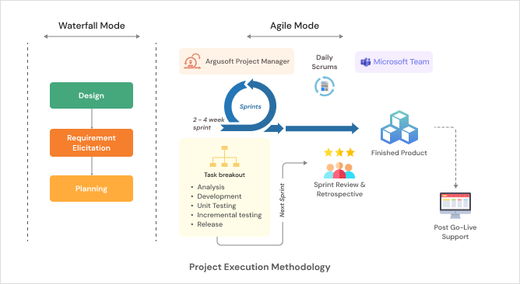

Functional Landscape Diagram
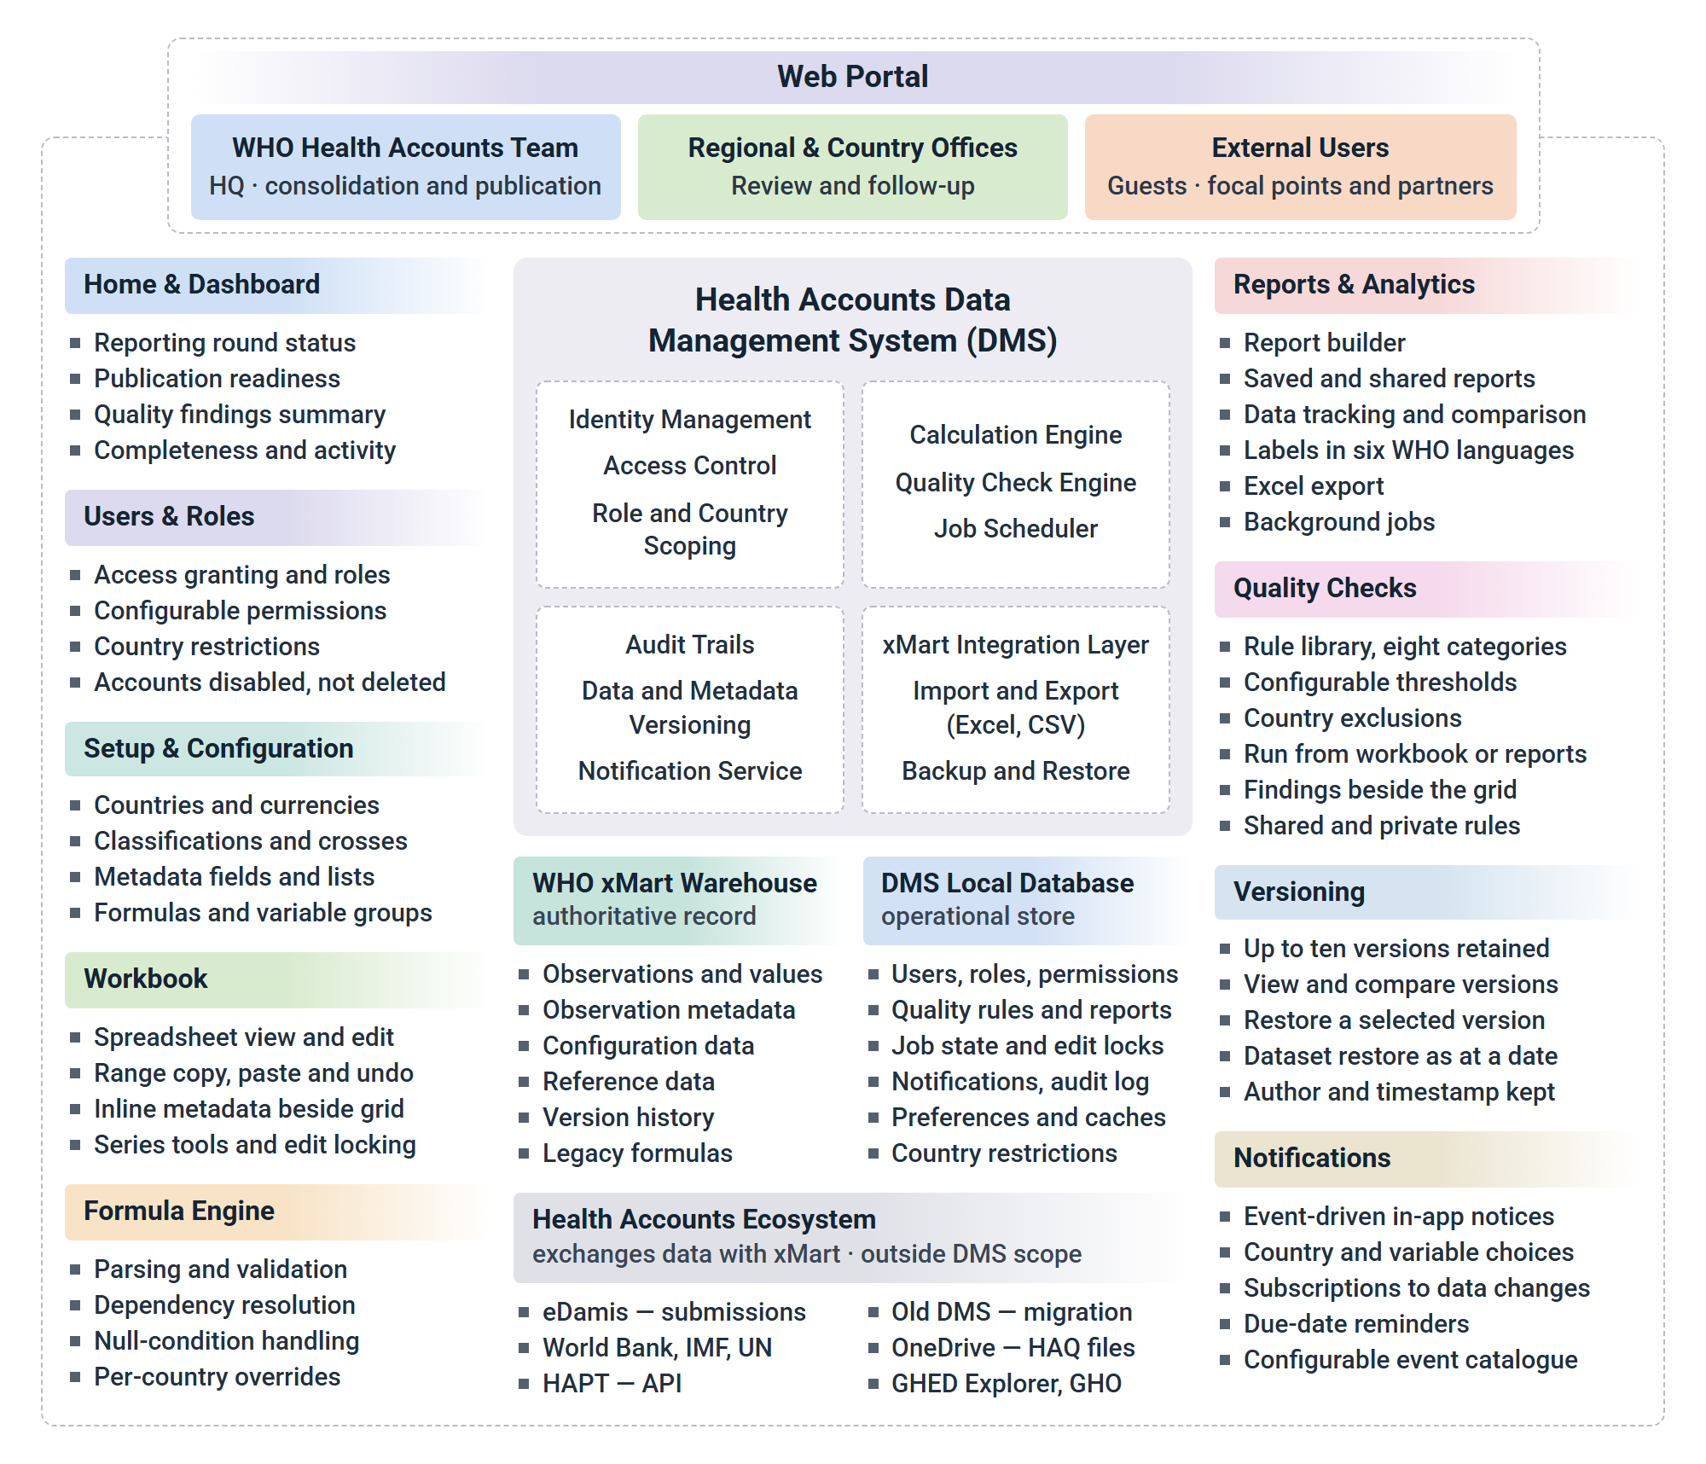
Functional Landscape

Proposed Solution
In response to the requirements set out in the Terms of Reference and the Functional Requirements, we propose a centralized, web based Data Management System for Health Accounts, built upon WHO's existing xMart data warehouse. The application will serve as the single working environment for the WHO Health Accounts team and its colleagues in Regional and Country Offices, covering the full working cycle for country health expenditure data: bringing data together, checking it, calculating indicators, resolving quality issues, tracking what each country has reported, and preparing the year's figures for publication. Users will sign in with their WHO account through Entra ID, and external contributors will be supported as guest accounts under the same sign in path. A single API layer will carry every exchange with xMart and with any other WHO system that needs to read from the DMS, and the application will run on WHO Azure infrastructure sized for the year end peak.
One point shapes almost every design decision that follows. The Functional Requirements are explicit that the main data warehouse for Health Accounts data stays in xMart, that the DMS calls the xMart API whenever it needs to display or process data, and that processed results are returned to xMart once they are complete. The same requirement then adds that the DMS is expected to have a local database of its own. We have taken both halves of that literally. Country health expenditure data, its metadata, the configuration behind it and its version history remain in xMart and are never duplicated as a second authoritative copy. The DMS local database holds what belongs to the application rather than to the warehouse: user accounts and permissions, quality check and report definitions, saved user preferences, background job state, edit locks, notifications and the application audit log. This division keeps one source of truth for the figures that eventually reach the Global Health Expenditure Database and the Global Health Observatory, while giving the application the transactional store it needs to stay responsive and to support several people working at once.
The application will be built to perform well even when a request spans a large slice of the warehouse. Expected volumes range from a few dozen rows to a million, and a full quality check run at year end covers every country at once. To keep this comfortable we will combine server side filtering and paging with caching of the reference data that changes rarely, such as country and currency lists, classifications, crosses, metadata field definitions and formula definitions. Redis is our recommended cache for this, with cache entries cleared automatically when the corresponding value is edited in the Setup module. Long running work does not block the screen: full quality check runs, complex report generation and bulk exports are handed to a durable background job queue, and the user is told when the job finishes through an in app notification carrying a link to the result. Within the browser we will apply virtualized rendering, lazy loading of each module and prefetching of the data a user is most likely to open next, so that a workbook opens quickly regardless of how much history sits behind it.
After a careful review of the scope of work, the Functional Requirements and the API specification, we propose an n-tier architecture for this project. The most important characteristic of this approach is the separation of the service and interface layers, which brings ease of maintenance and ease of extension. The pattern allows the application to grow without compromising performance or accuracy, and its service oriented design builds the application from loosely coupled, interoperable services that communicate through formal contracts independent of the underlying platform and programming language. The presentation tier itself is modelled on the MVC architecture.
The MVC pattern suits this project particularly well because the core business rules of Health Accounts work are already documented in detail, which means they can be built, modified or extended in the business layer without touching any other layer. The proposed solution also uses ORM (Object-Relational Mapping) in the model so that the system stays database agnostic, and it places every call to xMart behind a single integration component so that a change to an xMart contract, authentication method or data structure is absorbed in one place rather than across the application.
Working Prototype
Rather than describe the proposed system in writing alone, we have built a working prototype of it and made it available for evaluation at https://whohadms.argusservices.in/. It covers the application shell, the Setup module, the Workbook with its calculation engine, Quality Checks, Reports, versioning, the dashboard and the data retrieval interface, running against a representative Health Accounts dataset. The screenshots throughout this section are taken from it.
We want to be clear about what the prototype represents. It sets out our proposed solution based on our current understanding of the Terms of Reference, the Functional Requirements, the API specification and the clarifications issued. It is not the delivered product, and the screens shown in this section are not a final design. During the requirements finalization phase we will hold detailed workshops with the WHO Health Accounts team, study the existing DMS and the way the team works with it today, and build a precise understanding of the outcomes expected from the new system. The prototype will then be updated to reflect that input, and the resulting design will be submitted for WHO's review and approval before development begins, as set out in our work plan.
Every part of it, including the navigation, the workbook layout, the report builder and the content of the dashboard, is a proposal open to revision, and we expect it to change once the team has spent time with it.

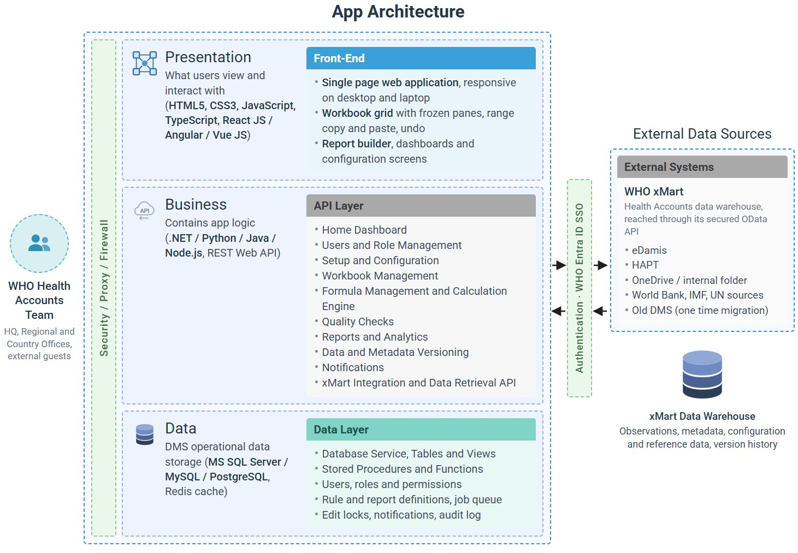
Architecture Diagram
Solution architecture.
The app architecture will have the following layers:

Front-end (Presentation Layer/Tier)
The front-end, also known as the presentation layer, would handle the user interface and user experience for the Health Account’s Data Management System. It would consist of technologies like HTML, CSS and Javascript that can be rendered through a web browser on desktops and mobile devices.
The front-end tier in a single page application (SPA) typically follows Model-View-Controller (MVC) architecture, which separates the concerns of the application into three distinct components - the data (model), the user interface (view), and the logic that binds the two (controller).
- The Model represents the data and the business logic of the application. It can retrieve data from the server via an API or manage data entered by the user.
- The View represents the user interface of the application. It is responsible for displaying the data to the user and collecting input from the user.
- The Controller is the component that sits between the Model and the View. It is responsible for receiving user input, updating the Model based on that input, and updating the View to reflect any changes in the data.
In a SPA, the front-end tier communicates with the server via APIs to retrieve and update data. This allows the front-end to operate independently of the back-end, improving scalability and maintainability of the application.
Such separation of concerns would allow for more modular and maintainable code and makes it easier to update the user interface without impacting the rest of the application.

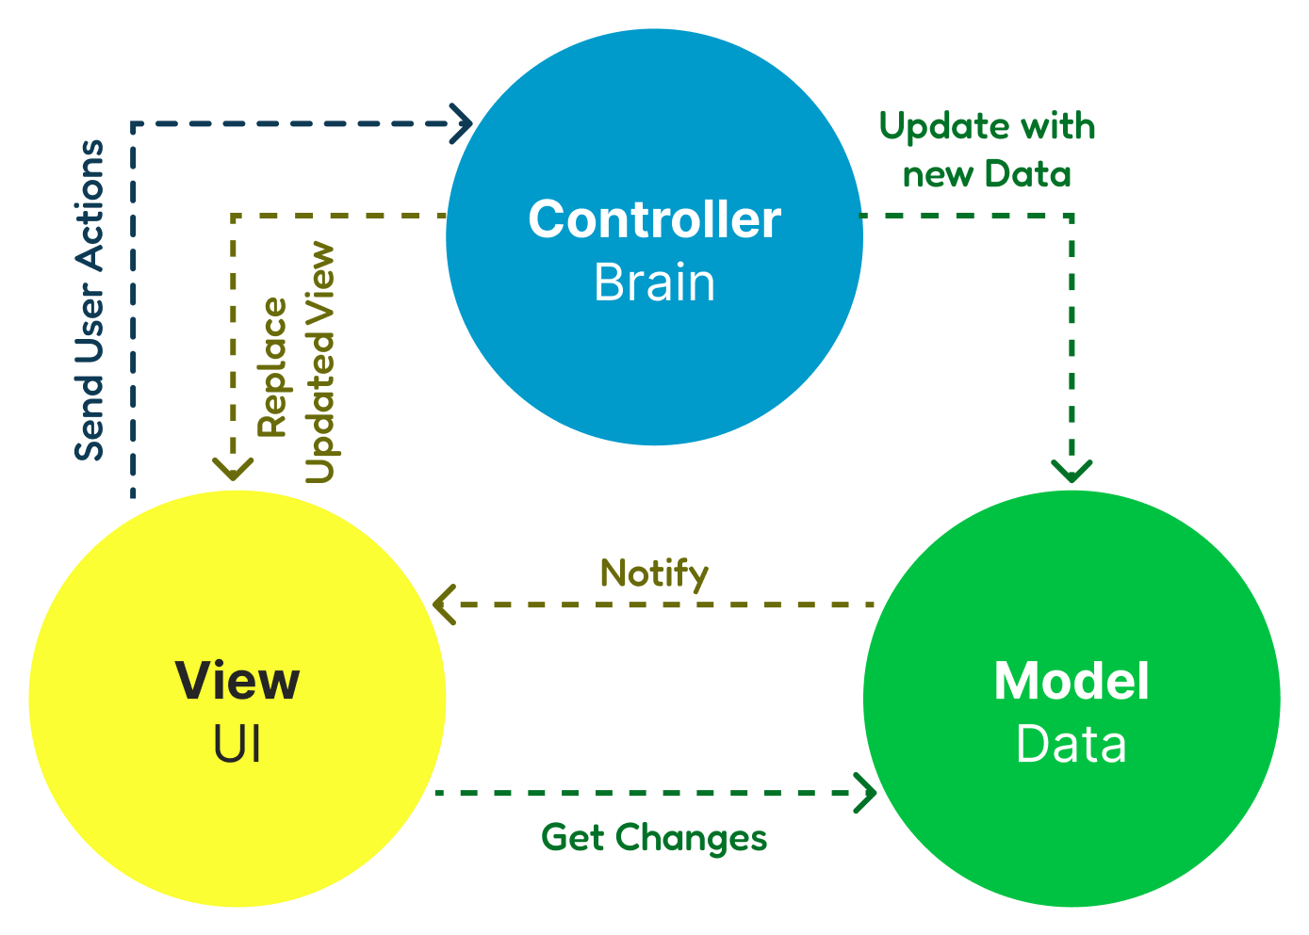

API - Application Programming Interface Layer/Tier
The API acts as a standard channel for the application to interact with the Business Logic & Rules. API Generally encompasses the Business Logic layer too, which is responsible for implementing the functionality required to support the business process.
The API Layer provides a reusable set of services that can be consumed by the front-end application. If required, the APIs can be used to exchange data with other external systems in an industry-standard manner. The API layer also provides help in decoupling the front-end and back-end layers of the application, allowing them to be developed and maintained independently. This means changes to one layer will not affect the other, allowing for more flexibility and scalability.

Data Access Layer
The data layer refers to the part of the application that deals with storing, retrieving and manipulating data. It abstracts the underlying data storage mechanism and provides a consistent way for the rest of the application to interact with the data. With abstraction, it automatically provides portability, where it is easier to port the application to a different data storage mechanism.
In the 3-tier architecture, the front-end tier is typically separate from the other two tiers (business logic and data) to allow for flexibility in design and implementation and to make it easier to update, maintain and modify components without impacting the other parts of the application. The front-end, API, and data tiers can be scaled independently, making it easier to handle increased user traffic or changes in system requirements.

Important Modules
We have studied the Terms of Reference, the Functional Requirements, the API specification for data exchange with xMart and the clarifications issued, and we have gone through the use cases in detail to understand the working practices they describe. This section sets out the modules we propose to build, and what each of them does.
The proposal covers the complete functionality described in the requirements. Delivery is phased, as the requirements themselves direct: the first release is the Pilot, containing the functionality marked for Pilot priority, and the remaining functionality is added incrementally in the agreed priority order once the Pilot is approved.
Assumptions
The following assumptions underpin the proposed solution. Each will be confirmed during project initiation, and any change will be handled through the agreed change process.
- WHO will provide access to the legacy DMS database, together with any available documentation, for the migration of legacy data and formulas.
- The recurring pipelines that bring country data into xMart from eDamis, HAPT, OneDrive and other sources are already in place and remain outside the scope of DMS development.
- The DMS user interface will be in English. Report output will be available with variable labels in the six official WHO languages.
Based on our understanding we propose the following modules.
- Home Dashboard
  - Reporting Round Overview
  - Publication Readiness
  - Quality Findings Summary
  - Data Completeness
  - Recent Activity and Notifications
- Users and Role Management
  - User Access and Sign In
  - Role Assignment
  - Role Permission Configuration
  - Country Level Access Restriction
  - User Status Management
- Setup and Configuration
  - Configuration Import from xMart
  - Countries and Groups of Countries
  - Currencies
  - Classifications and Categories
  - Crosses
  - Observation Metadata Fields
  - Formulas
  - Country Reporting Follow Up
- Workbook Management
  - Workbook Selection and Filters
  - Data Viewing and Editing
  - Observation Metadata
  - Series Estimation Tools
  - Concurrency and Locking
  - Workbook Export
- Formula Management and Calculation Engine
  - Predefined Indicator Formulas
  - Custom and Country Specific Formulas
  - Dependency Resolution and Validation
  - Legacy Formula Access
- Quality Checks
  - Rule Library
  - Rule Builder & Execution
  - Threshold Configuration
  - Quality Check Reports
  - Rule Export and Import
- Reports and Analytics
  - Report Builder
  - Predefined and Custom Reports
  - Data Tracking Reports
  - Multilanguage Report Output
  - Export and Background Generation
  - Report List and Favourites
- Data and Metadata Versioning
  - Version History
  - Version Comparison
  - Version and Dataset Restoration
- Notifications
  - Event Catalogue
  - Notification Configuration
  - Subscriptions and Preferences
  - In App Delivery
- Integration with WHO xMart
  - Data Retrieval from xMart
  - Data and Metadata Write Back
  - Data Retrieval API for xMart
  - Integration Monitoring and Error Handling
- Legacy Data and Formula Migration
  - Source Profiling and Mapping
  - Migration Execution
  - Reconciliation and Validation
- Additional Features
  - Multilanguage Report Labels
  - Accessibility
  - Browser Support and Responsive Layout
  - Audit Trail
- Security Features
  - Authentication and Single Sign On
  - Authorization and Data Scoping
  - Encryption in Transit and at Rest
  - File Upload Validation and Malware Scanning
  - Secure Coding Practices

Home Dashboard
The dashboard is the first screen a user sees after signing in, and we have designed it to answer the questions a Health Accounts analyst actually asks at the start of a working session. Every element on it is a link into the record it describes, so the dashboard works as a queue of things to do rather than a summary to read and leave.
The Reporting Round panel shows where the current cycle stands: which countries have submitted, which are still outstanding, and which are approaching or past their due date. It draws on the reporting schedule and focal point details held in the Setup module, and it is the panel the team will use most often between submissions. Beside it, Publication Readiness shows how many countries sit at Not publish and how many have moved to Ready to publish, which gives an immediate sense of how much of the round is finished. Quality Findings summarises the outcome of recent quality check runs by severity, with a link straight to the affected country and observation. Data Completeness presents coverage across countries and years as a heat map so that gaps stand out visually and can be turned into follow up. Recent Activity lists submissions received, changes made and the user's outstanding notifications.
Content on the dashboard is filtered by the signed in user's role and country scope, so a Regional Office colleague sees their own countries and an administrator sees the whole picture. The requirements also describe separate dashboards for administrators and regular users as a later addition. Our proposal delivers a common dashboard first, filtered by permission, and then adds the role specific layouts in the agreed phase, with the administrator view gaining operational content such as integration health, background job status and recent configuration changes.
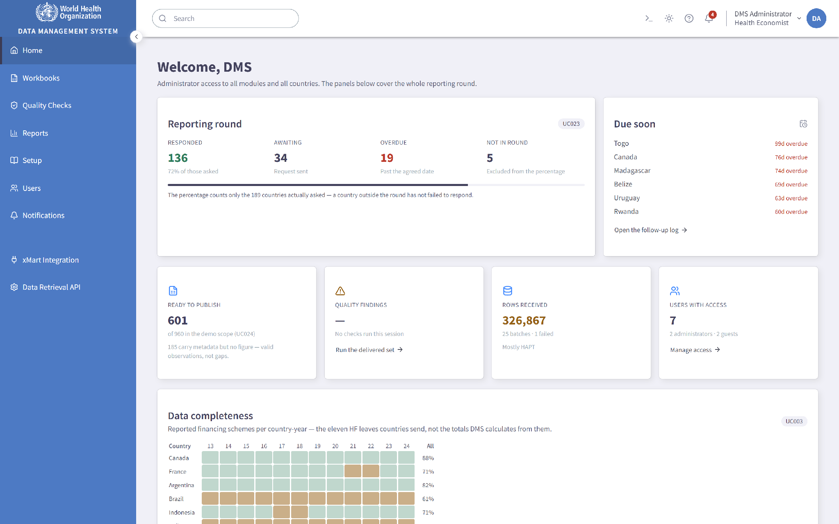
Home dashboard: reporting round, publication readiness, quality findings and data completeness.

Users and Role Management
This module gives administrators one place to control who can use the DMS and what they can do inside it. Sign in is handled entirely by WHO Single Sign On through Entra ID, so the application never stores or manages a password. Both WHO internal staff and external contributors are supported, the latter as guest accounts in Entra ID, and both follow the same sign in path. On the client side we recommend MSAL for the authentication flow, with the server validating tokens through standard OpenID Connect middleware.
An administrator grants access from the Users list by entering a colleague's WHO account or guest email address and choosing a role. The identity itself is established by Entra ID at first sign in, so the DMS record carries the authorization rather than the credential. The system provides the two roles the requirements define, Administrator and Regular user, and an administrator holds every capability a regular user holds in addition to the administrative ones, so there is no function that a regular user can reach and an administrator cannot.
Permissions are configuration rather than code. On the Role Permissions screen an administrator sets, for each module, the level that applies to regular users, choosing from the levels the requirements define: no access, view, view and export, edit selected countries, edit all, and full administrative control. Only the levels that carry meaning for a given module are offered, so "edit selected countries" is available on the Workbook but not on Users. Regular users keep view and export rights on the modules they cannot edit, which means the configuration can never produce a user who is unable to see the data they are responsible for. A Capability Preview panel beside the matrix shows in plain language what a regular user will and will not be able to do once the change is saved, which removes most of the guesswork from permission changes. Changes take effect immediately and are written to the audit log.
Access for a regular user can also be restricted to a defined list of countries, so that a Regional or Country Office colleague works only within their own countries. The restriction is applied in the API layer, which means it governs every module consistently, including the Workbook, reports, quality checks and every export, rather than being applied screen by screen where one path could be missed.
When someone leaves a post or changes responsibilities, their access is withdrawn using Disable user and can be restored later with Enable user, keeping all of their history and authorship intact. The system will not allow the last remaining enabled administrator to be disabled or moved to the Regular user role, so the platform cannot be left with nobody able to administer it. In line with the requirements, DMS users are never deleted. User records are referenced by observation authorship, version histories, rule and report ownership and audit entries, and removing a user would break the traceability those references provide. There is therefore no delete action anywhere in the module, and withdrawal of access is always achieved by disabling the account.

Users list with inline role and status controls.

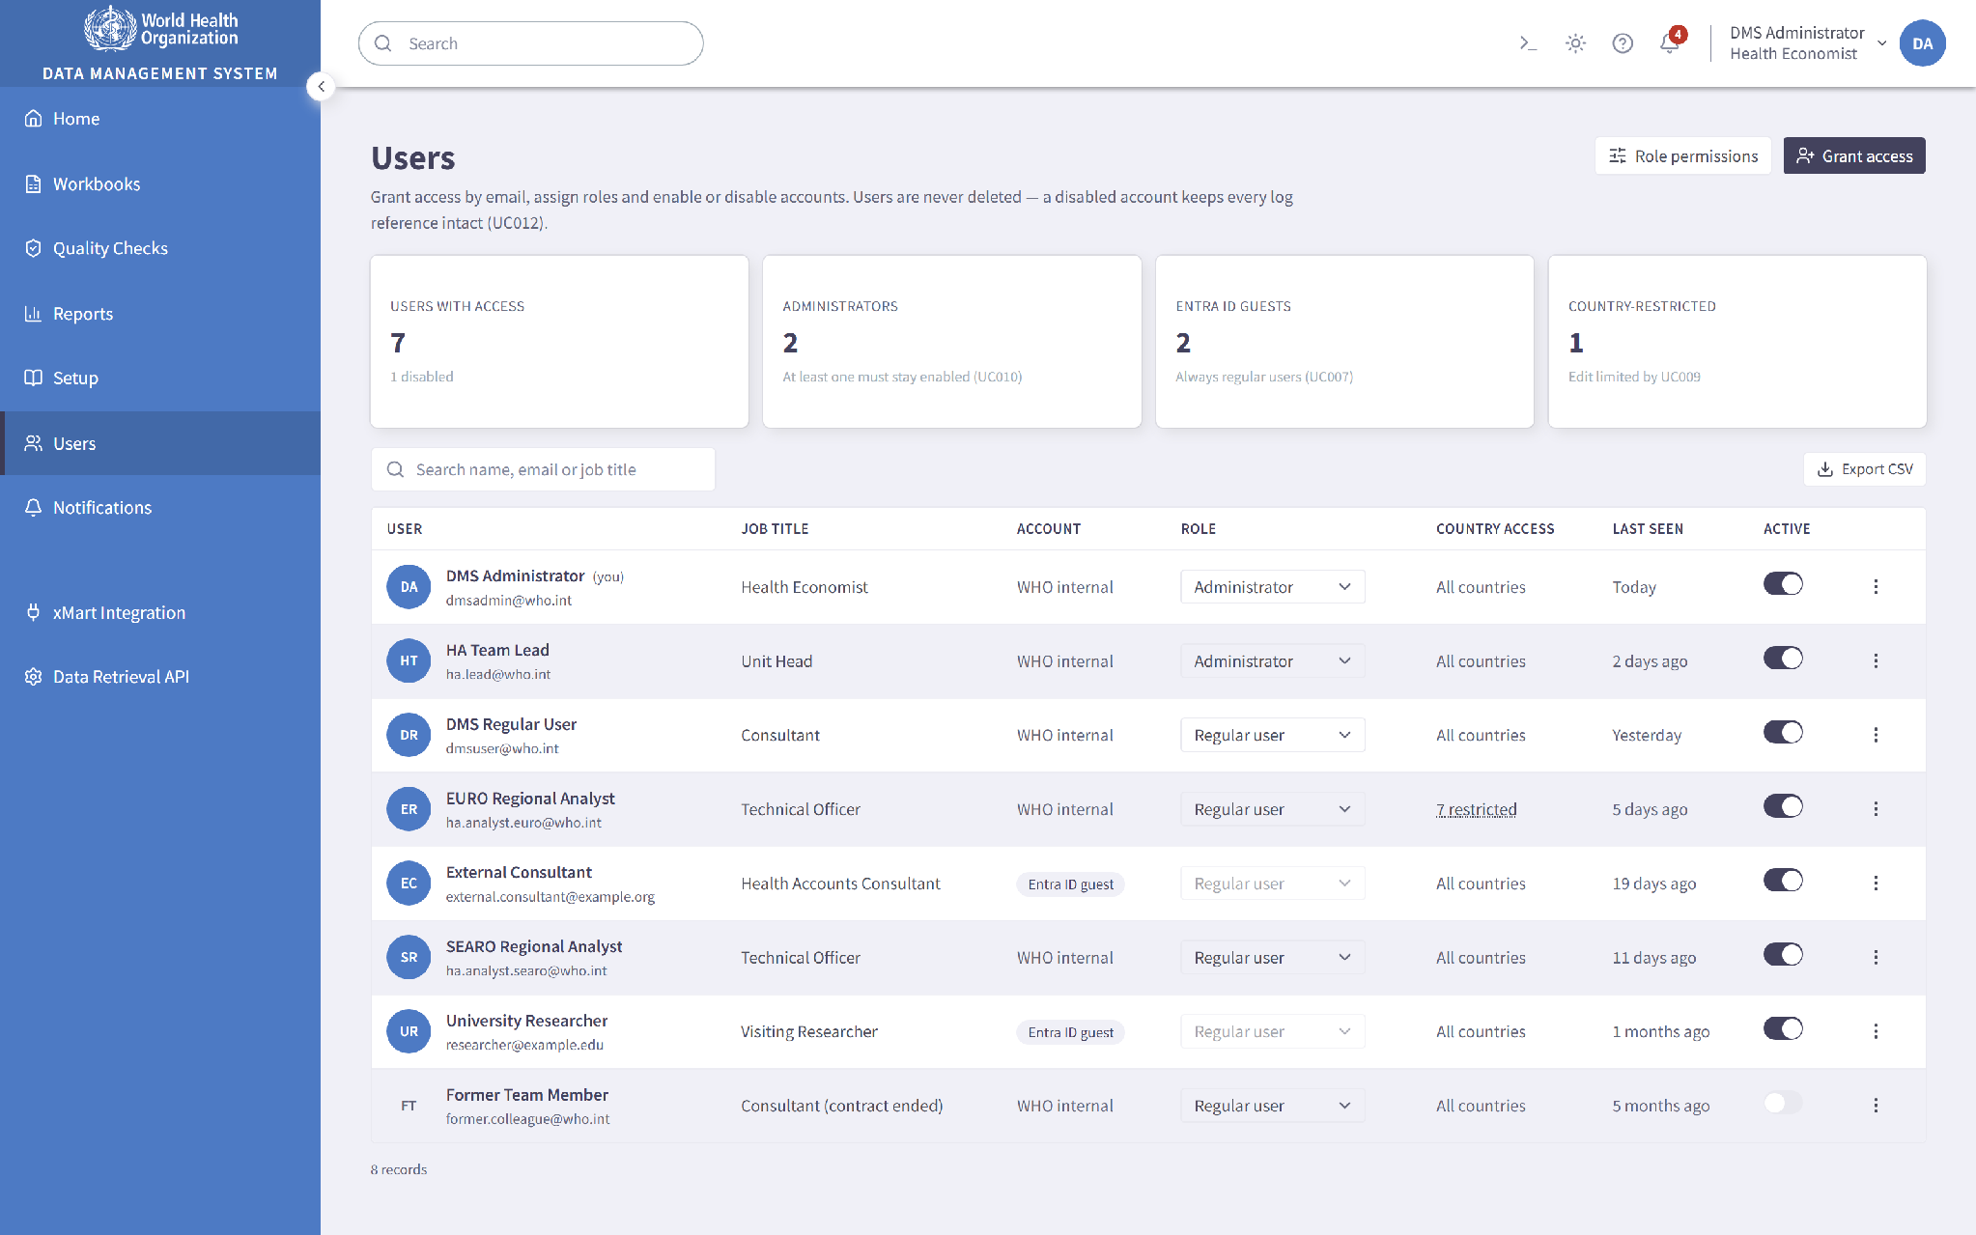

Setup and Configuration
The Setup module is where the Health Accounts team defines the vocabulary the rest of the system uses. Each configurable component sits on its own tab within a consistent list and editor pattern, so the interaction a user learns on one component applies to all of them. Every tab is addressable by its own URL, which means a colleague can be sent straight to the right screen.
Configuration begins by importing the reference data already held in the warehouse, so the DMS starts aligned with xMart rather than from an empty state. Later changes made in the DMS are written back to xMart. The module manages Countries and their attributes, Currencies, Classifications and Categories, Crosses, Observation Metadata Fields and Formulas, with values created, edited and, where the requirements allow, disabled and enabled through the interface.
Several behaviours in this module are worth describing specifically. Columns in any component list can be reordered by dragging the column headers, and the chosen order is remembered for that user across sessions, which matters because different colleagues work with different attributes. Deleting a value is permitted only where that value has never been used in any record, as the requirements state, so before removing anything the system checks usage and, where the value is in use, reports where it is used instead of simply refusing. Administrators can define new attributes for existing components and edit component details, so the metadata model can be extended without a code change. Component values and their attributes can be exported to a spreadsheet and imported again, which makes bulk maintenance and offline review practical. For the spreadsheet handling in this module and elsewhere we recommend ClosedXML or EPPlus on the server and SheetJS in the browser, with CsvHelper for CSV work.
Country attributes can be flagged as available for grouping and filtering, which is what turns an attribute such as WHO region, World Bank income group or OECD membership into a selectable Group of countries. Because groups are defined once here, they appear everywhere a country selection is offered, including quality check scope, report filters and workbook selection, and they stay correct as membership changes.
The module also records the reporting schedule for each country, including due dates and focal point details, which is what drives the dashboard's reporting round view and the due date reminders described under Notifications. Each country and year carries a publishing status of Not publish or Ready to publish, which can be set on a single record or applied in bulk to a selection, so an entire round can be moved to publication readiness in one action.
Crosses deserve a note because they are easy to model incorrectly. A cross is not a separate kind of record. It is an observation that carries values in more than one classification dimension at the same time, which is exactly how the long format observation table in xMart represents it. Modelling crosses this way keeps the Workbook, the Crosses tab and the warehouse structure consistent with one another. Predefined crosses are configured centrally, and users can define additional custom crosses for their own analysis. Metadata files already held in xMart are reachable from the DMS in the context of the observation or country they relate to, so supporting documentation does not require leaving the application.

Setup module showing the component tabs and a component list.

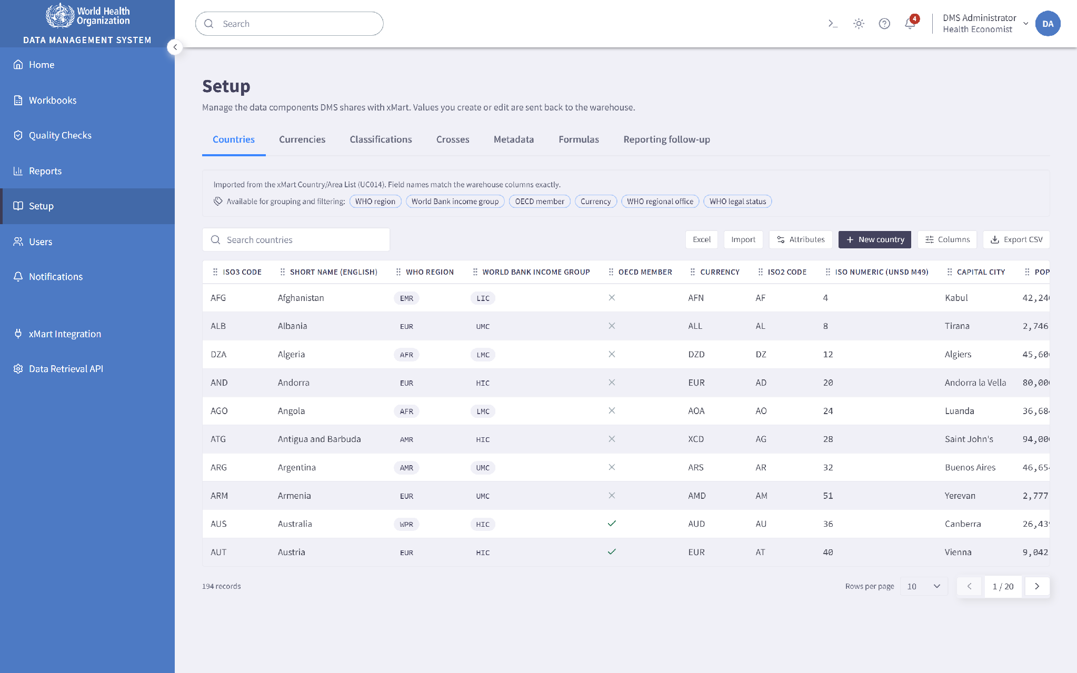

Workbook Management
The Workbook is the main working module of the DMS and the screen on which the Health Accounts team will spend most of its time. The requirements describe it clearly: a format similar to Excel, in which the values available for a country and year can be viewed and edited, formulas inserted, and copy, paste and undo used as they would be in a spreadsheet, with the metadata behind each observation reachable from the same place.
A workbook is a two dimensional view of a three dimensional dataset, formed by fixing one axis and displaying the other two. A Country Workbook shows one country against many variables and many years. A Variable Workbook shows one variable across many countries and many years. A Year Workbook shows one year across many countries and many variables. The user chooses the type and the scope, and the selection is reflected in the address of the page so that a particular view can be bookmarked, returned to or shared with a colleague.
Years run across the top and variables down the side, with a scale and currency selector above the grid so that figures can be read in the units the analyst is thinking in. Reported values and calculated indicators are visually distinct: as the requirements specify, formula cells are shown in a different colour and in italic, so a calculated figure is never mistaken for one a country reported. The year header row, the variable label column and the corner cell are all frozen, which means the context of a cell stays visible however far the user scrolls. Scrolling itself is continuous and virtualized rather than paged, because paging a data entry surface breaks range selection and makes copying a block of years across impossible.
Editing happens in place and follows spreadsheet conventions, so typing replaces, Enter and Tab commit and move on, and Escape abandons the edit. Formulas can be typed directly into a cell and are evaluated straight away, with every dependent indicator recalculating as soon as an input changes, so the effect of a correction is visible immediately rather than after a refresh. Copying and pasting works within a workbook and across workbooks, and the paste action distinguishes between pasting Values, Formulas and Metadata, because in Health Accounts work those are three different intentions. A multi level Undo and Redo stack covers edits, pastes, fills and bulk operations, so a mistaken paste over a block of data is recoverable.
Filtering is available on any displayed element. Rather than a permanent row of dropdown boxes, active filters appear as removable chips above the grid with an Add filter control beside them, so the current filter set can be read at a glance and any one filter reopened or removed in a single action. The filter state travels in the page address, which makes a filtered view shareable.
Metadata is reached from the grid itself. Cells that carry metadata are marked, and opening one opens a panel beside the grid rather than over it. The grid stays loaded and the cell selection is preserved, so reading a comment or checking a source does not cost the analyst their place in the data. This is a deliberate departure from the legacy tool, where metadata lived on a separate sheet. Editing metadata is subject to the same permissions, versioning and write back as editing a value. Users can also choose which metadata fields are displayed and in what order, and that preference is remembered.
The module provides the estimation tools the requirements ask for. Fill gaps completes missing points between two existing values in a series, and Extrapolate extends a series backwards or forwards, with the method chosen by the user. Observations produced this way are marked with the appropriate estimation method and data type so their origin stays visible in exports and reports afterwards. Alongside these, the workbook supports the calculation of standard indicators for all countries, simple statistical values such as average, minimum and maximum across a selected group of countries, and country specific formulas for estimation, which are saved for reuse.
Because the requirements are explicit that only one user may edit the same observations at a time, the workbook applies a lock when editing begins. Other users keep read only access and are shown who holds the lock and since when, rather than simply being refused. Locks are released on save, or after a configurable interval once a session ends, and an administrator can release a lock that has been left open. Workbook data can be exported to Excel. Quality check rules can also be run directly from the workbook against the data in view, with failing cells highlighted where they sit.
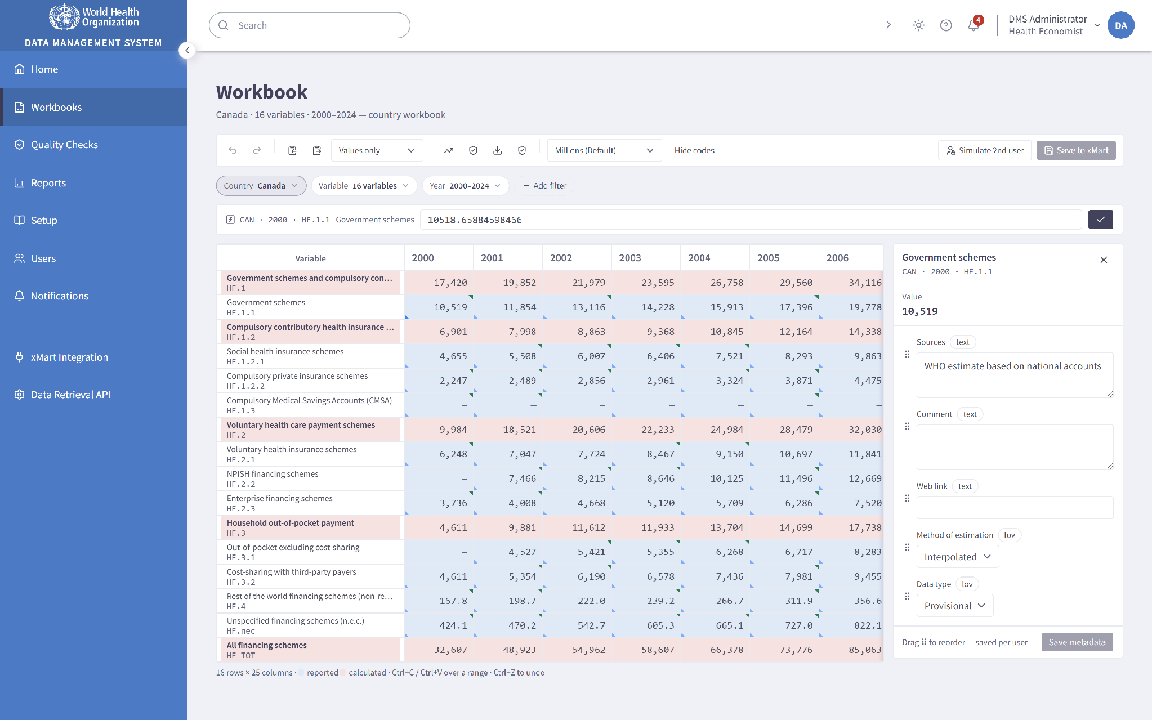
Workbook with frozen headers, filter chips, calculated rows shown distinctly, and the metadata panel open beside the grid.

Formula Management and Calculation Engine
The calculation engine is the technical heart of the DMS. We treat the engine as a distinct piece of engineering rather than a feature of the Workbook, and we build it rather than adapt a spreadsheet engine, for four reasons that come directly from the requirements.
First, Health Accounts formulas refer to variables, not to cells. An expression such as CHE = HF.1 + HF.2 + HF.3 + HF.4 + HF.nec names classification categories that are resolved for the current country and year. Second, formulas refer to other formulas. CHE%GDP depends on CHE, which in turn depends on the HF categories, so evaluation needs a dependency graph resolved in the right order with cycles detected, not text substitution. Third, every formula carries its own condition for handling missing values. The indicator table in the requirements attaches a condition to each one: some require all components to be present, others at least one. When a condition is not met the result must be blank and not zero, because a zero asserts that expenditure was nil while a blank says it is unknown, and that difference is visible in every published figure. Fourth, a predefined formula must be adjustable for one country without changing it for any other, so the engine resolves the applicable definition per country at the point of evaluation.
The engine is built as a tokenizer, a parser producing a syntax tree, a dependency graph over the referenced variables, and an evaluator that walks that graph in dependency order. Cycles are caught when a formula is saved rather than when it is run, so an invalid formula cannot be committed in the first place. Variable codes in this domain contain full stops, percent signs, currency symbols and hyphens, as in CHE%GDP_SHA2011 and GGHE-D_pc_US$_SHA2011, so references are resolved against the known set of variables rather than by guessing where a token ends, which is a common and quiet source of error. For the grammar we recommend ANTLR where a formally specified grammar is preferred, or a hand written recursive descent parser where a small and fully owned implementation is more appropriate. We would avoid general purpose expression libraries for the core engine, since none of them carry per country overrides or the null handling conditions this domain requires.
Administrators manage the predefined indicators on the Formulas tab in Setup, each with its expression, its condition for missing values, its unit of measure and its folder grouping. A predefined formula can be edited, and a Country Override can be created that applies to one country alone. Regular users can write their own formulas and save them for reuse, and these pass through exactly the same parsing, validation and cycle checking.
Because the engine holds an explicit dependency graph, the application can show a user why a figure is what it is. A Formula Inspector panel presents the expression, the inputs it resolved to, the condition that was applied, and the chain of other indicators that will change if an input changes. For a system whose outputs are published internationally, being able to explain a number is as important as calculating it.
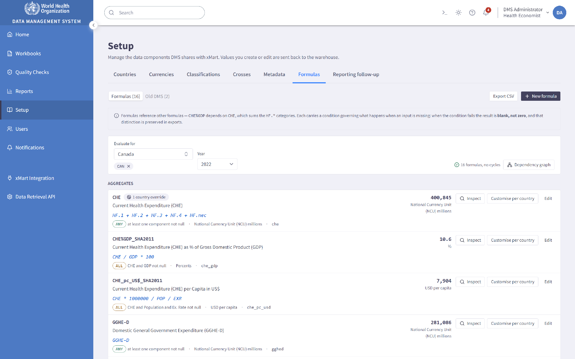
Formula management with the predefined indicator formulas and their conditions.

Quality Checks
The Quality Checks module is how the team validates itself that a dataset is fit to publish. It holds a library of rules, the means to run them over a chosen scope, and a report of what they found.
Rules are grouped by type, with a separate group for a user's own customized rules. Rules created by the development team during implementation, rules created by administrators and rules created by individual users are visually distinct from one another, as the requirements ask, so the standing of a rule is clear from the list rather than having to be looked up.
We will implement the predefined rule categories the requirements describe, with the final list confirmed by the technical unit at project start and the examples in the requirements as the starting point. These cover year on year growth in absolute and relative terms, growth between two versions of the data, observations that are new, that have disappeared or that are missing compared with previous reporting, inconsistency between categories where components should reconcile to their total, inconsistency between tables, atypical entries raised either as an error or as a warning, and outliers assessed across groups of countries.
The thresholds that decide whether a rule passes, fails or raises a warning are set by administrators on a Thresholds screen rather than fixed in code, so the team can tune sensitivity as the data and their expectations change, without waiting for a release. Rules apply to every country by default, and an administrator can exclude specific countries where a rule is not meaningful for them, then Reset exclusions to make the rule universal again. Exclusions are shown on the rule itself, so an excluded country is never quietly left unchecked.
A rule is run against a single country or against a group of countries chosen by attribute, using the same groups configured in Setup. The full year end run across all countries executes as a background job with visible progress, restart and retry, so a long run can be watched and recovered rather than simply waited on. Rules can also be triggered from a workbook against the data currently in view, with failing cells highlighted in place, which closes the gap between finding a problem and fixing it: the analyst does not have to carry a finding from a report back into the data by hand.
Each run produces a report presenting findings by rule, by country and by severity, with charts alongside the tabular detail and a download in Excel or CSV. Every finding links directly to the observation that produced it. Rule configurations can be exported and imported, which supports review outside the system and moving a configuration between environments.
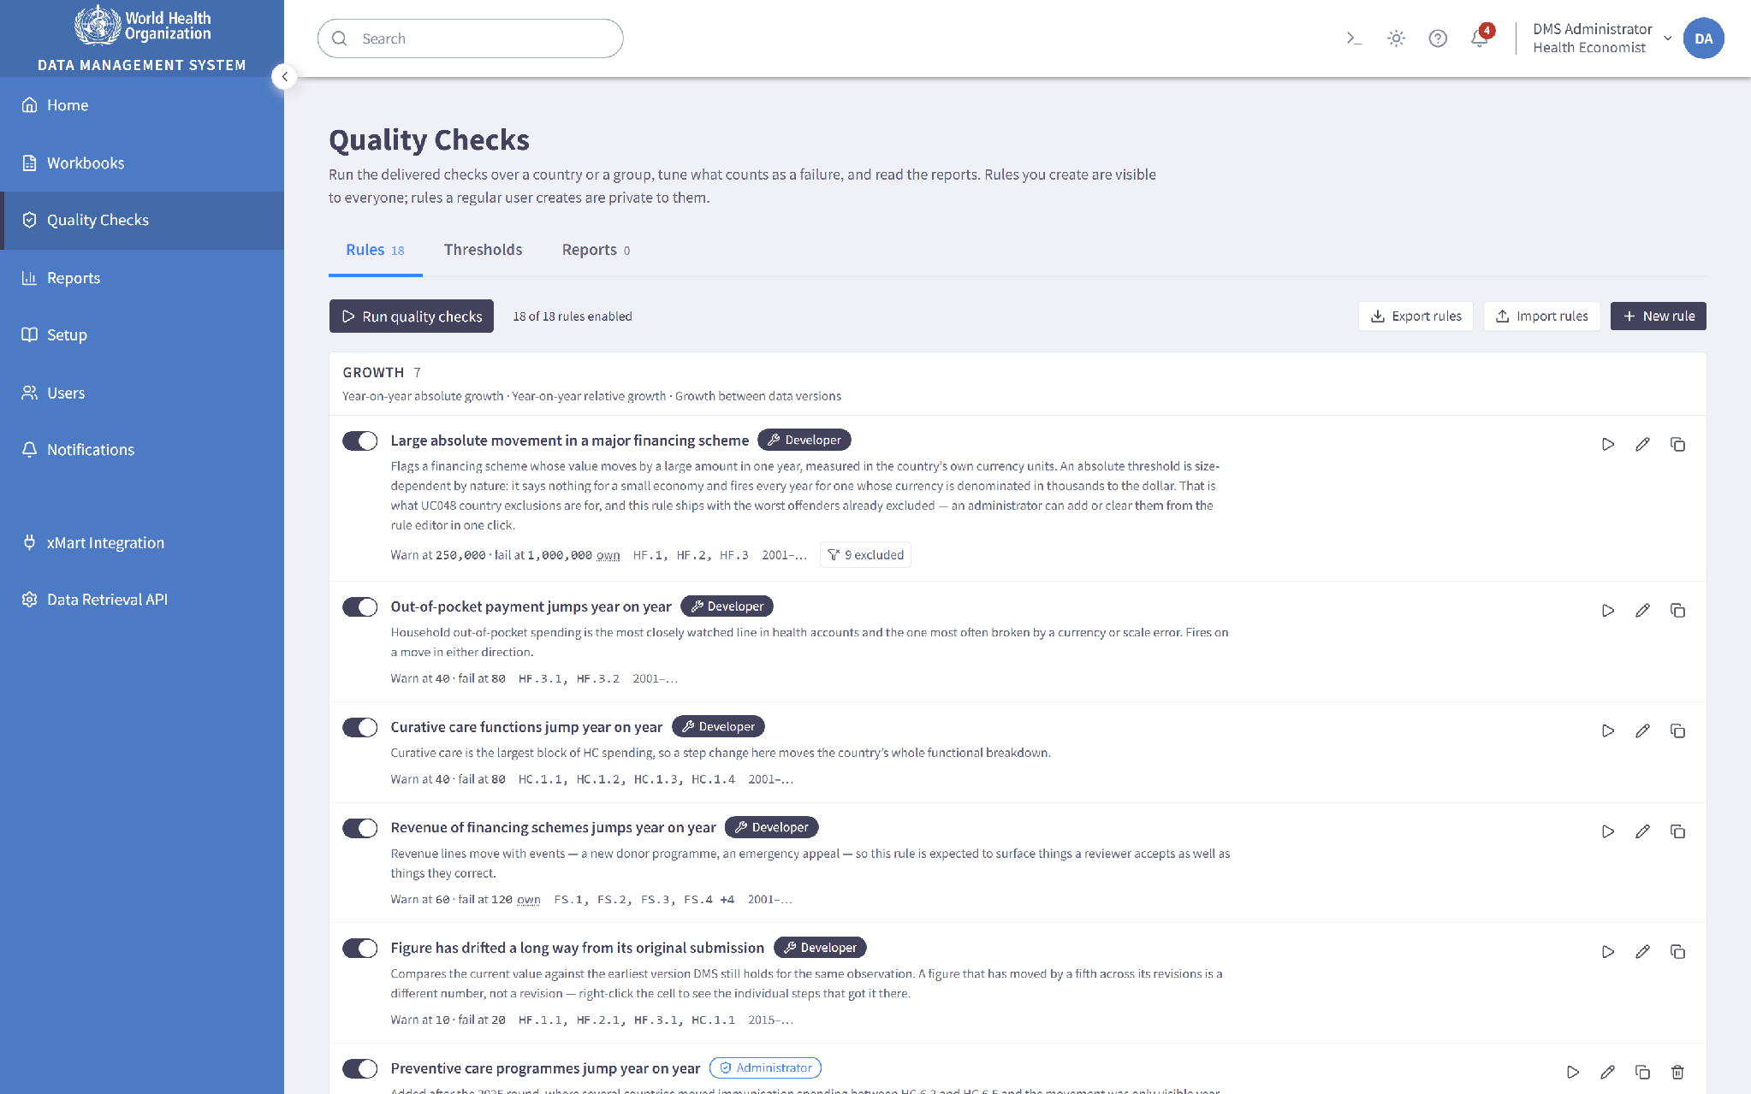
Quality check rule library, with rule origin visually distinguished.

Reports and Analytics
The Reports module produces the outputs the team needs for internal review, quality assurance and preparing the year's publication.
Administrators define reports in an interactive builder. Available fields, including countries and their attributes, years, classifications and categories, variables and indicators, and metadata fields, are dragged into Rows, Columns, Filters and Values areas to form a multi dimensional view. The Values area takes the aggregations of the observation measure, and subtotals can be switched on at any grouping level. A live preview updates as the definition changes, so a report is designed against real output rather than against an abstract specification. Saved reports become available to everyone. In line with the requirements the builder is an administrator function: regular users open predefined reports, apply filters and export the results.
A regular user can also create customized reports that are visible only to themselves, and any user can copy an existing report as the basis for a new one, which is usually the quickest route to a variant of an established output. Users arrange reports into their own list, mark Favourites and set the order, so a working set is always at hand.
The module includes data tracking reports covering what has been received, what has changed and what is still outstanding across the reporting round, which supports the follow up process configured in Setup.
Although the interface itself is in English, reports can be generated with variable labels in any of the six official WHO languages: English, French, Spanish, Arabic, Chinese and Russian. Column headings, classification and indicator labels, totals and unit strings all appear in the chosen language, on screen and in the exported file. Field values that are proper names, such as country and currency names, report titles and free text metadata, stay as recorded, which is the carve out the requirement itself makes. We use i18next for the language resources, kept outside the code so that a label correction or an additional language is a configuration change.
Reports export to Excel. Where the scope of a report makes generation slow, it runs as a background job so the user can carry on working, and an in app notification arrives on completion with a link to the file, or on failure with the reason. Job progress and history are visible in the module.
Unit handling in this module is treated as a matter of correctness rather than formatting. Health Accounts values are expressed in national currency units, in US dollars or as percentages, so conversion is applied to each observation before aggregation, and the unit label carries the country's own currency rather than a generic one. Where the contributions to a total arrived in more than one currency, the report produces no figure at all, because adding pesos to yen is meaningless and an anonymous unit label would let exactly that mistake through looking perfectly correct.

Report builder with the field areas and live preview.

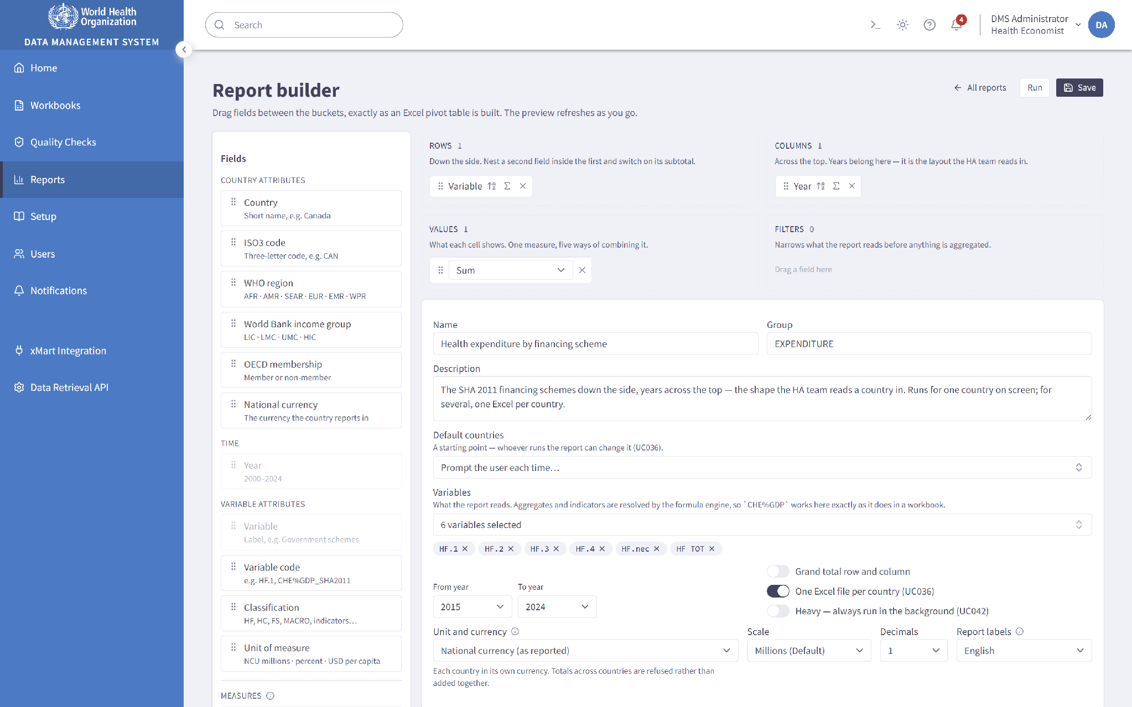

Data and Metadata Versioning
Versioning is built on the data versioning available in xMart, as the requirements direct, rather than on a parallel history kept in the DMS. Every committed change to an observation, a dataset or a metadata field produces a version carrying its author and the time it was made.
Users with the appropriate rights can view up to ten previous versions of an observation or variable and compare them, with differences in value and in metadata shown side by side so that what changed, when and by whom is legible at a glance. From the same screen a previous version can be selected and restored as the current value. Administrators can additionally restore a full dataset as at a specific date, which is the recovery path when a bulk operation has produced an unintended result.
Restoration is itself recorded as a version, so history is never rewritten. Restoring an earlier value adds a new entry describing that restoration rather than removing the entries in between, which keeps the record complete for audit purposes. Version comparison also feeds the quality check category concerned with growth between two versions of the data, so versioning serves validation as well as recovery.
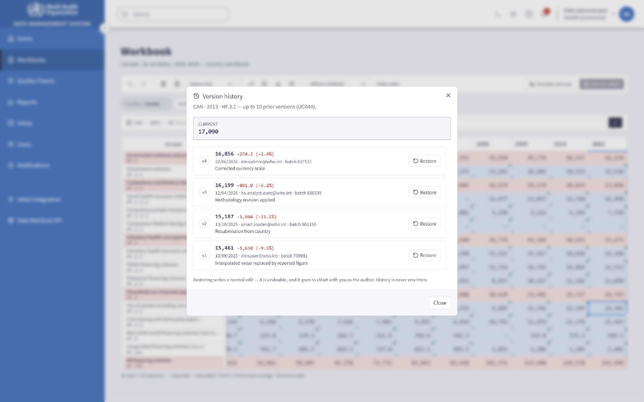
Version history for a single observation, with restore.

Notifications
The Notifications module provides the event driven, in application notifications the requirements describe.
Notifications are raised on defined events: a country's submission arriving, a reporting due date approaching or passing, a background report or quality check finishing or failing, a dataset moving to Ready to publish, a version being restored, or a configuration or permission change being applied. A predefined set is delivered with the system, based on the list the technical unit provides at project start.
Administrators create and edit notifications, setting the event that triggers each one and the countries or groups of countries it applies to for each user. Because the groups are the same ones configured in Setup, a subscription such as "all countries in the African Region" is expressed once and stays correct as the membership of that group changes. Users control what reaches them through Notification Preferences, choosing the countries and variables they care about, so that colleagues receive what is relevant to their responsibilities rather than every event in the system.
Notifications are delivered in the application and highlighted on the dashboard, with an unread count in the header. Where a notification refers to something the user can open, such as a completed report or a quality check result, it carries a working link to it. The reporting due dates configured in Setup raise reminders as dates approach and pass, which is what turns the follow up configuration into an active process rather than a reference table someone has to remember to consult.
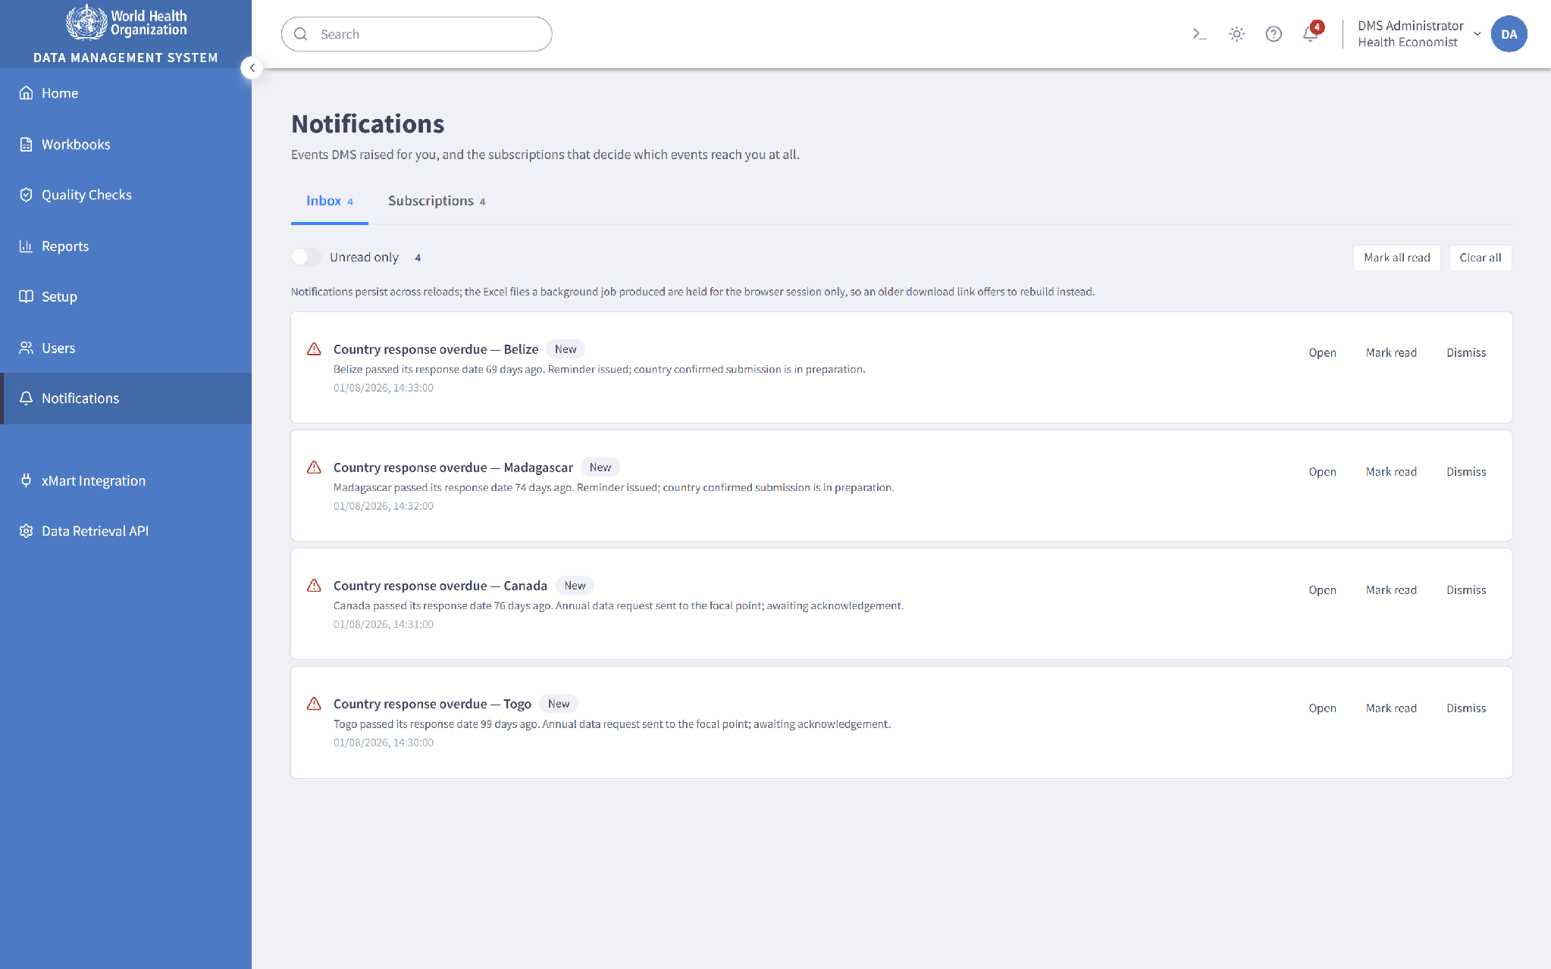
Notifications module: event catalogue and subscriptions.

Integration with WHO xMart
Integration with xMart is not a feature at the edge of this system. It is the mechanism by which the system holds its data, and the requirements define the exchange in both directions.
Whenever the DMS needs to display or process Health Accounts information it retrieves that information from xMart through the secured xMart API. This covers observations for the Workbook, the configuration behind the Setup module, the data underlying reports and quality checks, and version information. Retrieval is designed to ask only for what the screen needs, filtered by country, year range and the variables in scope, so that opening a workbook fetches one bounded slice rather than a country's entire history.
Changes made in the DMS are returned to xMart so that the warehouse stays authoritative. This covers observation values and metadata edited in the Workbook, and changes made in Setup to countries, currencies, classifications, categories, crosses, metadata fields and formulas. Each write back carries the identity of the user who made the change, as the requirements specify, and again keeps values as values and formulas as formulas.
The requirements leave the trigger for write back to be agreed at the start of the project, offering a save action or simply leaving a screen as the possibilities. Our recommendation is an explicit Save, with a clearly marked unsaved changes state on the screen. It gives the analyst a defined point at which work is committed, it makes a concurrent editing conflict detectable at a known moment, and it produces a version history whose entries correspond to deliberate decisions rather than to incidental navigation. From the user's point of view a save either succeeds completely or reports a failure naming the observations affected, and a failed transmission is queued for retry with the outcome visible to the user and to administrators.
Alongside consuming the xMart API, the DMS exposes a data retrieval API that xMart calls to extract DMS data. We will implement this to the specification in the API requirements: HTTP GET requests, CSV as the default output with JSON available as well, filtering on country code and on a single year or year range, the DMS internal identifier returned on every row, server side paging designed around the reference page size of one hundred thousand records, a UTC LastModified value that can be filtered by range and that reflects inserts, updates and deletes alike, retrieval of soft deleted records through an IsDeleted filter, the ability to return all data unfiltered, streamed responses for large extractions, OAuth 2.0 authentication and HTTPS only transport.
Two of those items are treated as first class design requirements rather than reporting conveniences. Every path in the application that modifies data updates the LastModified value, and deletion is implemented as a change of state rather than a physical removal, so a record that disappears from the DMS can still be identified as deleted by a caller that asks for it.
For administrators the module also provides operational visibility. Sync Status shows, per source and per direction, when data was last retrieved, when changes were last written back, what is pending and what has failed. An API Call Log records requests to and from xMart with their outcome, duration and payload size, so an integration problem can be diagnosed from evidence rather than reconstructed. Failed exchanges are queued, retried according to policy and escalated by notification when retries are exhausted. Background jobs covering quality check runs, report generation and bulk exports are monitored from the same place.
Finally, the requirements ask that functionality be implemented within the xMart platform itself wherever doing so saves effort and cost, and state that WHO will give credit to solutions that use xMart technology even partially. We have taken this into account in shaping the architecture. We propose to use xMart for the storage and data model of observations, metadata and configuration, rather than replicating that structure in the DMS; for native data versioning, on which the version history and restore functions are built; for format validation and transformation on ingestion, which the process map already places in xMart; for views and derived structures where a view is cheaper and faster than an equivalent query assembled in the application; for holding the legacy formulas imported from the old system as metadata; and for onboarding and updating model definitions through the xMart Model Uploader, a capability our team has already used in production on the WHO Emergency Public Dashboard. The interactive and rule driven functionality, meaning the Workbook, the calculation engine, the quality check engine, the report builder, user and permission management, notifications, job orchestration and the retrieval API, is implemented in the DMS database, where that kind of logic belongs. Our existing familiarity with the xMart OData API and the Model Uploader means this assessment can be confirmed and refined quickly during discovery rather than being settled after development has started.
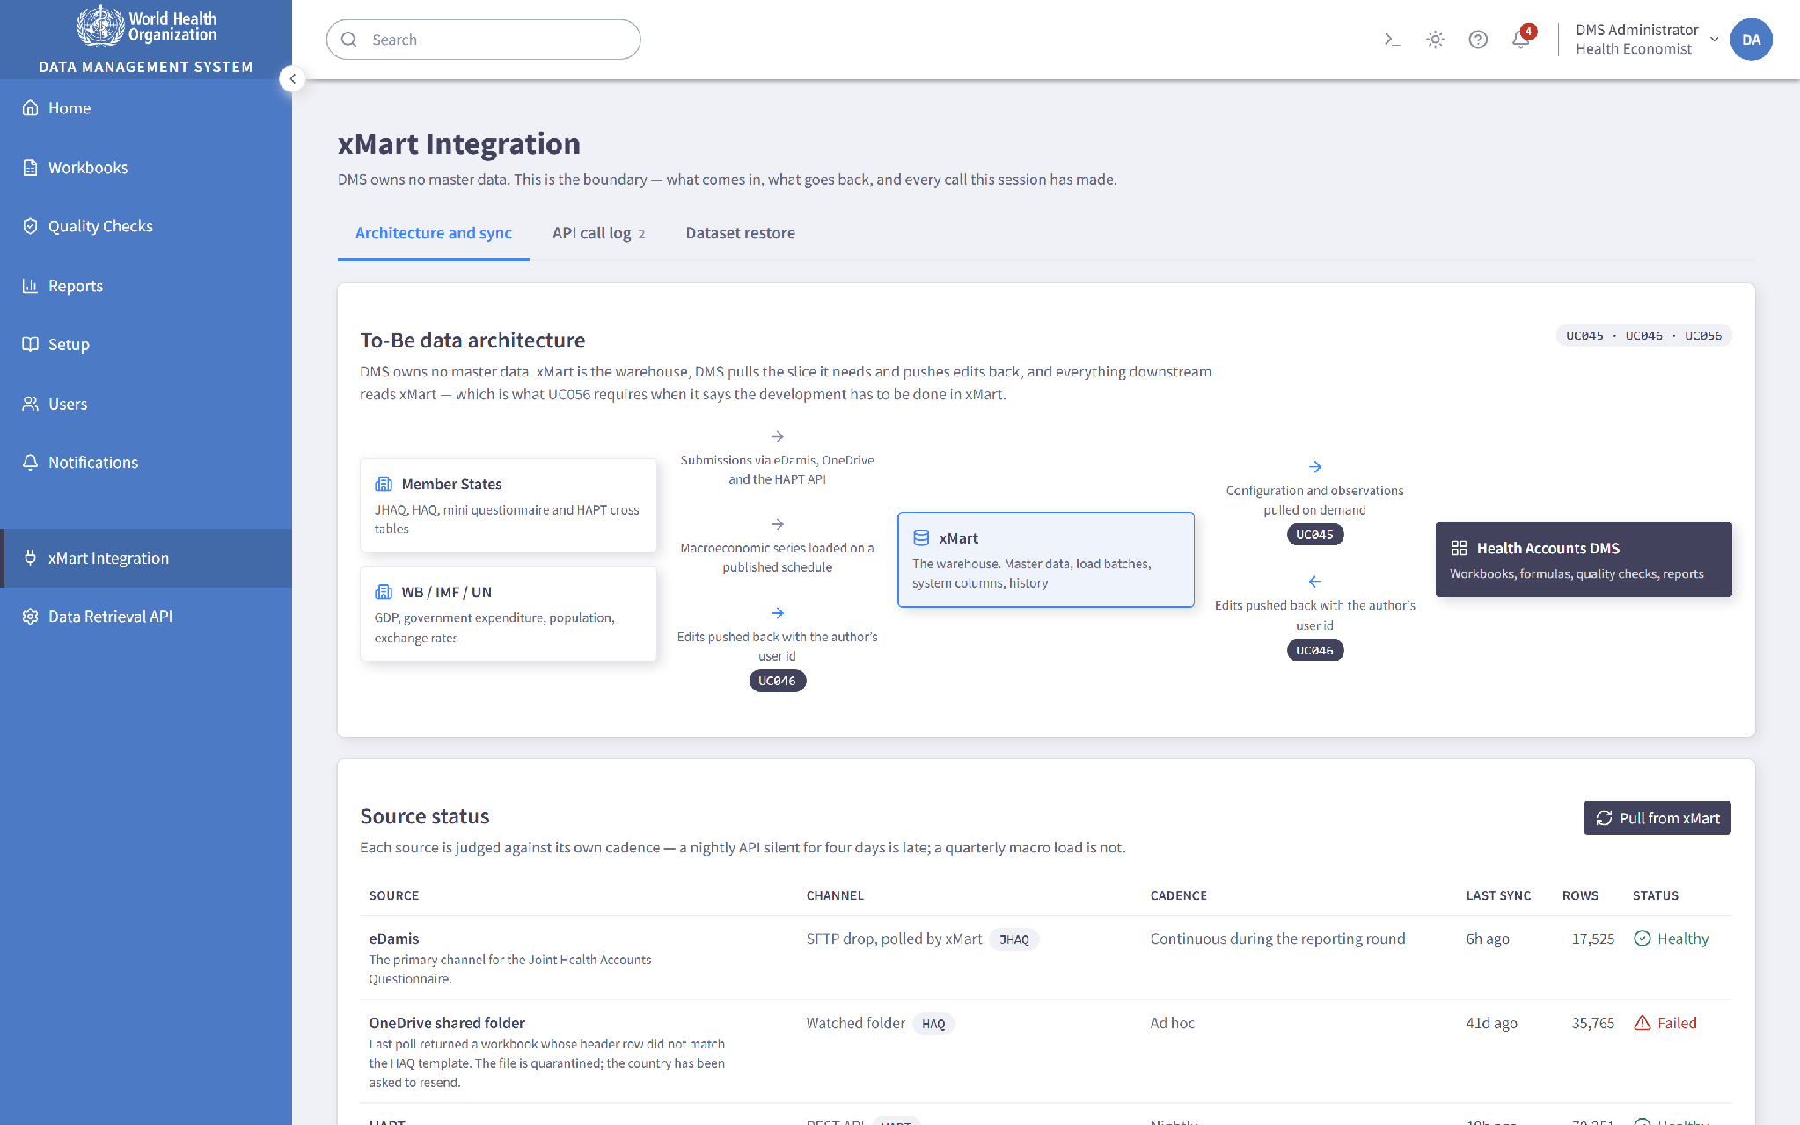
xMart integration: synchronisation status and the API call log.

Legacy Data and Formula Migration
The legacy DMS holds the Health Accounts history the new system needs to be able to consult, together with approximately seventy thousand formulas in its Microsoft SQL Server database. Argusoft will manage the migration of this content into the agreed xMart and DMS target structures as a controlled and reconciled process rather than a single transfer.
We begin by profiling the legacy schema, its data quality and its formula syntax, and producing a source to target mapping agreed with WHO. Extraction takes the latest version of each record and each formula, in line with the requirement that only the latest version is migrated. Transformation maps legacy identifiers onto the classification and category codes in use in the new system. Loading places the data in xMart, with the legacy formulas stored as plain text metadata fields so that each is available for inquiry from the new DMS against the observations it relates to.
The formulas are then translated into working formulas in the new DMS. The calculation engine described earlier is what makes this systematic rather than manual: because it parses an expression into a syntax tree instead of treating it as text, converting a legacy formula is a matter of re-expressing a parsed structure in the new syntax. The conversion is carried out together with the WHO Health Accounts team, whose knowledge of the legacy formula population is what allows individual cases to be settled authoritatively, and each converted formula is validated by comparing its computed result against the legacy result for the same country and year.
Reconciliation produces record counts, control totals and an exception report naming any formula that needs individual attention and why, so that anything outstanding is a known and jointly managed list rather than a silent gap. The migration is run at least twice in a non production environment before the production run, so that the reconciliation report rather than the cutover is where problems come to light, and a documented rollback position is established before the production run begins. WHO signs off against the reconciliation evidence before cutover.

Additional Features
Report output is available with variable labels in the six official WHO languages, as described under Reports and Analytics. Language resources are held outside the application code using i18next, so adding a language or correcting a label does not require a code change. Labels are translated while codes, unit keys and stored filter values stay canonical, which matters because a translated unit key would stop the currency checks in the reporting engine comparing like with like.
The application will be developed to meet the applicable WHO accessibility requirements, covering keyboard navigation, focus order, form labelling, colour contrast and compatibility with assistive technology. We treat this as a design constraint from the first wireframe rather than as remediation at the end. The workbook reinforces its use of colour with typography so that the distinction between reported and calculated cells does not depend on colour alone.
The application supports the browsers and viewport sizes agreed with WHO, verified by cross browser testing with Playwright. Layouts are responsive across desktop and laptop sizes. The Workbook, being a dense data entry surface, is designed for desktop use, which reflects how the team actually works.
Every data change, configuration change, permission change, quality check run, report generation and integration event is written to an audit trail carrying the user's identity, a timestamp and a description of the action. Administrators reach it through a searchable and filterable Audit Log view. Logs are structured using Serilog and can be shipped to a central platform such as the ELK stack or Azure Monitor for retention and analysis.

Security Features
Security is described in detail under Approach earlier in this proposal, and the points below cover how it appears in the design of the solution itself.
Authentication is delegated entirely to WHO Entra ID, so the application holds no passwords and inherits WHO's own account policies, including multi factor authentication. Authorization is enforced in the API layer, covering role permissions and country restrictions together, which means it cannot be bypassed by manipulating the client. All traffic runs over HTTPS, and the data retrieval API that xMart calls is protected with OAuth 2.0.
Data is encrypted in transit and at rest using WHO approved Azure services and configurations, with keys held in Azure Key Vault and separated from the application. Uploaded files are validated for type and size and scanned for malware using the security scan API WHO provides, and a file that fails either check is rejected before it reaches storage.
The application is built following OWASP secure coding practices, with input validation, output encoding, parameterised queries and secure session handling applied throughout, and least privilege applied to every service account. Our development process includes static application security testing, software composition analysis and dependency scanning, secret scanning, and dynamic application security testing before release.

Proposed Work Plan
Our work plan is aligned with the implementation approach, milestones, and deliverables defined in the Terms of Reference. It follows a hybrid delivery model that combines structured planning with iterative Agile development, enabling continuous stakeholder engagement, phased delivery, and early validation throughout the project lifecycle. Each phase concludes with defined review and approval checkpoints to ensure quality, transparency, and controlled progression before moving to the next stage.
In parallel with the phase-wise activities described below, Argusoft will maintain key project management artefacts including the Project Management Plan, Sprint Backlog, Risk & Issue Register, Change Log, Quality Assurance Plan, and Project Status Reports. These artefacts will be reviewed and updated throughout the engagement to support effective project governance, communication, and progress monitoring.

Phase 1: Project Initiation & Requirements Gathering
Following contract signing, Argusoft will conduct a project kick-off meeting with the WHO Health Accounts team to establish project governance, communication mechanisms, timelines, and reporting arrangements. Detailed requirement gathering workshops will be conducted to validate functional and non-functional requirements, study the existing DMS, understand business processes for data import, analysis, verification, and publication, review xMart capabilities, API specifications, and legacy data structures, and confirm integration and migration requirements. The findings will form the foundation for solution design and implementation.
Deliverables
- Project Management Plan
- Technical Requirement Study
- Validated Functional & Technical Requirements
- Updated Implementation Work Plan

Phase 2: Solution Design & Prototype Development
Based on the validated requirements, Argusoft will prepare the technical and graphical design of the solution, including the overall architecture, DMS data model, integration design, security design, wireframes, UI/UX prototypes, deployment architecture and Azure cloud resource-sizing requirements. The proposed design will be presented to WHO for review and approval before development activities commence. Argusoft will establish and operate the Development environment using vendor-provided infrastructure. WHO will provide the Azure subscription, licenses and required access. Argusoft will provision, configure, deploy and maintain the UAT and Production environments within WHO’s Azure subscription using approved IaC and DevOps practices.
Deliverables
- System Design Document
- Wireframes / UI-UX Prototypes
- Hardware Requirement Proposal
- Approved Technical & Graphical Design

Phase 3: System Development, Integration & Pilot Implementation
Development will be delivered through two-to-three-week Agile sprints, implementing the Pilot functionality first and then the remaining agreed requirements. The Pilot will include a general dashboard; advanced role-specific dashboards for administrators and regular users may be delivered under Priority 3. This phase includes the DMS application and APIs, bidirectional xMart integration, quality assurance, and UAT milestone deployments for WHO working-group functional acceptance. Argusoft will also perform the one-time migration of legacy Health Accounts data and approximately 70,000 legacy formulas from the old DMS, including loading formula metadata into xMart and conversion to the new DMS formula syntax as required by UC060. Existing external-source pipelines into xMart are already in place and are outside DMS development scope.

Deliverables
- Pilot DMS Functionalities
- Remaining Functional Modules
- Interim Demonstrations
- UAT Deployments
- Integrated and Tested System Components

Phase 4: System Testing & User Acceptance
Comprehensive testing will be conducted to verify that all system modules comply with the agreed functional requirements and acceptance criteria. This phase includes system testing, integration testing, performance testing, User Acceptance Testing (UAT), issue resolution, and final validation in collaboration with the WHO Health Accounts team before production deployment.
Deliverables
- Quality Assurance & Testing Reports
- User Acceptance Testing (UAT) Completion
- Final Demonstration
- Production Readiness Approval

Phase 5: Production Deployment, Training & Knowledge Transfer
Following successful UAT, the Health Accounts Data Management System will be deployed to the WHO Production environment. Administrator and user training will be conducted, followed by handover of all project artefacts, including technical documentation, database documentation, source code, system architecture documentation, user and administrator guides, and third-party licence keys (where applicable).
Deliverables
- Deployment of DMS on Production Server
- Training of Users and Administrators
- Training Report
- Database Technical Documentation
- Source Code & Technical Documentation
- System Architecture Documentation
- User & Administrator Guides
- Third-Party Licence Keys (if applicable)

Phase 6: Warranty, Cloud Infrastructure Support & Project Closure
Cloud infrastructure support and monitoring for UAT and Production will begin when the WHO-hosted environments are established and continue through implementation and the three-month warranty, which is included within the overall ten-month project period. Following Production deployment, Argusoft will provide 8x5 warranty support covering issue resolution, defect correction, Azure infrastructure assistance, monitoring, SSL-certificate monitoring, troubleshooting and Monthly Support & Maintenance Reports. Post-warranty support will be treated as a separate assignment.
Deliverables
- Warranty Services (3 Months)
- Monthly Support & Maintenance Reports
- Project Completion Report

Development Timeline
Considering the project starts on 15th September, 2026
Phase | Start Date | End Date | Duration / Logic
Phase 1: Project Initiation & Requirements Gathering | 15 Sep 2026 | 30 Sep 2026 | 2 weeks – mobilisation, kick-off, requirements workshops, existing DMS/xMart review
Phase 2: Solution Design & Prototype Development | 15 Sep 2026 | 14 Oct 2026 | 1 month – architecture, data/integration design, UI/UX prototypes, design approval
Phase 3: System Development, Integration & Pilot Implementation | 15 Oct 2026 | 14 Mar 2027 | 5 months – Agile sprints, Pilot, remaining modules, xMart integration, migration
Phase 4: System Testing & User Acceptance | 15 Feb 2027 | 15 Apr 2027 | ~2 months – testing, integration, UAT, reconciliation and defect resolution
Phase 5: Production Deployment, Training & Knowledge Transfer | 1 Apr 2027 | 15 Apr 2027 | 2 weeks – final UAT closure, training, production deployment and handover
Phase 6: Warranty, Cloud Infrastructure Support & Project Closure | 15 Apr 2027 | 15 Jul 2027 | 3 months – warranty, infrastructure support, monitoring, issue resolution and closure

Quality Assurance Methodologies and Processes
Argusoft will apply a quality-first, risk-based assurance approach to ensure that the Health Accounts Data Management System (DMS) satisfies WHO’s functional, technical, integration, security, accessibility, migration and performance requirements. Quality assurance will be embedded throughout requirements validation, architecture and design, iterative development, integration, deployment and warranty support. Reviews, sprint demonstrations and formal validation checkpoints will provide progressive evidence that each contractual deliverable meets its approved acceptance criteria.

Test Strategy, Environments and Responsibilities

Argusoft will prepare a Master Test Plan covering test scope, approach, responsibilities, environments, test data, traceability, entry and exit criteria, defect management, reporting and acceptance evidence. Development-level, component and integration testing will be performed in the vendor-provided Development environment. Formal system verification and UAT will be conducted in the WHO-provided UAT environment using WHO-provided representative test data and xMart UAT access. As WHO has confirmed that no existing test cases or API regression suite are available, Argusoft will create the functional, integration, migration, formula-validation, security, performance and regression test assets required for the project.

Requirements Traceability and Acceptance

Argusoft will maintain a Requirements Traceability Matrix mapping each ToR objective and high-level requirement to the applicable use case, design component, sprint, test scenario and test case, UAT result, defect status and final acceptance status. This traceability will demonstrate coverage of all required use cases and support milestone-level acceptance.

The WHO working group will provide milestone and final acceptance based on applicable functional and operational test results. For each acceptance decision, Argusoft will submit the current traceability matrix, executed test evidence, defect status, migration and formula reconciliation results, security findings and remediation status, performance results, and a release-readiness or Test Completion Report.

Entry and Exit Criteria

Each test cycle will have documented entry and exit criteria. Entry criteria will include approved requirements and acceptance criteria, an available and stable test environment, a deployed test build, available interfaces, representative test data and completed developer testing. Exit criteria will include completion of planned tests, agreed requirements coverage, successful regression testing, resolution of all Critical and High-severity defects, documented disposition and WHO acceptance of any remaining lower-severity defects, and approval of the applicable Test Completion Report.

Defect Severity and Release Controls

Defects will be recorded, triaged, prioritized, assigned, corrected, re-tested and closed through a controlled issue-management workflow:
- Critical – system unavailability, security exposure, data corruption or failure of a critical process without a viable workaround; must be resolved before release.
- High – failure of a major function or business process without an acceptable workaround; must be resolved before release.
- Medium – impaired functionality for which a reasonable workaround exists; must be resolved or formally accepted for deferred correction.
- Low – minor usability, presentation or documentation issue; tracked and prioritized through the agreed backlog.

The final severity definitions, service expectations and approval authority will be confirmed during inception. No Production release will proceed with unresolved Critical or High-severity defects.

Functional, Workbook, Formula and Quality-Check Testing

Functional testing will verify all approved business processes and use cases, including users and roles, country-level access, configuration, classifications and crosses, metadata, workbooks, formulas, reports, versions, notifications, audit trails and administration. Workbook testing will include locking and concurrent read-only access, copy/paste, undo, filtering, import/export, formula/value handling, recalculation, version comparison and restoration.

Formula testing will verify syntax conversion, expected calculation results, rounding and precision, null and zero behaviour, divide-by-zero and invalid-reference handling, country/year/classification references, recalculation triggers, auditability and exception reporting. Quality Check module testing will cover predefined and customized rules, administrator and regular-user permissions, country/group applicability and exclusions, Passed/Failed/Error/Warning outcomes, manual workbook-triggered execution, Excel export and re-import of rule configuration, report generation and storage, and full year-end execution for approximately 196 countries. Retry, restart, progress visibility, job status and result consistency will also be verified against WHO-approved rules and representative expected results.

DMS–xMart Integration and API Testing

Argusoft will validate the bidirectional DMS–xMart interfaces, including API contracts, OAuth 2.0 authentication, HTTPS, CSV and optional JSON output, business-key and date-range filtering, internal identifiers, paging designed for the Annex 3 reference page size of 100,000 records, streaming, complete and incremental retrieval, range-filterable UTC LastModified values, inclusion or exclusion of soft-deleted records, update processing, error responses, retry behaviour and end-to-end data reconciliation. Existing external-source pipelines into xMart are outside the DMS development scope and will not be represented as direct DMS integrations.

Legacy Data, Metadata and Formula Migration Testing

Migration assurance will validate source-to-target mappings, record counts, mandatory fields, data types, referential integrity, duplicate handling, metadata associations, formula extraction and conversion, reconciliation totals, exception handling and audit evidence. Testing will cover the legacy data and approximately 70,000 formulas stored in the old DMS SQL Server, subject to the detailed migration and conversion rules agreed during discovery. Validation will use full-population checks where practical and WHO-approved sampling for fields or calculations requiring business review. A failed-conversion and reconciliation exception report will support correction and formal sign-off.

Performance, Reliability and Recovery Testing

During discovery, Argusoft and WHO will agree representative performance scenarios and measurable thresholds for interactive workbook operations, API calls, report generation, imports and exports, migration processing and year-end quality-check execution. Tests will cover workloads ranging from small selections to the stated 25-million-row maximum using server-side paging, streaming, asynchronous or background processing, or bulk extraction as appropriate; the design will not assume that all records are loaded interactively into a browser.

Performance and reliability testing will also cover approximately 20 concurrent internal users, the confirmed xMart batch capability, queue processing, progress visibility, restart and retry behaviour, failed-job recovery, notifications and sustained stability. Backup, restoration and recovery procedures will be tested against WHO-agreed recovery objectives before Production readiness.

Security, Accessibility and Compatibility Testing

Security assurance will be supported by Argusoft’s in-house cybersecurity team, including professionals holding certifications such as HTB CPTS, CompTIA Security+ and eJPT. Activities will include threat modelling, peer review, static application security testing, software-composition analysis, dependency and secret scanning, dynamic application security testing, authentication and authorization testing, API security testing, audit-log verification, input validation, country- and role-based access testing, and remediation verification before Production release. File-upload controls and malware scanning will be validated using the WHO-provided security scan API.

Accessibility testing will validate the applicable WHO accessibility requirements, keyboard navigation, focus order, labels, contrast and assistive-technology compatibility. Cross-browser and responsive testing will verify the supported user experience across the agreed browsers and viewport sizes.

Regression, UAT, Deployment and Warranty Verification

A maintainable regression suite will be established because no existing suite is available. Automated regression testing will be applied where cost-effective and sustainable, supplemented by manual testing for complex workflows and visual or exploratory scenarios. Argusoft will support WHO during UAT, triage and classify defects and agreed observations, implement in-scope corrections and minor modifications, and re-test resolved items.

Before Production deployment, Argusoft will complete the agreed regression, security, migration-reconciliation, performance, backup/restore and release-readiness checks. During warranty, the team will monitor solution quality, reproduce and resolve reported defects, verify corrections and maintain traceability to the affected requirement and release.

Quality Assurance Deliverables

The QA workstream will produce and maintain the following evidence:
- Master Test Plan and testing strategy.
- Requirements Traceability Matrix.
- Test scenarios, cases, scripts and representative test datasets.
- API contract, integration and DMS–xMart reconciliation report.
- Legacy data, metadata and formula migration reconciliation report.
- Performance, reliability and recovery test report.
- Accessibility and compatibility test report.
- Security testing and remediation report.
- UAT support, defect-closure and release-readiness report.
- Test Completion Report for each contractual milestone.
- Final consolidated testing and acceptance report.

This evidence-based assurance approach will provide WHO with transparent, measurable proof that the delivered DMS is functionally complete, secure, reliable, accessible, correctly integrated with xMart, accurately migrated and ready for sustainable operation by the WHO Health Accounts programme.

Capacity Building and Knowledge Transfer

Capacity-Building Objective
Argusoft’s capacity-building approach will progressively transfer business, administrative, operational and technical knowledge to WHO so that designated personnel can confidently use, administer, operate, support and further develop the DMS. Knowledge transfer will be treated as a continuous project workstream and will culminate in a verified handover, rather than being limited to a single end-of-project activity.

Continuous Knowledge Transfer
Knowledge transfer will be embedded throughout inception, design, development, migration, testing and deployment through requirements workshops, architecture and design walkthroughs, sprint demonstrations, configuration and workflow-validation sessions, migration-mapping and reconciliation reviews, formula-conversion walkthroughs, DMS–xMart API walkthroughs, UAT defect-triage participation, and deployment and operational-readiness reviews. Key decisions, procedures and lessons learned will be documented so that project knowledge is retained by WHO.

Training-Needs Assessment and Plan
During inception, Argusoft will work with WHO to confirm participant roles, existing knowledge, priority workflows and administrator responsibilities. Based on this assessment, Argusoft will prepare a role-based training plan, agenda, practical exercises and representative scenarios using the approved WHO UAT environment and WHO-provided test data.

Remote Training for WHO Experts
Argusoft will deliver one instructor-led remote training session in English for up to 20 WHO-designated experts. The agenda will include distinct segments for key/business users, administrators, and technical or operational personnel.
- Key and business users: navigation, workbooks, formulas, metadata, reports, Quality Checks, version history, notifications and common business workflows.
- Administrators: users, roles, country-based access, system configuration, rule management, operational monitoring, audit logs and troubleshooting.
- Technical and operational personnel: solution architecture, deployment, configuration, DMS–xMart interfaces, database, monitoring, backup and restoration, security operations and release procedures.

Train-the-Trainer and Reusable Materials
The approach will follow a train-the-trainer model, enabling WHO-designated experts to support subsequent onboarding and internal knowledge dissemination. Materials will be supplied in editable and reusable formats where applicable and will include the training plan and agenda, presentation materials, role-based exercises, quick-reference guides, User Guide, Administrator Guide, frequently asked questions and troubleshooting guidance. A session recording will be provided subject to WHO approval and applicable policies.

Technical and Operational Documentation
The handover documentation will include the Solution Architecture Document and diagrams; database schema, data types, table structures and data dictionary; API and xMart integration documentation; source-code and component documentation; configuration and environment guide; build, deployment, rollback, CI/CD and Infrastructure-as-Code procedures; monitoring, logging and alert-management runbook; backup, restoration and recovery procedures; security and access-control guide; migration mappings, formula-conversion rules and reconciliation records; Quality Check and formula-configuration guidance; known-issues and troubleshooting runbook; third-party component, dependency and licence inventory; and relevant testing, security-remediation and completion reports.

Source Code and System Handover
Argusoft will hand over the complete project-specific application source code, database scripts, build and deployment assets, Infrastructure-as-Code, configuration templates, API specifications, technical documentation, testing artefacts and applicable third-party licence information through the repository and handover mechanism agreed with WHO. The package will include the instructions required to build, deploy, configure, operate, maintain and further enhance the solution. WHO will own the project-specific deliverables, subject to the licence terms applicable to third-party and open-source components.

Training and Handover Acceptance
Training effectiveness will be assessed through attendance, completion of guided practical exercises, participant questions, a concise knowledge check and participant feedback. Material knowledge gaps will be addressed through updated guidance, written clarifications or handover materials. The Training Report will document attendance, topics covered, materials delivered, feedback, outstanding questions and follow-up actions.
Before final acceptance, Argusoft will conduct a structured handover walkthrough and jointly verify with the WHO working group that the source repository, documentation, deployment instructions, database specifications, guides, training materials, licence information and required project artefacts are complete and accessible. Any identified gaps will be resolved before submission of the Project Completion Report.

Capacity-Building Deliverables
- Training Needs Assessment and Training Plan
- Training agenda, presentation materials and practical exercises
- User Guide and Administrator Guide
- Quick-reference, FAQ and troubleshooting materials
- Training attendance, feedback and knowledge-check records
- Training Report
- Technical and Operational Documentation Package
- Source Code and Technical Artefact Handover Package
- Third-Party Components and Licence Inventory
- Handover Checklist and Acceptance Record
- Project Completion Report

Support, Maintenance & Warranty Services
Argusoft will provide application warranty and cloud-infrastructure support from Production deployment through completion of the three-month warranty period within the overall ten-month project. The warranty will cover all DMS modules and will include correction of defects, errors, functional gaps and operational issues, together with agreed feature enhancements, customizations and additional reports falling within the contractual scope. In accordance with WHO’s clarification, each individual modification that can be completed within 10 working days by one resource will be treated as in scope. Requests requiring more than 10 person-days will be jointly assessed by WHO and Argusoft and handled separately, as applicable. Up to 20% scope adjustment during development and warranty will be included in the proposed cost and planned and prioritized by the WHO working group.
Support beyond the warranty is outside the present assignment and may be provided through a separate assignment. Where requested in the Financial Proposal, Argusoft may provide indicative post-warranty support rates or options for WHO’s evaluation; any such services will be activated only through a separate contractual arrangement.

Support Coverage and Responsibility Boundaries
Application support will cover DMS defects, failed jobs, workbook and formula issues, Quality Checks, reports, notifications, configuration and application logs. Integration support will cover diagnosis of bidirectional DMS–xMart interface failures, API errors and reconciliation issues, together with coordination with the WHO xMart team. Infrastructure support will cover the WHO-hosted UAT and Production Azure environments, including approved configuration, monitoring, certificates, deployment pipelines, Infrastructure-as-Code-controlled changes and troubleshooting. Security support will cover vulnerability triage, dependency and platform patching, security-event investigation, remediation and verification.
Changes to the xMart platform, WHO tenant and subscription administration, and existing external-source pipelines into xMart will remain with the appropriate WHO teams. Argusoft will nevertheless coordinate actively with WHO and Microsoft, where required, to diagnose dependencies and restore the delivered DMS services.

Help Desk and Service-Request Management
WHO-designated users will report incidents and service requests through an agreed email or ticketing channel. Each request will receive a unique identifier and will be recorded with its category, severity, affected environment, reported time, owner, status, actions taken and closure evidence. Argusoft will acknowledge, triage, classify, assign, investigate, resolve, test and close each request in coordination with the authorized WHO representative. Duplicate requests will be linked, material status changes will be communicated, unresolved issues will follow the agreed escalation path, and closure will require confirmation of resolution or an agreed disposition. A request may be reopened if the issue persists, and recurring solutions will be incorporated into the knowledge base and known-error records.

Support Window, Severity and Escalation
The 8×5 application-support window will provide agreed overlap with WHO Geneva/CET business hours. The exact service window, authorized contacts, holiday calendar and escalation arrangements will be confirmed during inception and recorded in the Support and Maintenance Plan.
As a provisional baseline, Critical incidents—such as Production unavailability, data corruption, a major security exposure or a critical process blocked without a workaround—will receive an initial response within one business hour. High-severity incidents affecting a major function without an acceptable workaround will receive an initial response within four business hours. Medium-severity incidents for which a reasonable workaround exists will receive an initial response within one business day, and Low-severity usability, presentation, documentation or non-urgent requests will receive an initial response within two business days. Resolution or workaround targets will depend on diagnosis, impact and complexity. Final definitions, response targets, escalation thresholds and resolution expectations will be agreed with WHO during inception.

Automated Monitoring and Operational Response
Argusoft will configure 24×7 automated monitoring and alert generation for application and API availability, infrastructure health and utilization, database availability and capacity, failed deployments, failed or delayed background jobs, DMS–xMart integration failures, error rates and application exceptions, authentication and authorization failures, certificate expiration, backup success or failure, security events and significant configuration changes. The 24×7 commitment relates to automated monitoring and alert generation; human investigation and intervention will follow the agreed 8×5 support and escalation model unless otherwise agreed with WHO.
Incidents will be managed through triage, containment, workaround or service restoration, permanent correction, regression testing and closure confirmation. Recurring or significant incidents will be handled through problem management, including root-cause analysis, corrective and preventive actions and knowledge-base updates. Root-Cause Analysis reports will be provided for Critical incidents and for other incidents requested by WHO.

Controlled Change, Release and Security Maintenance
Application fixes, minor modifications and infrastructure changes will follow controlled change and release procedures, including impact assessment, WHO prioritization where applicable, source control, peer review, testing in the appropriate environment, approval, deployment through CI/CD or Infrastructure-as-Code pipelines, rollback planning and post-deployment verification. Emergency changes will be documented and retrospectively reviewed.
Argusoft’s development, DevOps and in-house cybersecurity teams will support vulnerability triage, dependency and platform patching, security-event investigation, remediation and verification throughout the warranty. Critical and High-severity security findings attributable to the delivered solution will be remediated before warranty closure. Security updates will be impact-assessed, tested and deployed through WHO-approved change procedures, and their status will be included in the monthly report.

Backup, Recovery and Service Continuity
Argusoft will monitor configured backup processes, support periodic restoration verification, maintain recovery and rollback procedures, and assist in restoring application services following an operational failure. Support will include failed-job restart and retry, deployment rollback and configuration recovery using approved operational runbooks. Backup retention, restoration frequency and recovery objectives will be agreed with WHO based on the approved Azure architecture and applicable WHO policies.

Reporting and Governance
Argusoft will submit a Monthly Support and Maintenance Report covering incidents and service requests opened, closed and outstanding; severity and response performance; root-cause analyses and recurring problems; application fixes and minor modifications; infrastructure and configuration changes; deployments and rollbacks; monitoring availability and significant alerts; capacity and performance observations; backup and restoration status; certificate status; security vulnerabilities, patches and remediation; DMS–xMart integration issues; risks and dependencies; recommended actions; and planned activities for the next period. Review meetings and escalation discussions will be held with WHO as agreed to prioritize work and maintain operational transparency.

Warranty Completion and Acceptance
At the end of the warranty period, Argusoft will submit a Warranty Completion Report consolidating incidents, defects, minor modifications, releases, infrastructure changes, monitoring results, security remediation, open-item status and operational recommendations. Warranty completion will be subject to WHO working-group review and confirmation that all agreed Critical and High-severity warranty issues have been resolved and that any remaining lower-severity items have an agreed disposition.

Key Personnel

Key Experts
Name | Role | Experience | Profile Summary
Mayank Modi | Project Manager | 17+ years | PMP certified by the Project Management Institute (PMI). Master’s degree with expertise in leading large-scale enterprise information systems projects for WHO, UN agencies, governments, and international organizations. Extensive experience in Information systems design and development. Proven leadership skills while managing complex data management and digital transformation projects using Agile and Waterfall methodologies. Strong expertise in project governance, stakeholder engagement, risk management, quality assurance, reporting, user training, and successfully managing multi-disciplinary teams. Excellent communication & team management skills.
Yashvi Pomal | Lead Business Analyst | 5+ years | Expertise in business analysis and development strategies, requirements engineering, and enterprise data management platforms. Experienced in documenting As-Is and To-Be business processes, BPMN modelling, workflow analysis, functional specifications, user stories, acceptance criteria, and analytical reports. Strong background in stakeholder workshops, cross-functional process analysis, data management systems, user training, and supporting Agile delivery for WHO and government digital transformation initiatives.
Karan Patel | Technical Lead | 10+ years | With Master’s degree, expert in designing and leading the development of enterprise data management platforms using Microsoft .NET, C#, ASP.NET, Angular, SQL Server, Azure, and REST APIs. Extensive experience in solution architecture, system integration, secure data collection and standardization, advanced analytics, database design, microservices, and enterprise application customization. Proven track record leading development teams through architecture, deployment, training, handover, and cloud-based implementations, with experience in Azure, containerization, and Microsoft technologies.
Vishal Godhani | Senior Software Engineer | 7+ years | Extensive experience developing enterprise web applications using .NET, C#, ASP.NET, Angular, JavaScript, HTML5, CSS3, SQL Server, and RESTful APIs. Skilled in designing scalable system architectures, database design, microservices, workflow-driven applications, system optimization, and enterprise integrations. Strong expertise in responsive UI development, API integration, performance optimization, and implementing secure, maintainable solutions for WHO and large public sector platforms.
Janmejay Jani | Data Analyst | 9+ years | Expert in data modelling, database design, ETL processes, statistical analysis, and enterprise reporting. Extensive experience working with SQL, Business Intelligence tools, Excel, SPSS, SAS/R, XML, and data quality management. Skilled in analysing complex datasets, designing data validation and quality rules, reporting and dashboard development, metadata management, and optimizing large-scale data management systems. Experience supporting health information systems, expenditure data analysis, and evidence-based decision-making is a strong asset.
Niraj Lathiya | DevOps / Cloud Infrastructure Engineer | 7+ years | Expert in Azure cloud architecture, CI/CD, Infrastructure as Code (Terraform), Azure DevOps, GitLab CI/CD, Docker, Kubernetes (AKS), Azure Functions, API Management, IIS, SQL PaaS, Storage Accounts, monitoring, security, and automation. Extensive experience deploying and maintaining enterprise applications on Microsoft Azure, implementing DevOps pipelines, monitoring cloud environments, troubleshooting deployments, managing SSL certificates, and ensuring secure, reliable, and scalable digital operations.
Vrutti Gandhi | Product Designer (UI/UX) | 9+ years | Expert in user-centred design for enterprise data management platforms, dashboards, and workflow-driven applications. Extensive experience in information architecture, wireframing, prototyping (Figma), usability testing, accessibility, responsive design, and data visualization. Skilled in translating complex business processes into intuitive user experiences and collaborating closely with business users, developers, and policy teams to improve usability, accessibility, and user adoption across public sector and WHO projects.

Non Key Experts

Role | Experience | Profile Summary
Software Quality Assurance (QA) Specialist | 9+ years | Expert in quality assurance for enterprise web applications and data management systems. Extensive experience in test planning, functional, integration, regression, performance, security, and User Acceptance Testing (UAT). Skilled in API testing, automation frameworks, defect management, quality reporting, and validating workflow-driven and data-intensive applications to ensure compliance with functional requirements and acceptance criteria.
Database Engineer | 7+ years | Expert in database architecture, SQL Server, PostgreSQL, MySQL, performance tuning, data migration, ETL processes, metadata management, backup and recovery, and database optimization for enterprise data management systems.
Technical Writer/ Trainer | 5+ years | Experienced in preparing technical documentation, user manuals, administrator guides, training materials, and conducting remote user and administrator training sessions for enterprise information systems and digital platforms.

The proposed team structure ensures optimal allocation of expertise across all project phases, with clearly defined responsibilities and active involvement throughout the lifecycle to ensure continuity, quality, and accountability in delivery.

Resumes of Key Resources

Mayank Modi - Project Manager (PMP Certified)
Experience: 17+ Years
Proposed Role: Key Expert 1 – Project Manager
Professional Summary
- Mayank Modi is a seasoned Project Manager with 17+ years of experience leading large-scale enterprise information systems, digital health platforms, data-driven solutions and government technology programmes for government institutions, WHO and international clients. He holds a Master of Computer Applications (MCA) and is a Project Management Professional (PMP).
- He has managed the full lifecycle of complex technology programmes, from requirements and inception through solution design, development, testing, UAT, production deployment, training, handover and operational support. His experience includes managing multidisciplinary teams of 20+ resources, coordinating Business Analysts, Software Engineers, QA, DevOps and UI/UX teams, and maintaining delivery across scope, schedule, resources, quality, risks and dependencies.
- Mayank brings particularly relevant experience in public health, government information systems, data analytics and enterprise platforms, including eKavach for the Government of Uttar Pradesh, MedPlat/TeCHO+ for the Government of Gujarat, and international projects for WHO and KPMG Netherlands. He has worked closely with government officials, healthcare stakeholders, product owners and international clients to translate programme objectives into practical digital solutions.
- His project management experience combines Agile and Waterfall delivery, stakeholder governance, requirements and scope management, risk and issue management, resource planning, quality assurance, UAT, production rollout, user training and operational handover. He has also supported solution design, business process transformation and user-centred digital delivery, making him well suited to lead the multidisciplinary delivery of the WHO Health Accounts Data Management System.

Core Competencies
- Project & Programme Management
- Enterprise Information Systems
- Digital Health & Public Health Platforms
- Government & International Client Management
- Agile & Waterfall Methodologies
- Project Governance & Delivery Management
- Requirements & Scope Management
- Resource Planning & Team Leadership
- Risk, Issue & Dependency Management
- Stakeholder Engagement & Communication
- Quality Assurance & UAT Management
- Production Deployment & Go-Live
- User Training & Train-the-Trainer
- Business Process Transformation
- Solution Design Coordination
- Change Management & Operational Handover
- Analytical Reporting & Project Documentation
Technical / Delivery Skills
- Agile/Scrum, Sprint Planning and Delivery Governance
- SDLC and Enterprise Application Delivery
- High-Level Solution Design Coordination
- Requirements & Business Process Analysis
- UAT Planning and Execution
- Risk Registers, Issue Logs and Mitigation Planning
- Resource Allocation and Cross-functional Team Management
- Production Deployment and Operational Transition
- Stakeholder Reporting and Management Reviews
Professional Certification
- Project Management Professional (PMP) – Credential #2908385, December 2020
- Sun Certified Professional – 2009
Qualification
- Master of Computer Applications (MCA) – Gujarat University
- Bachelor of Computer Applications (BCA) – South Gujarat University
Relevant Project Experience
1. TIMS (Ticket Information Management System) — eGov Jamaica / Ministry of National Security Jamaica
Role: Project Manager
Period: 2023 – Present
Project Description
TIMS is a web-based application developed for the Ministry of National Security to streamline the management of traffic tickets from issuance through resolution. The system integrates with critical systems including SmartCheck, TTIS and INCRS and supports multiple services and entities involved in the Ministry's operations.
Key Responsibilities
- Spearheaded the project in close collaboration with eGov Jamaica and the Ministry of National Security to address diverse stakeholder requirements and ensure seamless integration with existing systems.
- Led regular stakeholder meetings to communicate project status, address challenges and review risk mitigation plans.
- Implemented Agile methodologies, including sprint planning, daily stand-ups and retrospective meetings in coordination with the Scrum Manager.
- Coordinated cross-functional teams comprising developers, QA, DevOps and UI/UX resources.
- Managed project scope, resource planning and allocation, milestones and delivery activities.
- Identified project risks and implemented mitigation and contingency plans throughout the project lifecycle.
- Ensured delivery within agreed timelines and budget while maintaining quality and stakeholder alignment.
2. eKavach — Government of Uttar Pradesh, India
Role: Project Manager
Period: 2021 – 2023
Project Description
eKavach is a comprehensive public health platform implemented using MEDplat for the Health Ministry of Uttar Pradesh. The platform supports more than 250,000 field health workers serving a population of more than 250 million, covering services including family planning, pregnancy tracking, identification of high-risk pregnant women, treatment counselling and immunization tracking.
Key Responsibilities
- Led a large team of 20+ resources and participated in understanding public health challenges, defining user-centric digital solutions and overseeing application development and deployment.
- Conducted consultations with field workers, healthcare professionals and government officials to capture requirements and inform the platform development strategy.
- Managed the project lifecycle from inception through go-live.
- Directed Business Analysts in requirements analysis, gap identification and estimation of required customizations.
- Guided prototype and solution design and secured approval from government stakeholders.
- Led the Train-the-Trainer programme supporting the adoption of the platform by more than 250,000 healthcare workers.
- Coordinated application registration and multi-level review through the DPG process, culminating in the product being listed as a Digital Public Good under SDG 3.
- Coordinated integration with the Government of Uttar Pradesh State FAMS to support bulk disbursement of Performance-Based Incentives and Team-Based Incentives.
3. TEMS (Trust & Estate Management System) — Administrative General's Department, Jamaica
Role: Project Manager
Period: 2017 – 2020
Project Description
TEMS is an enterprise information system developed for the Administrative General's Department of Jamaica, requiring requirements analysis, system design, development, stakeholder coordination and user acceptance.
Key Responsibilities
- Led client communications for requirements gathering and scope definition.
- Guided the technical team in developing high-level and detailed system designs, including block diagrams and class diagrams.
- Addressed potential system challenges and implemented adjustments to support scalability and sustainability.
- Directed resource planning and management and aligned team activities with project milestones.
- Maintained regular engagement with clients and stakeholders through solution progress reviews.
- Managed the User Acceptance Testing (UAT) process and coordinated the development team and client stakeholders to refine and approve the solution.
4. SOFY – Data Analytics Platform — KPMG, Netherlands
Role: Project Manager
Period: 2014 – 2020
Project Description
SOFY is a data analytics platform developed for KPMG Netherlands, involving customization of the platform to meet business requirements and transformation of complex datasets into actionable insights.
Key Responsibilities
- Directed development activities and ensured alignment with KPMG's product vision.
- Worked closely with KPMG Product Owners to understand business requirements and customize the platform accordingly.
- Initiated requirements identification and engaged stakeholders across multiple domains to understand and document business processes.
- Led resource planning and management and established project scope and milestones with the team.
- Maintained continuous communication with clients and stakeholders through solution progress reviews and feedback cycles.
- Participated in onsite discussions and support activities in the Netherlands.
5. MedPlat (TeCHO+) — Government of Gujarat, India
Role: Project Manager
Period: 2014 – 2017
Project Description
MedPlat (TeCHO+) is a digital health platform supporting public health programmes and frontline health workers across Gujarat, requiring extensive stakeholder engagement, requirements gathering, Agile delivery, system development, quality assurance and government coordination.
Key Responsibilities
- Led requirements gathering with field workers, healthcare professionals and government officials.
- Worked closely with Business Analysts to develop Work Breakdown Structures and allocate tasks to team members.
- Managed the project using Agile methodology.
- Monitored project progress and communicated updates to government stakeholders.
- Maintained the project Risk Register and coordinated mitigation of identified risks.
- Reviewed QA reports and error logs and coordinated appropriate resolution activities.
- Facilitated collaboration across developers, QA, DevOps and UI/UX teams.
- Coordinated with government agencies to align project objectives with digital health strategies.
- Managed stakeholder expectations and maintained transparent communication throughout project execution.
- Conducted training sessions and workshops for government officials and healthcare professionals to support adoption and effective use of the platform.


I confirm my availability to undertake the proposed assignment for the duration and level of effort required under the Terms of Reference. I further confirm that I am being proposed exclusively by Argusoft India Ltd. for this assignment and will remain available to perform the responsibilities assigned to me.

Signature of Expert :

Yashvi Pomal - Lead Business Analyst
Experience: 5+ Years
Proposed Role: Key Expert 2 – Business Analyst / Group Lead
Professional Summary
- Yashvi Pomal is an IT professional with 5+ years of experience in business analysis, project coordination, requirements engineering, and Agile delivery of large-scale mobile, web, and desktop applications, with significant experience in public health and health information systems.
- She has demonstrated experience working with government clients, international organizations, and multidisciplinary technical teams, translating business needs and stakeholder expectations into structured requirements, functional specifications, workflows, prototypes, documentation, and implementable solutions.
- Yashvi has experience across the end-to-end business analysis and delivery lifecycle, including requirements elicitation and analysis, business process understanding, functional documentation, user stories, stakeholder consultations, Agile/Scrum delivery, sprint planning, task prioritization, UAT support, defect tracking, risk identification, enhancement analysis, release coordination, and post-release support.
- Her relevant public health experience includes MEDPlat – TeCHO+ for the Government of Gujarat, eKavach for the Government of Uttar Pradesh, and EWARS for the World Health Organization, providing practical exposure to health-data workflows, government health programmes, field-level operations, user requirements, stakeholder coordination, and internationally deployed health information systems.
- Through these engagements, she has worked closely with government officials, programme stakeholders, business users, developers, testers, and project management teams to understand operational requirements, validate proposed functionality, resolve issues, coordinate changes, and ensure that delivered solutions remain aligned with business objectives and user needs.
- She has strong experience in analysing existing functionality, identifying business and functional gaps, defining enhancements, preparing functional and technical documentation, supporting solution validation, and coordinating UAT and product releases.
- Yashvi is a Certified Scrum Master and Certified Scrum Product Owner, with strong capabilities in Agile/Scrum delivery, stakeholder and client management, requirements analysis, project coordination, UAT planning and execution, risk identification and mitigation, decision-making, task prioritization, communication, and cross-functional team facilitation.
Core Competencies
- Business Analysis & Requirements Engineering
- Requirements Elicitation & Analysis
- Business Needs & Gap Analysis
- Business Process & Workflow Analysis
- Functional Requirements & Specifications
- User Stories & Acceptance Criteria
- Functional & Technical Documentation
- Agile & Scrum Delivery
- Stakeholder & Client Management
- Government & Public Health Projects
- Health Information Systems
- Project Coordination & Delivery Tracking
- Sprint Planning & Task Prioritization
- User Acceptance Testing (UAT)
- Functional Validation & Enhancement Analysis
- Defect Tracking & Resolution Coordination
- Risk Identification & Mitigation
- Interactive Prototyping
- Release Management
- Cross-functional Team Facilitation
- Product Adoption & Implementation Support
- Process Documentation & User Guides
Professional Skill Set
Certification:
- Certified Scrum Product Owner (CSPO)
- Certified Scrum Master (CSM)
- Scrum Fundamentals Certified (SFC)
Project Management:
Agile & Scrum-based Project Management, Sprint Planning, Task Prioritization, Delivery Tracking, Release Coordination, Stakeholder Coordination, Risk and Issue Tracking
Business Analysis:
Requirements Elicitation, Requirements Analysis, Business Needs Assessment, Functional Requirements, User Stories, Acceptance Criteria, Business Process Analysis, Enhancement Analysis, Gap Analysis, Interactive Prototyping
Stakeholder Management:
Government Client Coordination, International Organization Coordination, Stakeholder Consultation, Client Feedback Management, Cross-functional Communication, Requirements Validation
Quality & Delivery:
UAT Planning & Execution, Functional Validation, Defect Tracking, Issue Resolution Coordination, Risk Identification & Mitigation, Enhancement Validation, Product Release Coordination
Documentation:
Functional & Technical Documentation, Requirements Documentation, User Guides, Administrator Guides, Developer Documentation, Process Documentation, Project Resource Documentation
Languages:
English, Hindi, Gujarati
Qualification
- Master of Business Administration (MBA)
DY Patil Institute of Distance Learning, India
- Bachelor of Computer Engineering
Marwadi University, India
Relevant Project Experience
1. MEDPlat – TeCHO+ Implementation — Government of Gujarat
Role: Senior Business Analyst
Year: 2021
Location: Gandhinagar, Gujarat
Project Description
MEDPlat – TeCHO+ is a statewide, name-based digital health platform supporting Family Health Surveys, Reproductive and Child Health (RCH) programmes, LMP tracking, and maternal and child health monitoring. The system enables real-time data collection and reporting across multiple levels of health administration.
Key Responsibilities
- Led day-to-day project coordination and supported the effective adoption of Agile methodology across the project team.
- Managed and maintained comprehensive functional and technical documentation throughout the project lifecycle.
- Conducted requirements gathering and enhancement analysis for mobile applications based on business and user needs.
- Reviewed existing system functionality and identified enhancements required to align the solution with evolving business requirements.
- Coordinated bug tracking and resolution with development teams and supported timely closure of functional issues.
- Coordinated and supported User Acceptance Testing (UAT) activities with relevant stakeholders.
- Supported successful product releases and ensured delivered functionality remained aligned with agreed scope, quality standards, and stakeholder expectations.
2. eKavach — Government of Uttar Pradesh
Role: Senior Business Analyst
Year: 2020
Location: Gandhinagar, Gujarat
Project Description
eKavach is a comprehensive public health platform implemented under the National Health Mission, Uttar Pradesh, supporting 200,000+ health workers and more than 1 million beneficiaries across immunization, nutrition, and disease monitoring programmes.
Key Responsibilities
- Coordinated Agile execution and supported sprint-level planning and delivery activities.
- Defined requirements for new user roles and functional modules based on programme and stakeholder requirements.
- Prepared detailed requirement documents and interactive prototypes to communicate proposed functionality to technical and business stakeholders.
- Tracked tasks and project progress using GitLab and coordinated activities across development and testing teams.
- Supported rapid identification and resolution of ground-level operational issues affecting users and field operations.
- Acted as a bridge between development, testing, and client stakeholders to ensure requirements and issues were clearly communicated and addressed.
- Supported finalization, validation and rollout of new features and enhancements.
3. EWARS (Early Warning, Alert and Response System) — World Health Organization
Role: Business Analyst
Year: 2020
Location: Gandhinagar, Gujarat
Project Description
EWARS is a World Health Organization initiative supporting disease surveillance and outbreak response in humanitarian emergencies through a field-based, real-time information system.
Key Responsibilities
- Maintained and updated project resource repositories and supporting project documentation.
- Authored comprehensive system documentation, including the EWARS Web User Guide, EWARS Mobile User Guide, IT Administrator Installation Guide, and Developer Guide covering system architecture and modules.
- Collaborated regularly with WHO stakeholders to gather feedback, clarify requirements, and maintain alignment with project objectives.
- Coordinated defect tracking and follow-up activities with technical teams to support timely resolution.
- Supported delivery of a well-documented and globally deployable health information solution.
- Contributed to knowledge transfer and documentation required for effective system adoption, administration, and continued technical use.

I confirm my availability to undertake the proposed assignment for the duration and level of effort required under the Terms of Reference. I further confirm that I am being proposed exclusively by Argusoft India Ltd. for this assignment and will remain available to perform the responsibilities assigned to me.

Signature of Expert :

Karan Patel – Tech Lead / Technical Lead
Experience: 10+ Years
Proposed Role: Key Expert 3 – Technical Lead
Professional Summary
- Karan Patel is a seasoned technology professional with 10+ years of experience in designing, developing and technically leading enterprise-scale information systems, data management platforms and data-intensive applications. He holds a Master of Engineering in Computer Engineering and a Bachelor of Engineering in Information Technology.
- He has extensive experience in .NET Core, ASP.NET, Web API, SQL Server, Microsoft Azure, ETL, data cleansing, data integration, data migration, data harmonization and data warehousing, with a strong focus on developing scalable, secure, maintainable and high-performance enterprise solutions.
- Karan has served as Technical Lead and Team Lead on complex projects for the World Health Organization (WHO), Government of Zambia and international clients, including the WHO Emergency Dashboard, WHO JEE Reporting, CHiP – Community Health Information Platform for the Government of Zambia, and Ignite ETRM. His responsibilities have included technical architecture, backend and API development, system integration, technical team leadership, code reviews, deployment, security assessment support, UAT, production rollout and technical troubleshooting.
- He has particularly relevant experience in data collection, standardization, integration and secure exchange across multiple systems, including WHO xMart and DHIS2. His data-management experience covers ETL, data cleansing, transformation, migration, harmonization, warehousing and integration of data from multiple sources, providing a strong technical foundation for the proposed Health Accounts DMS.
- Through his work on WHO and government health-information platforms, Karan has gained practical experience in health-data systems, interoperability, secure APIs, data retrieval, reporting and cloud-based enterprise applications, including working with technical, infrastructure, cybersecurity and client teams to support successful deployment and operation.
- Karan has demonstrated technical leadership throughout the software delivery lifecycle, including technical planning, sprint coordination, architecture and design reviews, code reviews, development oversight, deployment management, troubleshooting, performance optimization, UAT and production support. He has worked closely with WHO, government, PATH, infrastructure and cybersecurity stakeholders to align technical implementation with business and operational requirements.
- His technical expertise spans C#, .NET Framework, .NET Core, ASP.NET MVC, ASP.NET Web API, ASP.NET WebForms, Azure Functions, JavaScript, TypeScript, Angular, SQL Server, Entity Framework, RabbitMQ, SignalR, OAuth 2 and OData, complemented by experience in Azure cloud services, application integration, microservices, data management, security and performance optimization.
Core Competencies
- Technical Leadership & Team Management
- Enterprise Information Systems
- Data Management & Integration Platforms
- System Architecture & Solution Design
- Backend & API Development
- Data Collection & Standardization
- Data Integration & Interoperability
- ETL, Data Migration & Data Harmonization
- Data Warehousing
- xMart & DHIS2 Integration
- Microsoft .NET Technology Stack
- Microsoft Azure Cloud
- Secure API & Data Exchange
- Microservices & Modular Architecture
- Agile/Scrum Development
- Technical Planning & Code Reviews
- Deployment & Release Management
- Cybersecurity & Vulnerability Assessment Support
- Performance Optimization
- UAT & Production Rollout
- Technical Troubleshooting & Production Support
- Stakeholder & Customer Coordination
Technical Skills
- Languages: C#, SQL, JavaScript, TypeScript
- Frameworks: .NET Framework, .NET Core, ASP.NET MVC, ASP.NET WebForms, Entity Framework
- Backend & APIs: ASP.NET Web API, Azure Functions, OData, RabbitMQ, SignalR, NRules, Task Schedulers
- Frontend: Angular 11, JavaScript, TypeScript, jQuery, Bootstrap, CSS3, HTML5, Knockout.js, Highcharts.js, Leaflet, ArcGIS Maps
- Application Servers: IIS 7.0, IIS 8.0
- Databases: Microsoft SQL Server
- Data Management: ETL, Data Cleansing, Data Integration, Data Migration, Data Harmonization, Data Warehousing
- Cloud: Microsoft Azure Cloud Services
- Security & Integration: OAuth 2, Secure APIs, Data Exchange Protocols, Cybersecurity Assessments, Vulnerability Management
- Development & Database Tools: Visual Studio, Visual Studio Code, SQL Server Management Studio, Azure Data Studio
- Third-Party APIs: ICE FIX API, CME FIX API, Bloomberg Data License API, Vessel Finder API and travel booking APIs
Qualification
- Master of Engineering – Computer Engineering
BVM Engineering College, V.V. Nagar, Gujarat, India | 2013–2015
- Bachelor of Engineering – Information Technology
GEC Sector-28, Gandhinagar, Gujarat, India | 2009–2013
Relevant Project Experience
1. Emergency Dashboard — World Health Organization (WHO)
Role: Team Lead
Period: 2022 – Present
Project Description
Emergency Dashboard is a WHO Health Emergencies Programme platform enabling real-time visualization of outbreak data and health indicators from multiple systems.
Key Responsibilities
- Led end-to-end development and system integration with the xMart data platform.
- Provided technical leadership for backend development, system integration and data retrieval components.
- Managed backend performance and optimized data retrieval for visualization and dashboard requirements.
- Oversaw cloud deployment and cybersecurity compliance in accordance with WHO policies.
- Collaborated with WHO infrastructure teams to coordinate production releases and deployment activities.
- Conducted refactoring and modernization of legacy code components to improve maintainability and performance.
- Supported troubleshooting and resolution of technical issues affecting application performance and production operations.
2. CHiP – Community Health Information Platform — Government of Zambia
Role: Technical Lead
Period: 2020 – 2022
Project Description
CHiP is a community health information platform supporting real-time data collection, monitoring and reporting across multiple districts in Zambia. The platform integrates mobile and web interfaces with national health repositories and was implemented in collaboration with the Ministry of Health and PATH.
Key Responsibilities
- Led backend and integration components and ensured development of a scalable and modular system architecture.
- Worked closely with PATH's technical team and the Ministry of Health's IT team for requirements alignment, technical discussions and testing.
- Collaborated with the Government of Zambia's cybersecurity team to complete vulnerability assessments and achieve security clearance for go-live.
- Implemented secure APIs and data exchange protocols for integration with DHIS2 and other national systems.
- Directed sprint planning, technical coordination and code reviews to maintain development quality.
- Led DevOps activities and supported deployment, rollout and operational continuity.
- Troubleshoot technical issues and coordinated resolution across development and integration components.
3. JEE Reporting — World Health Organization (WHO)
Role: Team Lead
Period: 2018 – 2020
Project Description
JEE Reporting is a WHO platform supporting Joint External Evaluation (JEE) missions for assessment of national public health preparedness.
Key Responsibilities
- Provided technical leadership across backend and frontend development teams.
- Designed and implemented system architecture using .NET Core and Angular.
- Managed deployment pipelines and Azure-based hosting in alignment with WHO security standards.
- Coordinated with WHO's IMT and cybersecurity units to address technical and security requirements.
- Led User Acceptance Testing and production rollout across multiple regions.
- Coordinated technical teams throughout development, deployment and production implementation.
4. Ignite ETRM — Energy Trading and Risk Management Platform
Role: Team Lead
Period: 2016 – 2018
Project Description
Ignite ETRM is a cloud-based Energy Trading and Risk Management system supporting front, middle and back-office operations.
Key Responsibilities
- Led the backend development team implementing event-driven microservices and data pipelines.
- Designed scalable services supporting trade, pricing and logistics modules.
- Integrated third-party APIs including ICE and CME for real-time market data exchange.
- Applied DevSecOps and CI/CD principles to support automated software releases.
- Led performance optimization activities and supported system resilience and scalability.
- Provided technical guidance to the development team on architecture and implementation.
5. Musterkunde — Germany
Role: Senior Software Developer
Period: 2015 – 2016
Project Description
Musterkunde is a CRM and analytics solution for German banks supporting customer profiling and predictive insights.
Key Responsibilities
- Developed backend modules using .NET Core and Entity Framework Core.
- Implemented ETL data flows and statistical reporting using SSIS/SSRS.
- Designed OData endpoints for analytics integration.
- Supported frontend development teams through API and data model design.
- Contributed to database and data-processing activities supporting analytics requirements.

I confirm my availability to undertake the proposed assignment for the duration and level of effort required under the Terms of Reference. I further confirm that I am being proposed exclusively by Argusoft India Ltd. for this assignment and will remain available to perform the responsibilities assigned to me.

Signature of Expert :

Vishal Godhani – Senior Software Engineer
Experience: 7+ Years
Proposed Role: Key Expert 4 – Senior Software Engineer
Professional Summary
- Vishal Godhani is a Senior Software Engineer with 7+ years of experience in designing, developing and maintaining enterprise-scale web applications, data-driven platforms and workflow-based information systems. He holds a Bachelor of Engineering in Computer Engineering and has strong experience across the complete software development lifecycle, including application design, backend and frontend development, database development, API integration, testing, optimization, deployment and production support.
- He has extensive hands-on experience with .NET, C#, ASP.NET, ASP.NET MVC, Web API, Angular, JavaScript, HTML5, CSS3 and SQL Server, together with experience in RESTful APIs, database design, microservices, workflow-driven applications and enterprise system integration. His technical background aligns well with the proposed DMS's requirement for a modular, web-based application supported by an RDBMS and integrated APIs.
- Vishal has worked on enterprise and public-sector platforms including the WHO Emergency Public Dashboard, DSG vPlaybook, Companies Office of Jamaica (COJ), GFMS and EnrichMVP Web and Mobile. His experience covers dashboard and reporting applications, financial and business workflows, responsive web applications, data-driven modules, API integration and database-backed enterprise systems.
- His experience with the WHO Emergency Public Dashboard is particularly relevant to this assignment. The platform is an interactive web-based application providing a global snapshot of events and emergencies being responded to by WHO and incorporates information from WHO and Ministry of Health sources. The solution uses .NET, C#, Angular and SQL and provides direct experience with WHO's application environment and public-health data presentation.
- Vishal brings strong experience in designing and developing modular application components, database structures, APIs and reusable frontend components, with practical exposure to microservices and enterprise integration. He has worked on application performance optimization, efficient data retrieval, system modernization and troubleshooting of production applications.
- His experience includes developing responsive and interactive interfaces using Angular and JavaScript, implementing backend services using .NET technologies, developing SQL Server database components, integrating REST APIs and supporting secure and maintainable enterprise applications. This provides a strong technical foundation for the proposed DMS's modules, dashboards, data processing, quality checks, reporting and xMart integration.
- Through projects such as DSG vPlaybook, Vishal has also gained experience with interactive digital content and analytics-oriented applications. vPlaybook is an interactive digital guide containing text, images, audio and video together with analytics, ratings and feedback functionality, providing relevant exposure to digital learning/content-oriented application functionality.
- Vishal has demonstrated experience throughout the software delivery lifecycle, including technical design, development, database implementation, API integration, code-level troubleshooting, performance optimization, testing, deployment support and production maintenance. His combination of .NET, Angular, SQL Server, API integration, enterprise application development and public-sector/WHO project experience is directly relevant to the Senior Software Engineer role.
Core Competencies
- Senior Software Engineering
- Enterprise Web Application Development
- System Architecture & Application Design
- Modular & Workflow-Based Applications
- Backend & API Development
- .NET / ASP.NET Development
- Angular & JavaScript Development
- Database Design & Development
- Microsoft SQL Server
- REST API Integration
- Microservices & Service-Based Architecture
- Data Processing & Integration
- System Optimization & Performance Tuning
- Responsive Web Application Development
- Dashboard & Reporting Applications
- Enterprise System Integration
- Application Modernization
- Secure & Maintainable Application Development
- Agile / Scrum Development
- Testing & Defect Resolution
- Deployment & Production Support
- Technical Troubleshooting
Technical Skills
- Languages: C#, JavaScript, TypeScript, SQL
- Backend Frameworks: .NET, .NET Core, ASP.NET, ASP.NET MVC, ASP.NET Web API
- Frontend: Angular, AngularJS, JavaScript, TypeScript, HTML5, CSS3, Bootstrap, jQuery
- APIs & Integration: REST APIs, Web API, OData, API Integration
- Architecture: MVC, Modular Architecture, Microservices, Workflow-Based Applications
- Databases: Microsoft SQL Server, MySQL, MongoDB
- Data Management: Database Design, Data Processing, Data Integration, Data Transformation, Data Validation
- Cloud & Deployment: Microsoft Azure, IIS, Azure DevOps
- Application Technologies: Entity Framework, RESTful Services
- Development Tools: Visual Studio, Visual Studio Code, SQL Server Management Studio, Git
- Other: Responsive Web Development, Dashboard Development, Performance Optimization, Application Security and Maintainability
Qualification
Bachelor of Engineering – Computer Engineering
Relevant Project Experience
1. Emergency Dashboard — World Health Organization (WHO)
Role: Senior Software Engineer
Period: 2022 – Present
Environment: .NET, C#, Angular 9, SQL
Project Description
The WHO Emergency Public Dashboard is an interactive web-based application providing a global snapshot of events and emergencies being responded to by WHO worldwide. The platform also incorporates information from official WHO and Ministry of Health websites relating to public-health emergencies. Argusoft has undertaken design, development, integration, testing, deployment, enhancement and ongoing support of the platform.
Key Responsibilities
- Developed and maintained enterprise web application components using .NET, C#, Angular and SQL.
- Designed and implemented frontend components for interactive dashboards and data visualization.
- Developed backend services and APIs supporting application functionality and data retrieval.
- Worked on integration with WHO xMart through OData-based APIs for structured retrieval and processing of xMart data.
- Designed and implemented database components supporting application data and reporting requirements.
- Worked on efficient data retrieval and processing to support dashboard performance.
- Contributed to application modernization and refactoring of legacy components to improve maintainability and performance.
- Implemented and maintained reusable application components within the web-based architecture.
- Supported testing, defect resolution, deployment and production troubleshooting.
- Worked with WHO technical and infrastructure stakeholders to support releases and ongoing application operations.
2. DSG – vPlaybook
Role: Senior Software Engineer
Environment: .NET MVC, Web API, Entity Framework, AngularJS, Angular 6, NW.JS, SAML 2.0, Google Analytics
Project Description
vPlaybook is an interactive digital guide focused on customer conversations. The platform provides analytics, ratings and feedback for content and use cases across sales teams and supports multiple content formats including text, images, audio and video.
Key Responsibilities
- Developed enterprise web application modules using ASP.NET MVC, Web API and Angular.
- Designed and implemented reusable frontend components using AngularJS and Angular.
- Developed RESTful Web APIs supporting application workflows and frontend functionality.
- Designed and implemented database components using Entity Framework and SQL Server.
- Worked on application workflows, content management and user-facing functionality.
- Integrated application services and external components to support enterprise functionality.
- Implemented data processing and business logic for analytics and reporting functionality.
- Worked on application performance optimization and efficient data retrieval.
- Participated in code reviews, testing, defect resolution and production releases.
- Contributed to modernization and enhancement of application components.
Relevance: The project demonstrates Vishal's experience with enterprise web applications, Angular, .NET MVC, Web APIs, database architecture, analytics and digital content, including functionality relevant to e-learning/content-oriented platforms.
3. GFMS – Financial Management System
Role: Senior Software Engineer
Environment: .NET, C#, ASP.NET, Angular, SQL Server
Project Description
GFMS is a financial management system supporting structured financial information, business processes, workflow-based activities and database-driven reporting and management functionality.
Key Responsibilities
- Developed enterprise application modules supporting financial management processes.
- Designed and implemented backend services using .NET, C# and ASP.NET.
- Developed frontend functionality using Angular and JavaScript.
- Designed database structures and implemented SQL Server components.
- Developed data-processing and validation logic supporting financial workflows.
- Implemented APIs for communication between application components.
- Worked on workflow-driven modules and business rules.
- Optimized database queries and application components to improve system performance.
- Participated in application testing, defect resolution and release activities.
- Supported production troubleshooting and ongoing application enhancements.
4. EnrichMVP – Web and Mobile
Role: Senior Software Engineer
Environment: .NET, Angular, JavaScript, Web APIs, SQL Server
Project Description
EnrichMVP is a web and mobile application platform involving enterprise application functionality, user workflows and data-driven application components.
Key Responsibilities
- Developed web application functionality using .NET, Angular and JavaScript.
- Developed reusable and responsive user-interface components.
- Implemented backend services and REST APIs for web and mobile application functionality.
- Designed and developed database-driven application components.
- Implemented business logic, workflows and data validation.
- Worked on API integration and data exchange between application components.
- Supported application performance optimization and efficient data processing.
- Participated in testing, debugging and resolution of application defects.
- Supported application deployment and production issue resolution.
- Contributed to development of scalable and maintainable application components.

I confirm my availability to undertake the proposed assignment for the duration and level of effort required under the Terms of Reference. I further confirm that I am being proposed exclusively by Argusoft India Ltd. for this assignment and will remain available to perform the responsibilities assigned to me.

Signature of Expert :

Janmejay Jani - Data Analyst
Experience: 9+ Years
Proposed Role: Key Expert 5 – Data Analyst
Professional Summary
- Janmejay Jani is a Data Analyst and Data/AI professional with 9+ years of overall experience, including more than five years performing data analysis, data science and business-data-analysis responsibilities. His experience includes data analysis, data modelling, data engineering, reporting, data processing and analytical solution development across large and complex datasets and public-health information systems.
- He holds a Bachelor of Engineering in Computer Science and a PG Programme in Deep Learning – Foundations and Applications from the Indian Institute of Science, Bangalore. His technical background combines data analysis, database development, data engineering, statistical analysis, machine learning, data visualization and software development.
- Janmejay has performed substantial data-analysis responsibilities across TeCHO+, MEDPlat and EagleApps. His work has included data collection, cleaning, transformation, standardization, validation, ETL, migration, data modelling, statistical analysis, reporting and dashboard development. Together, these projects demonstrate relevant experience in public-health analytics, enterprise data management and large-scale information platforms.
- His public health experience includes developing reporting and analytics capabilities for TeCHO+ and MEDPlat, working with continuously collected health data, developing data-processing pipelines, generating health indicators, performing geospatial analysis, and creating dashboards and analytical outputs to support health programme monitoring and decision-making.
- He has strong experience across the data lifecycle, including data modelling, database design, data collection, data cleaning, transformation, integration, ETL, migration, validation, standardization and analytical processing. His experience with relational and NoSQL databases enables him to work effectively with structured, semi-structured and large-scale datasets.
- Janmejay has applied data mining, segmentation, classification, clustering and predictive techniques to identify patterns and derive insights from datasets. He has also worked with statistical reporting and analytical processing, including SSIS/SSRS-based ETL and statistical reporting in enterprise environments.
- His technical expertise includes Python, SQL, R & SPSS, Pandas, NumPy, PyTorch, TensorFlow, scikit-learn, Matplotlib, Plotly, Grafana and multiple relational and NoSQL databases, complemented by experience with ETL frameworks, data pipelines, reporting systems and full-stack technologies.
- Janmejay brings an additional strength through his experience with AI and advanced analytics, including NLP, text analytics and transformer-based models. While these capabilities extend beyond the core Data Analyst requirement, they provide useful expertise for future analytical, automation and data-quality enhancements within a modern data management platform.
Core Competencies
- Data Analysis & Analytical Modelling
- Data Modelling & Database Design
- Data Collection & Data Preparation
- Data Cleaning & Transformation
- Data Standardization & Validation
- Data Integration & ETL
- Data Migration
- Data Mining & Segmentation
- Statistical Analysis & Reporting
- Classification, Clustering & Prediction
- Healthcare Data Analytics
- Health Indicator Analysis
- Geospatial Data Analysis
- Data Pipelines & Data Processing
- Reporting & Dashboard Development
- Data Visualization
- Large Dataset Management
- Data Quality & Validation
- Database Management
- Analytical Problem Solving
- Machine Learning & Advanced Analytics
Technical Skills
- Programming & Query Languages: Python, Java, JavaScript, TypeScript, SQL, Node.js
- Data Analysis & Statistical Processing: Statistical Analysis, Data Mining, Classification, Clustering, Prediction, Data Transformation, Data Cleaning, Data Validation, Segmentation, Geospatial Analysis, Text Analytics
- Data Science & Machine Learning: PyTorch, TensorFlow, scikit-learn, NumPy, Pandas, Matplotlib, Plotly, Transformers, LLMs, LSTM, GRU, CNN, GANs, Autoencoders
- Databases: PostgreSQL, Oracle, MySQL, Microsoft SQL Server, MongoDB, Cassandra
- Data Engineering: ETL, Data Pipelines, Data Integration, Data Migration, Data Standardization, Data Transformation
- Reporting & Visualization: SSRS, Real-time Dashboards, Reporting Systems, Plotly, Matplotlib, Grafana
- Statistical Software: R for data preparation, exploratory analysis, descriptive statistics, statistical modelling and visualization; SPSS for data cleaning, cross-tabulation, descriptive/inferential analysis and statistical reporting.
- Frameworks & Technologies: Spring, Spring Boot, Hibernate, ExpressJS, NodeJS, Angular, Flask, Streamlit
- Tools: JIRA, Trello, GitLab, Git, Maven, Bamboo
- Cloud Technologies: Microsoft Azure, AWS
Qualifications
- Bachelor of Engineering in Computer Science
Government Engineering College, Gandhinagar, India
Professional Certification
- PG Programme in Deep Learning – Foundations and Applications
Indian Institute of Science, Bangalore, India
Languages: English, Hindi, Gujarati
Relevant Project Experience
1. TeCHO+ — Digital Public Health Platform
Role: Group Lead – Technology / Data & AI
Environment & Tools: Python, PyTorch, Plotly, Angular 12, Spring Boot, PostgreSQL, SonarQube, Git
Data-analysis function: Health-data analytics, indicator analysis, geospatial reporting, classification, clustering and prediction.
Project Description
TeCHO+ is a configurable mHealth framework built on the MEDPlat platform, supporting Family Health Surveys, Reproductive & Child Health (RCH) programmes, LMP tracking, maternal and child health monitoring, and real-time health-data collection and reporting.
Key Responsibilities
- Developed a reporting system that processes collected health data and performs geospatial analysis to generate insights into health indicators based on geographical location.
- Developed algorithms for classification, clustering and prediction of required data fields.
- Worked on AI-based functionalities to support data-driven strategies and improve user engagement.
- Designed and developed reliable and maintainable data-processing and analytical solutions.
- Worked on making TeCHO+ interoperable using established standards and patterns.
- Contributed to core architectural and business logic supporting data processing and analytics.
- Collaborated with Business Analysts and Testing teams to validate analytical functionality and ensure alignment with requirements.
2. MEDPlat – Low Code Public Healthcare Platform
Role: Data Scientist
Environment & Tools: Python, PyTorch, Plotly, Angular, Tailwind, NumPy, Pandas, MongoDB, Git
Data-analysis function: Statistical analysis, healthcare-data processing, dashboards, segmentation and data-quality validation.
Project Description
MEDPlat is a configurable low-code public healthcare platform designed to support healthcare management and monitoring across multiple geographies. The platform enables field workers to deliver healthcare services through mobile applications while providing stakeholders with web-based, real-time insights into service delivery.
Key Responsibilities
- Developed and maintained data pipelines supporting continuous data collection and integration.
- Developed real-time dashboards and reporting tools for healthcare stakeholders.
- Applied machine learning models to automate routine data analysis and identify patterns in healthcare datasets.
- Developed multilingual chatbots to support field workers and stakeholders in accessing information from the platform.
- Implemented text analytics to extract insights from unstructured sources including field reports, patient feedback and clinical notes.
- Trained transformer-based models including BART, BERT, RoBERTa and DistilBERT for summarization and tagging of healthcare documents and field reports.
- Used R and SPSS for exploratory analysis, segmentation and statistical assessment of continuously collected healthcare data.
- Implemented text classification models to categorize incoming information such as patient feedback into relevant categories.
- Worked with large healthcare datasets and applied data cleaning, transformation, analysis and validation techniques to support reliable analytical outputs.
3. EagleApps — Boston College
Role: Team Lead / Data & Backend Development
Environment & Tools: Java, Spring Boot, Hibernate, JAX-RS/JAX-WS, REST/SOAP, Microservices, JUnit, Maven, Oracle 19c, JavaScript, Angular 9, Python, PyTorch, Grafana, Bamboo
Data-analysis function: Data migration, cleansing, standardization, transformation, validation and recommendation analytics.
Project Description
EagleApps is a suite of modern web-based applications supporting academic and enrollment activities for students, faculty and administrators. The platform uses a modular component architecture to support institutional expansion and integration.
Key Responsibilities
- Worked as Team Lead for multiple application modules and collaborated with Product Owners and designers to understand requirements and deliver user stories.
- Developed backend and database architecture supporting application data flows and services.
- Developed and maintained backend services consumed by the application interface.
- Developed a data migration module to transfer and transform course data on a per-term basis.
- Performed data fixing and standardization to enable seamless migration of course information across academic terms.
- Collected, cleaned, transformed and validated large datasets to support application and analytical requirements.
- Developed a tool using historical data and inputs from multiple sources to generate personalized course recommendations based on student requirements and market trends.
- Participated in code reviews, technical specification development and defect resolution.
- Supported testing teams in validating data-related functionality and monitoring defects.
- Participated in Agile ceremonies including sprint planning, daily stand-ups, retrospectives and reviews/demos.
I confirm my availability to undertake the proposed assignment for the duration and level of effort required under the Terms of Reference. I further confirm that I am being proposed exclusively by Argusoft India Ltd. for this assignment and will remain available to perform the responsibilities assigned to me.

Signature of Expert :

Niraj Lathiya - Lead DevOps
Experience: 7+ Years
Proposed Role: Key Expert 7 – DevOps Engineer
Professional Summary
- Niraj Lathiya is a DevOps professional with 7+ years of experience in cloud infrastructure, DevOps automation, deployment management and cloud-based application operations, with hands-on experience across Microsoft Azure and AWS environments.
- He has experience designing, provisioning and managing cloud infrastructure for enterprise and international projects, including KPMG SOFY, DSG vPlaybook, WHO SIMEX and HOGC, with practical experience in Azure, AWS, Azure DevOps, Kubernetes, Azure App Services, Terraform, Bicep, Microsoft SQL Server and PostgreSQL.
- Niraj has contributed to the complete DevOps lifecycle, including cloud architecture, infrastructure provisioning, Infrastructure as Code (IaC), deployment automation, environment configuration, CI/CD, release management, troubleshooting, security, performance optimization and operational support.
- His experience includes establishing and managing Azure-based development and deployment environments, automating application deployments through Azure DevOps, configuring cloud infrastructure, and supporting reliable operation of applications across development, testing and production environments.
- He has hands-on experience with Kubernetes and container orchestration, together with Terraform and Bicep for infrastructure automation. This provides relevant capability for establishing scalable and maintainable environments for the proposed DMS and supporting controlled application deployment across WHO's Azure environments.
- Niraj has worked closely with development, QA and technical teams to identify and resolve infrastructure, deployment and application-environment issues, support release activities, improve system reliability and maintain operational continuity.
- He has also contributed to cloud security, infrastructure hardening, troubleshooting and performance optimization, with experience identifying infrastructure risks and implementing measures to improve availability, security and operational stability.
- His combination of Azure cloud, Azure DevOps, Kubernetes, IaC and deployment-management experience, together with previous exposure to WHO's technical environment through SIMEX, provides a strong foundation for supporting the DMS's development, UAT and production infrastructure.
Core Competencies
- DevOps & Cloud Engineering
- Cloud Infrastructure Architecture
- Microsoft Azure
- AWS Cloud Services
- CI/CD & Deployment Automation
- Azure DevOps
- Infrastructure as Code (IaC)
- Terraform & Bicep
- Kubernetes & Container Orchestration
- Azure App Services
- Environment Provisioning & Configuration
- Cloud Infrastructure Management
- Deployment & Release Management
- Infrastructure Automation
- Application Deployment
- System Monitoring & Troubleshooting
- Performance & Reliability Optimization
- Cloud Security
- Infrastructure Security
- Operational Support & Maintenance
- Technical Problem Solving
- Development & QA Team Coordination
- Database Infrastructure Management
- Technical Leadership
Technical Skills
- Cloud Platforms: Microsoft Azure, AWS
- DevOps & CI/CD: Azure DevOps, CI/CD Practices, Deployment Automation, Release Management, Infrastructure Automation
- Containerization & Orchestration: Kubernetes
- Infrastructure as Code: Terraform, Bicep
- Azure Services: Azure App Service, Azure DevOps, Azure Infrastructure Services
- Databases: Microsoft SQL Server, PostgreSQL
- Programming & Scripting: Node.js
- Infrastructure & Operations: Cloud Architecture, Environment Provisioning, Infrastructure Management, Deployment Management, Troubleshooting, Performance Optimization
- Security: Cloud Security, Infrastructure Security, Security Hardening, Secure Deployment Practices

Qualification
- Bachelor of Technology
BVM University | 2017–2019
Languages: English, Hindi, Gujarati
Relevant Project Experience
1. KPMG SOFY
Role: Lead DevOps
Period: May 2022 – Present
Technologies: Azure, Kubernetes, MS SQL Server, Node.js, Bicep
Project Description
KPMG SOFY is an enterprise platform requiring scalable cloud infrastructure, reliable deployment processes and effective DevOps management to support application development and operations.
Key Responsibilities
- Designed and implemented DevOps solutions to streamline deployment and infrastructure management.
- Led requirements gathering sessions to align technical solutions with business and project needs.
- Provided technical leadership and guidance to the project team on DevOps and cloud operations best practices.
- Managed and optimized Azure infrastructure, leveraging Kubernetes, Bicep and MS SQL Server.
- Supported infrastructure automation and deployment activities across the project environment.
- Collaborated with QA teams to identify, troubleshoot and resolve infrastructure and application issues.
- Worked to improve overall system stability, performance and operational reliability.
2. DSG – vPlaybook
Role: Lead DevOps
Period: October 2021 – April 2022
Technologies: Azure, Azure DevOps, App Service, SQL
Project Description
vPlaybook involved implementation and management of cloud-based application infrastructure using Microsoft Azure, with emphasis on deployment automation, availability, security and operational reliability.
Key Responsibilities
- Gathered and analyzed project requirements to define scalable and efficient DevOps strategies.
- Designed and implemented cloud architecture using Azure services, with focus on availability and security.
- Led deployment and infrastructure automation using Azure DevOps and Azure App Services.
- Provided technical leadership and guided the team in DevOps and cloud operations best practices.
- Collaborated with QA teams to identify, troubleshoot and resolve system issues.
- Supported performance and reliability improvements across the application environment.
3. WHO – SIMEX
Role: Lead DevOps
Period: August 2021 – September 2021
Technologies: Azure, Azure DevOps, App Service, SQL
Project Description
SIMEX is a WHO project requiring cloud-based deployment and infrastructure setup to support application operations.
Key Responsibilities
- Gathered and analyzed project requirements to define the DevOps environment and setup.
- Designed and implemented cloud architecture using Microsoft Azure services.
- Deployed and managed infrastructure to support smooth application operations.
- Automated deployment processes using Azure DevOps.
- Implemented security measures and supported operational stability of the environment.
4. HOGC
Role: Lead DevOps
Period: July 2021 – January 2022
Technologies: Terraform, AWS, App Service, PostgreSQL
Project Description
HOGC involved deployment and management of cloud infrastructure using AWS and Infrastructure as Code technologies.
Key Responsibilities
- Assisted in gathering and understanding project requirements for cloud infrastructure and DevOps implementation.
- Planned and deployed cloud architecture using AWS and Terraform.
- Implemented infrastructure automation using Infrastructure as Code practices.
- Managed cloud deployment and operational infrastructure.
- Supported implementation of security measures to ensure smooth and reliable operations.

I confirm my availability to undertake the proposed assignment for the duration and level of effort required under the Terms of Reference. I further confirm that I am being proposed exclusively by Argusoft India Ltd. for this assignment and will remain available to perform the responsibilities assigned to me.
Signature of Expert :

Vrutti Gandhi - Product Designer / UI/UX Specialist
Experience: 9+ Years
Proposed Role: Key Expert 6 – Product Designer
Professional Summary
- Vrutti Gandhi is a creative UI/UX and Graphic Designer with 9+ years of experience in designing intuitive, user-centric digital experiences for web and mobile applications. She specializes in translating complex business requirements into visually engaging, accessible, responsive and easy-to-use interfaces.
- She has experience designing enterprise web applications, mobile applications and knowledge management platforms for international organizations, government agencies and commercial clients. Her experience covers the complete design lifecycle, including user research, information architecture, wireframing, interactive prototyping, visual design, usability testing and front-end implementation.
- Vrutti has worked closely with Business Analysts, Product Owners, developers and QA teams to translate functional requirements and business workflows into practical UI/UX solutions and ensure effective implementation of approved designs.
- Her project experience includes EWARS for the World Health Organization, Trust and Estate Management System for the Accountant General's Department (AGD), CAFI for UNDP, TeCHO+, and Foodbam, providing experience across public health, government, international development and enterprise platforms.
- Her combination of user-centered design, responsive and mobile-first design, information architecture, prototyping, usability testing, accessibility-oriented design and cross-functional collaboration is directly relevant to the proposed Product Designer role.
Core Competencies
- User Experience (UX) Design
- User Interface (UI) Design
- User-Centered Design
- Responsive & Mobile-First Design
- Wireframing & Interactive Prototyping
- Information Architecture
- User Journey Mapping
- Design Systems & Style Guides
- User Research & Usability Testing
- Accessibility-oriented Design
- Dashboard & Workflow Design
- Visual Design & Data Presentation
- HTML5, CSS3 & JavaScript-based UI Development
- Graphic Design for Digital & Print Media
- Branding, Icons & Infographics
- Cross-functional Collaboration
- Stakeholder Feedback & Design Validation
- Front-end Implementation Support
Technical Skills
UI/UX Design: Figma, Adobe Photoshop, Adobe Illustrator, Wireframing, Interactive Prototyping, Design Systems, Style Guides, User Journey Mapping, Information Architecture
Front-end Technologies: HTML5, CSS3, Bootstrap, Foundation, Material UI, Ionic Framework, LESS, SASS, JavaScript, jQuery
Development & Collaboration Tools: GitLab, NetBeans, Brackets
Operating Systems: Windows, Ubuntu, Linux
Design Approach: User-centered design, iterative prototyping, responsive design, mobile-first design, accessibility-oriented design, usability testing and design systems
Qualification
- Bachelor of Engineering, Information Technology
Languages: English, Hindi, Gujarati
Relevant Project Experience
1. Early Warning, Alert and Response System (EWARS) — World Health Organization (WHO)
Role: Mobile UI/UX Designer
Project Description
EWARS is a WHO initiative supporting disease surveillance and outbreak response in humanitarian emergencies through a field-based, real-time information system.
Key Responsibilities
- Collaborated with Business Analysts, Product Managers and developers to gather and understand user requirements.
- Designed intuitive user journeys, wireframes and interactive prototypes for web and mobile platforms.
- Developed responsive user interfaces suitable for different devices and user contexts.
- Designed application navigation, dashboards, forms and visual components.
- Created UI mockups, design specifications and reusable design assets.
- Conducted usability reviews and incorporated stakeholder feedback into iterative design improvements.
- Supported continuous enhancement of the application based on evolving user and business requirements.
- Worked closely with development teams to ensure accurate implementation of approved designs.
2. Trust and Estate Management System (TEMS) — Accountant General's Department (AGD), Jamaica
Role: Group Lead – UI/UX
Project Description
TEMS is a government workflow-based system requiring intuitive interfaces and structured user journeys for complex administrative and operational processes.
Key Responsibilities
- Led UI/UX design activities across the project lifecycle.
- Developed comprehensive design systems and UI guidelines to maintain consistency.
- Created wireframes, high-fidelity prototypes and interactive mockups using Figma.
- Prepared HTML prototypes and detailed UI specifications.
- Conducted design validation with business stakeholders.
- Collaborated closely with developers to ensure design consistency and accurate implementation.
- Incorporated stakeholder feedback into iterative design improvements.
3. Central African Forest Initiative (CAFI) — United Nations Development Programme (UNDP)
Role: Lead UI/UX & Graphic Designer
Project Description
CAFI is an international development platform requiring a modern, responsive and accessible web experience for a diverse international user base.
Key Responsibilities
- Led UX/UI design for the redesign and redevelopment of the CAFI web portal.
- Conducted user research and collaborated with business stakeholders to understand functional and usability requirements.
- Designed user journeys, information architecture, wireframes and high-fidelity interactive prototypes.
- Developed a modern, responsive and mobile-first user interface to improve experience across devices.
- Designed multilingual page layouts, reusable UI components, icons, banners and visual assets aligned with CAFI brand identity.
- Established UI design standards, style guides and component libraries to maintain visual consistency.
- Worked closely with developers during implementation to ensure accurate realization of approved designs.
- Supported usability testing, design reviews and iterative enhancements based on stakeholder feedback.
- Contributed to accessibility improvements and intuitive navigation for a diverse international user base.
4. TeCHO+ — Government Health Programme
Role: UI/UX Designer
Project Description
TeCHO+ is a large-scale digital health platform supporting healthcare workers and programme administrators through digital health workflows and information management capabilities.
Key Responsibilities
- Designed responsive interfaces for healthcare workers and programme administrators.
- Developed wireframes, prototypes and visual design specifications.
- Created comprehensive UI style guides to maintain consistency across application interfaces.
- Developed interactive prototypes using Figma.
- Worked closely with Business Analysts and engineering teams to translate requirements into intuitive interfaces.
- Supported continuous enhancement of application usability based on stakeholder and user feedback.
5. Foodbam — Cloud-based Restaurant Procurement Platform
Role: UI/UX Designer
Project Description
Foodbam is a cloud-based restaurant procurement platform supporting supplier management, ordering workflows, contract management and reporting.
Key Responsibilities
- Conducted user research to understand business workflows and user needs.
- Developed wireframes and responsive layouts for platform workflows.
- Created interactive prototypes to validate proposed user experiences.
- Supported user testing and incorporated feedback into design iterations.
- Worked with development teams to support accurate implementation of approved designs.
- Designed intuitive interfaces for procurement, supplier management, ordering and reporting workflows.


I confirm my availability to undertake the proposed assignment for the duration and level of effort required under the Terms of Reference. I further confirm that I am being proposed exclusively by Argusoft India Ltd. for this assignment and will remain available to perform the responsibilities assigned to me.
Signature of Expert :

Annexure 1 : Company Profile

About Argusoft India
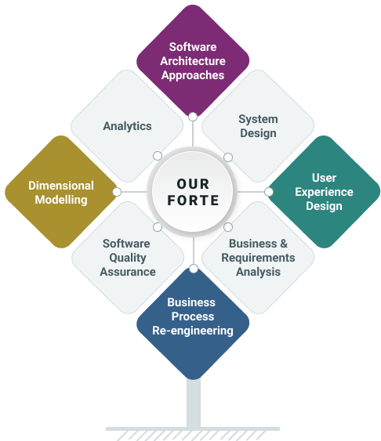
Argusoft has been in business for over 25 years and has successfully undertaken a range of large enterprise-grade projects with small, medium, to very large private, public and government organizations. Argusoft is a software solutions design consultancy that develops, deploys on-cloud/on-premises and grooms such enterprise-class software solutions. Most significantly, our solutions are incredibly protean, ensuring that the business needs are always quickly and easily aligned to the solution. We capitalize on our low-code framework to deliver fully customized solutions that are very stable, quick to configure and hence faster to deliver.

Argonauts (team argusoft!) are trained to think ‘design’ at every step. We architect, design, and code, always keeping our clients' business objectives in mind. We work as total partners, fully shouldering the responsibility of their business enabling software systems or, in the case of software product companies, as trusted technology partners of their core business offering.

Argusoft has successfully accomplished several significant SOA software development projects for Fortune 1000 US and India clients over the last dozen years. It plans to continue its focus on this activity as a turnkey software services provider. Argusoft’s forte is its solution design and technological prowess to build and deploy large enterprise-class software systems successfully. Several of these systems have also been developed and managed by Argusoft for several years. Argusoft has never been restricted by domains or verticals.

Why we do, what we do
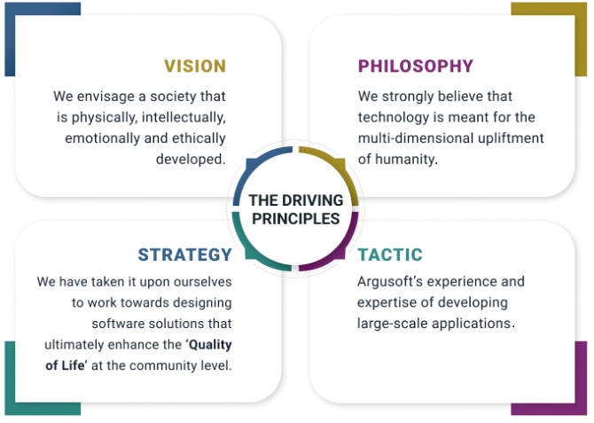

Registration Certificate and GST Certificate
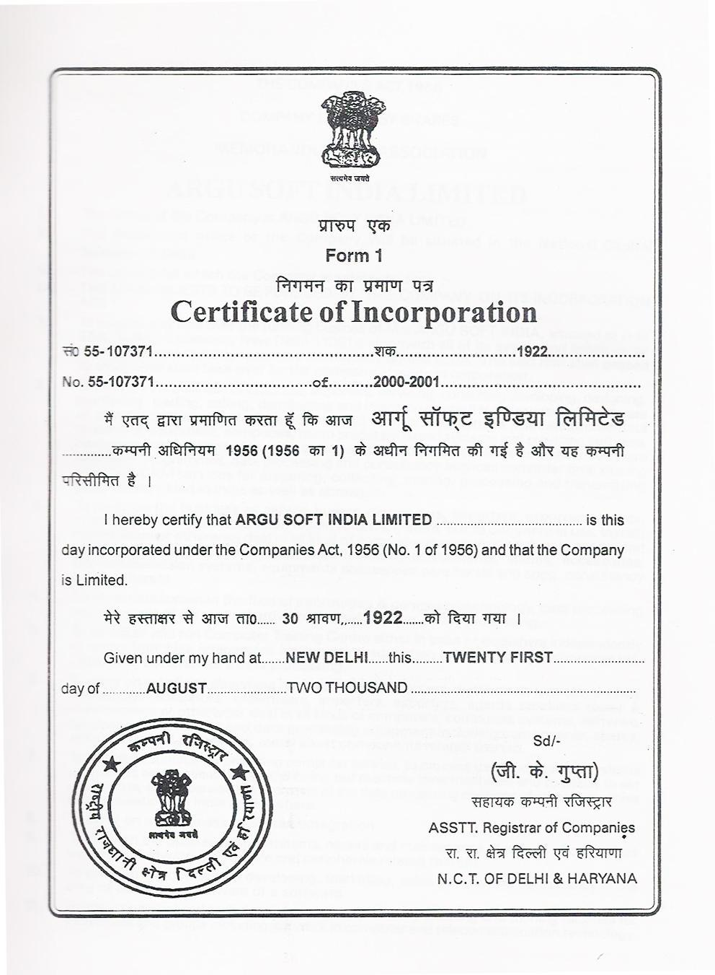

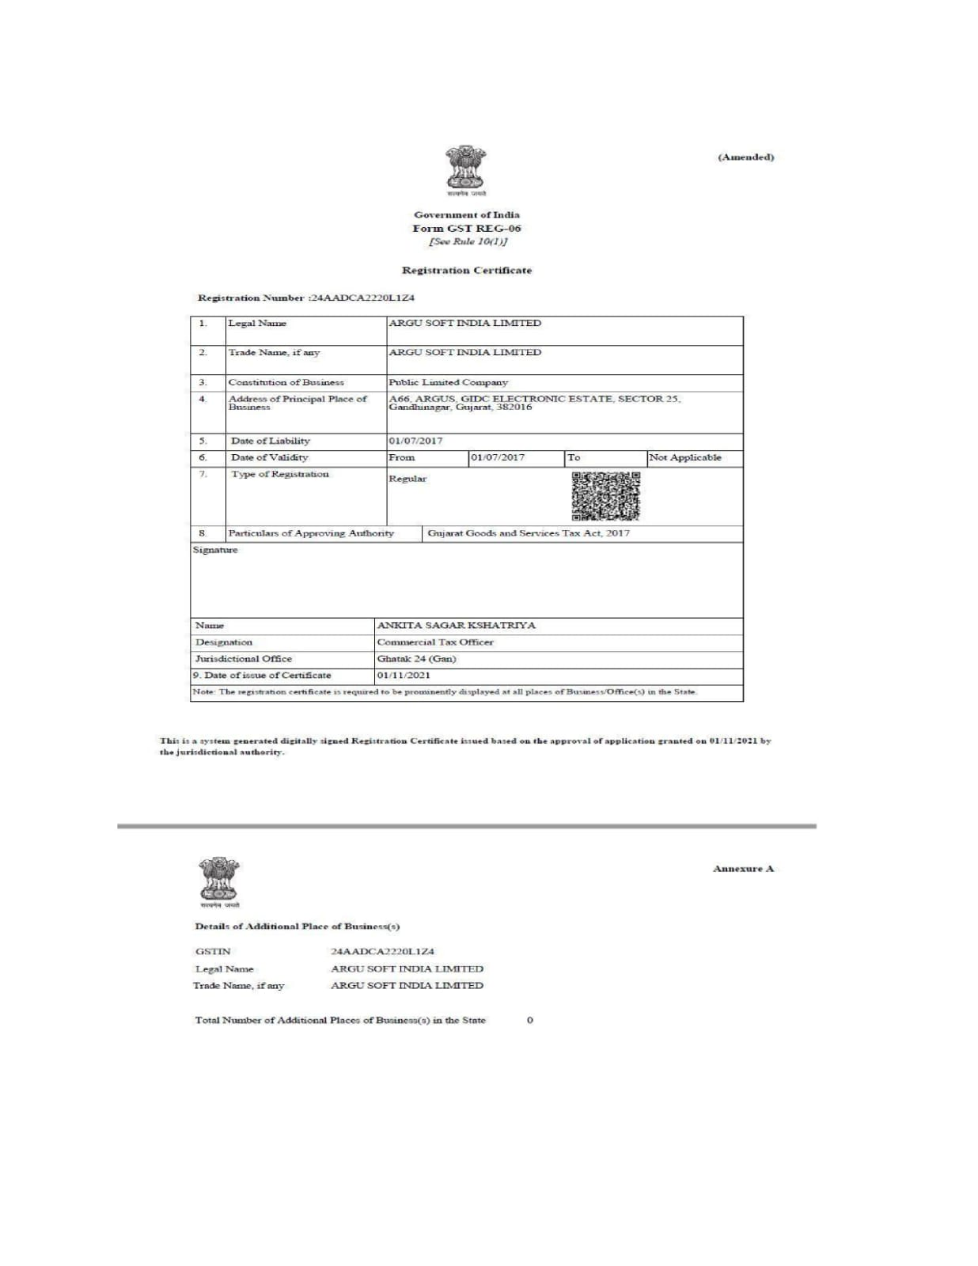

Awards, Certifications and Accreditation
Argusoft has achieved a range of ISO certifications, including
ISO 9001:2015  for Quality Management System (QMS) | ISO/IEC 27001:2003  for Information Security Management System (ISMS), and | ISO 14001:2015  for Environmental Management System
ISO/IEC 20000-1:2011  for IT Service Management (ITSM) | ISO/IEC/IEEE 23026:2015  for Systems and Software Engineering — Engineering and management of Websites for Systems, Software, and Services Information.

Geographical Presence
Argusoft has a global presence in terms of digital solution deliveries. It has designed and implemented solutions in over a dozen countries in five continents. Argusoft provides Consulting, Solution Design, Solution Architecture, Software Solution Development, Business Analysis, QA & Testing, Client Support, and Business Operations from its global delivery centre in India office. It has several partner offices in the US, Middle East, and Japan which are responsible for Business Development activities.
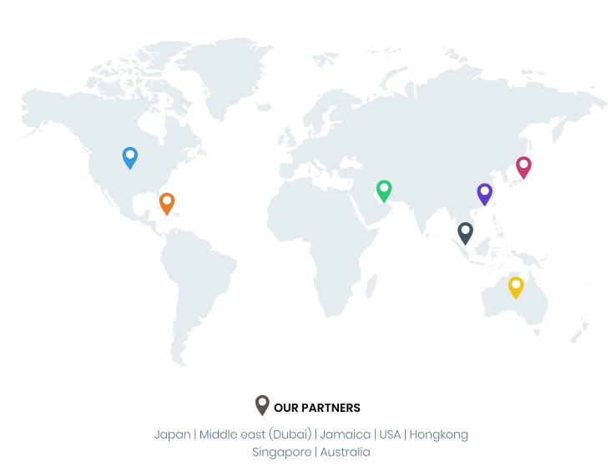
Argusoft - India Operations | Argusoft - US Operations
A-66, Sector 25, GIDC, Gandhinagar,  Gujarat 382016, India | 35463 Dumbarton Ct., Newark,  CA 94560, USA

Annexure 2 : ISO Certifications

Argusoft India

CMMI Level 5 

ISO 9001:2015 Quality management system


ISO 14001:2015 Environmental management system



ISO/IEC 20000-1:2018 IT service management (ITSM)


ISO/IEC 27001:2022 Information security management system (ISMS)


ISO/IEC/IEEE 23026:2015 - Engineering and Management of Websites for Systems, Software, and Services Information



Annexure 3: Letters of Recommendation

EWARS
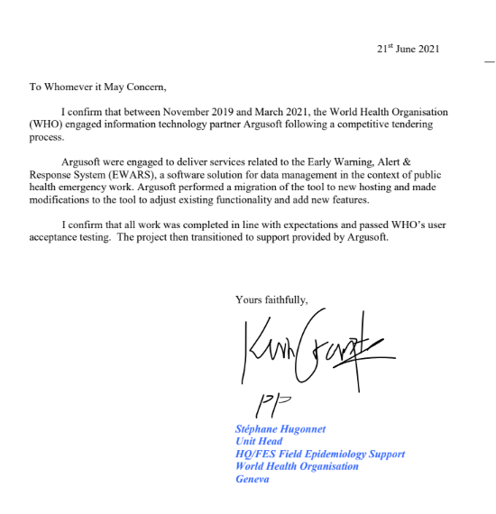

P4H

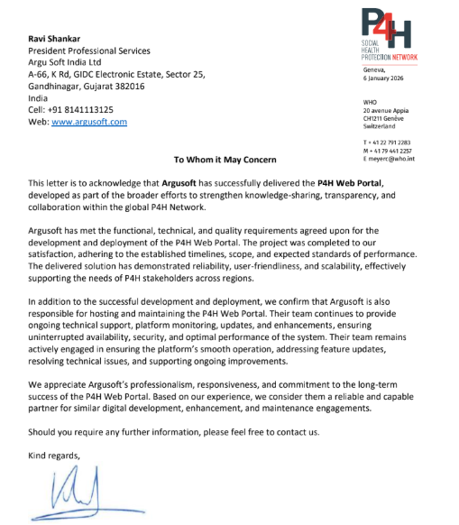

MEDPlat Implementation - eKavach
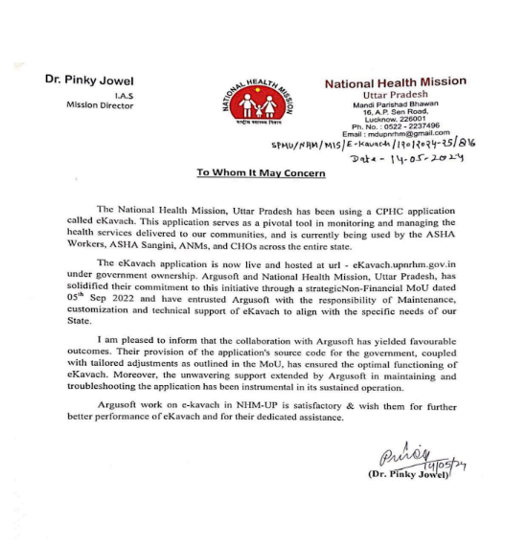

MEDPlat Implementation - PHMP

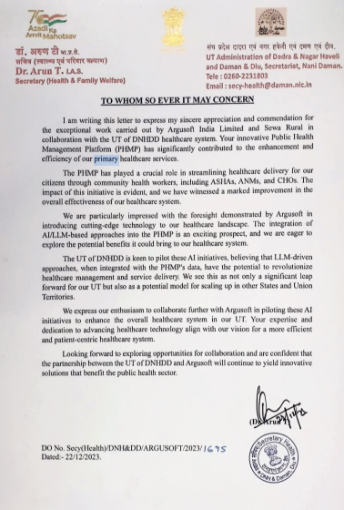

Annexure 4 – Functional Compliance Matrix (Uc001–Uc061)
Introduction
This Functional Compliance Matrix provides a use-case-level mapping of Argusoft's proposed solution against the Functional Requirements for the Health Accounts Data System (DMS), including all use cases UC001–UC061 and UC060.1.
Argusoft confirms that the proposed solution is designed to fulfil the functional requirements defined in the WHO Functional Requirements document. The implementation will follow the phased approach specified by WHO, with the functionalities identified for the Pilot delivered first and the remaining functionalities incorporated progressively following Pilot approval. The Pilot list has been considered in accordance with the clarification issued by WHO, including the clarification that general dashboard functionality is included in the Pilot.
- Phase 1 – Pilot:
Functional requirements identified by WHO for delivery as part of the Pilot implementation. This includes the Pilot functionalities specified in the WHO Functional Requirements document and the subsequent clarification that general dashboard functionality is included in the Pilot.
- Phase 2 – Post-Pilot:
Remaining functional requirements that will be delivered progressively following successful completion and approval of the Pilot, in accordance with the phased implementation approach agreed with WHO.
UC001–UC061 Functional Compliance Matrix
UC | Functional Requirement | Delivery Stage | Proposed Response
UC001 | Web Based Application | Pilot | DMS will be delivered as a browser-based web application accessible without client-side installation.
UC002 | Access to All Modules from Application Home Site | Pilot | A centralized DMS home site will provide access to all modules according to user permissions.
UC003 | Dashboard Displayed in Application Home Site | Pilot | A DMS dashboard will be provided on the application home site, with detailed dashboard content finalized with WHO during inception.
UC003.1 | Different Dashboard for Administrators and Regular Users | Post-Pilot | Role-specific dashboard views will be supported and configured according to user roles and permissions.
UC004 | Users Module | Pilot | User administration, access management, role assignment and user status management will be provided.
UC005 | Grant Access for a User | Pilot | Administrators will be able to grant DMS access to authorized users.
UC006 | Access with WHO Single Sign-On | Pilot | DMS will integrate with WHO Entra ID/Single Sign-On for authenticated access.
UC007 | Assign Roles to DMS Users | Pilot | Administrators will be able to assign roles and associated permissions to DMS users.
UC008 | Edit DMS Roles Permissions | Post-Pilot | Authorized administrators will be able to configure and manage permissions associated with DMS roles.
UC009 | Restrict Countries for a Regular User | Post-Pilot | Country-level access restrictions will be supported for Regular Users according to assigned permissions.
UC010 | Temporarily Disable a DMS User | Post-Pilot | Administrators will be able to temporarily disable a user's DMS access.
UC011 | Enable a Disabled DMS User | Post-Pilot | Administrators will be able to restore access for previously disabled users.
UC012 | DMS Users Cannot Be Deleted | Pilot | User records will be retained, with access managed through user status rather than deletion.
UC013 | Setup Module | Pilot | A centralized Setup and Configuration module will manage DMS configuration components.
UC014 | Import Configuration Data from xMart | Pilot | Required configuration data will be retrieved/imported from xMart through the agreed integration mechanisms.
UC015 | Reorder Columns in All Data Components Lists | Pilot | Applicable data-component lists will support configurable column ordering.
UC016 | Edit Predefined List of Values | Pilot | Authorized administrators will be able to manage predefined configuration values.
UC017 | Create a New Value for a Data Component | Pilot | Authorized users will be able to create new configuration values for applicable data components.
UC018 | Create New Attributes for Existing Data Components | Post-Pilot | The configuration model will support creation of additional attributes for applicable data components.
UC019 | Edit the Details of a Component | Post-Pilot | Authorized users will be able to edit applicable component details through the Setup module.
UC020 | Delete One Value of a Component | Post-Pilot | Authorized administrators will be able to remove applicable configuration values subject to data dependencies.
UC021 | Export and Import Data Components Values and Their Attributes | Post-Pilot | Applicable configuration values and attributes will support import and export.
UC022 | Groups of Countries | Pilot | Country groups will be supported for configuration, access, calculations, quality checks and reporting.
UC023 | Countries Data Reporting Follow Up | Pilot | Country/year reporting status and follow-up information will be supported.
UC024 | Data Publishing Status Flag | Pilot | Data publishing/readiness status will be maintained and displayed within DMS.
UC025 | Predefined Crosses | Pilot | Predefined classification crosses will be available and manageable by authorized users.
UC026 | Custom Crosses | Pilot | Users will be able to create applicable country-specific/custom classification crosses.
UC027 | Metadata Fields for Each Observation | Pilot | Observation-level metadata will be supported, including applicable legacy formula metadata.
UC028 | Access Metadata Files Stored in SharePoint from DMS | Pilot | DMS will provide access to applicable metadata files stored through the agreed WHO SharePoint/xMart arrangement.
UC029 | Predefined Formulas | Pilot | A formula management and calculation capability will support predefined indicator formulas.
UC030 | Custom Formulas | Pilot | Authorized users will be able to create and use custom formulas according to applicable permissions.
UC031 | Workbooks Module | Pilot | The Workbook module will provide Excel-like data viewing/editing, formulas, metadata and data manipulation capabilities.
UC031.1 | Order Workbook Data Based on Any Element Displayed | Post-Pilot | Workbook data will support applicable sorting and ordering based on displayed elements.
UC032 | Export Workbooks Data | Post-Pilot | Workbook data will be exportable using the supported formats and templates.
UC033 | Locking Functionality | Post-Pilot | Workbook-level locking will prevent simultaneous conflicting edits to the same data.
UC034 | User Customized Display of Metadata Fields | Post-Pilot | Users will be able to customize the display of applicable metadata fields.
UC035 | Reports Module | Pilot | A dedicated Reports and Analytics module will provide predefined and configurable reporting capabilities.
UC036 | Create and Edit a Predefined Report Available to All Users | Pilot | Authorized administrators will be able to create and edit predefined reports available to users.
UC037 | Create and Edit Customized Reports Available for the User Only | Post-Pilot | Users will be able to create and manage customized reports for their own use.
UC038 | Copy a Report as the Basis for a New Report | Post-Pilot | Existing reports will be copyable and usable as the basis for new reports.
UC039 | Data Tracking Reports | Pilot | Data tracking and reporting capabilities will support monitoring of data status and changes.
UC040 | User Customized List of Reports | Post-Pilot | Users will be able to manage their personalized list of applicable reports.
UC041 | Multilanguage Report | Post-Pilot | Reports will support applicable WHO official-language labels and multilingual reporting requirements.
UC042 | Export Report to Excel Format | Pilot | Reports will support export to Excel format.
UC043 | Variables, Data Sets and Metadata Versioning | Pilot | Version history for applicable observations, variables, datasets and metadata will be supported through xMart/DMS integration.
UC044 | Compare and Restore Previous Versions | Pilot | Authorized users will be able to compare and restore applicable previous versions.
UC045 | API from xMart to DMS | Pilot | DMS will retrieve required data from xMart through the defined API integration.
UC046 | API from DMS to xMart – Data and Metadata Updates | Pilot | DMS changes will be transmitted to xMart through the agreed API integration.
UC047 | Quality Checks Module | Pilot | A dedicated Quality Checks module will support rule management, execution and result visualization.
UC048 | Exclude Countries from a Quality Check | Pilot | Quality-check execution will support country/group exclusions.
UC049 | Create and Edit a Predefined Quality Check Rule Available to All Users | Post-Pilot | Authorized administrators will be able to create and edit predefined quality-check rules.
UC050 | Create and Edit a Customized Quality Check Rule Available for the User | Pilot | Users will be able to create and manage customized quality-check rules according to permissions.
UC051 | Export and Import Quality Checks Rules | Post-Pilot | Quality-check rule configurations will support import and export.
UC052 | Manual Run of Quality Check from a Workbook | Pilot | Users will be able to manually trigger applicable quality checks from the Workbook context.
UC053 | Predefined Quality Checks During Development | Pilot | Predefined quality-check rules will be incorporated based on WHO requirements.
UC054 | Configuration Values for Quality Check Rules | Pilot | Quality-check thresholds and configuration values will be configurable.
UC055 | Generate, Visualize and Download Quality Check Report | Pilot | Quality-check results will be generated, visualized and downloadable through DMS.
UC056 | Develop Functionalities in WHO xMart | Pilot | Argusoft will work with WHO to implement the required xMart-side functionality/configuration necessary to fulfil the agreed DMS scope.
UC057 | Expected Processing Volumes | Post-Pilot | The solution architecture will support the specified data volumes and year-end processing requirements.
UC058 | Notifications Module | Post-Pilot | An event-based In-App Notifications module will be provided.
UC059 | Create or Edit Notifications | Post-Pilot | Authorized administrators will be able to create and edit notification definitions and targeting.
UC060 | Old DMS Formulas Migration | Pilot | Argusoft will perform the required one-off migration of legacy DMS formulas into xMart as metadata and make them accessible through the new DMS.
UC060.1 | Translation of Old DMS Formulas into New DMS Syntax | Post-Pilot | Argusoft will translate legacy formulas into the new DMS formula syntax as part of the agreed migration scope.
UC061 | Phased Implementation | Pilot | Implementation will follow the WHO-defined Pilot and subsequent Post-Pilot delivery approach.

